**The Unexplored Forts of Maharashtra**

1. **VishalGadh**

“लाख मेले तरी चालतील, पण लाखांचा पोशिंदा जगाला पाहिजे, राजे विशालगड गाठा, आणि पोहोचल्यास तोफांचे तीन वार द्या तोपर्यंत या गणीमास घोडखिंडीत अडकौन ठेवतो.”

Those were the final words of Veer Bajiprabhu Deshpande.

**Introduction:**

Vishalgad fort, is also called ‘Khelna’ or ‘Khilna’ by locals, and was one of the important forts of the Maratha empire. The name ‘Vishalgad’ means grand fort in Marathi, the name was given by Chhatrapati Shivaji Maharaj after annexing it during 1660. The structure covers an area of 1130 m and was built on a hilltop in the Sahyadri mountain ranges at a height of 3500 feet above sea level, and is about 76 km north – west of Kolhapur.  
Vishalgad Fort was built in the year 1058 by a Shilahara ruler ‘Marsinh’ and was initially known as ‘Khilgil’ fort. But down the centuries it passed into the hands of many rulers who ruled around the Deccan region.

**Battle of Pawankhind**

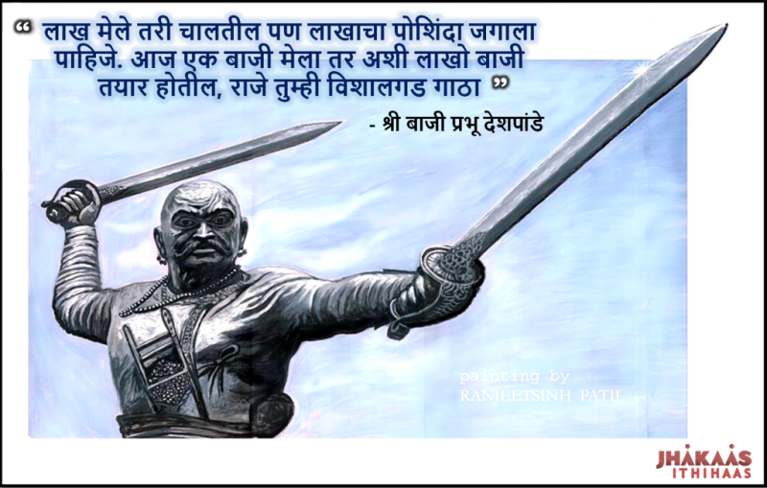

**Battle of Pävankhind** was a rearguard [last stand](https://en.wikipedia.org/wiki/Last_stand) that took place on 13 July 1660 at a mountain pass in the vicinity of fort [Vishalgad](https://en.wikipedia.org/wiki/Vishalgad), near the city of [Kolhapur](https://en.wikipedia.org/wiki/Kolhapur), [Maharashtra](https://en.wikipedia.org/wiki/Maharashtra), India between the Maratha Sardar Baji Prabhu Deshpande and Siddi Masud (later known as Siddi Jauhar ) of Bijapur Sultanate.

After Defeating Afjhalkhan, In the early 1660 the Maratha King Chhatrapati Shivaji Maharaj was trapped in the fort of Panhala, under siege and vastly outnumbered by an Adilshahi army led by an Abyssinian named Siddi Masud. Maharaj Planned to escape to the fort of Vishalgadh, which was administered by a Maratha chieftain named Range Narayan Orpe. Two Maratha sardars of the Adilshahi Commander Siddi Jouhar namely Suryarao Surve and Jaswantrao Dalvi had also encircled the fort of Vishalgadh simultaneously. Chhatrapati Shivaji Maharaj waited for months, planning and depleting the Adilshah's food source. He waited until he reckoned that they needed to gather more food, and then started his plan.

Chhatrapati Shivaji Maharaj, Veer Baji Prabhu, and around 600 of their best troops, hardened mountaineers of the Maval region, would dash through the Adilshahi force at night. A man named Shiva Kashid, who resembled Shivaji Maharaj’s appearance, had volunteered to dress like the king and get captured. It was envisaged that this would buy some additional time due to the confusion over identity, before Siddi Masud realised the error and gave chase.

On the Night of 13th July Chhatrapati Shivaji Maharaj made his escape, with his contingent of troops. Veer Baji Prabhu was second in command of this contingent. The Adilshahis gave hot and rapid pursuit, with an army of 10,000. It was clear that there was no way to shake off the enemy, and that the Marathas would not simultaneously prevail over both the Moghul garrison at Vishagadh and the chasing Adilshahi army. The only option was to divide the forces where one of the section will stay back and fight the larger Adilshahi forces in a rearguard action, while the rest of the Marathas would carry on to their destination.

“लाख मेले तरी चालतील, पण लाखांचा पोशिंदा जगाला पाहिजे, राजे विशालगड गाठा, आणि पोहोचल्यास तोफांचे तीन वार द्या तोपर्यंत या गणीमास घोडखिंडीत अडकौन ठेवतो.”

After saying those final words to the king, Veer Bajiprabhu Deshpande occupied Ghod Khind,(a valley present in the Kolhapur region of Maharashtra ) blocking the path of the pursuers, and made a determined defence against them. His brother Fulaji Prabhu as well as sardars such as Shambusing Jadhav and 300 Maratha forces were present with him.

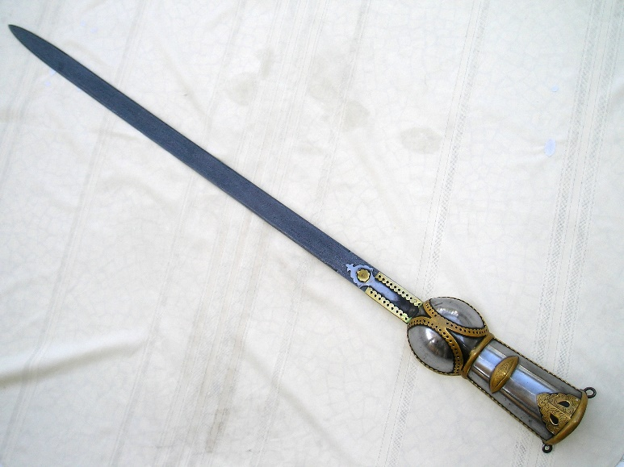

Wearing Dandpatta in both the hands the fierce battle started, The Marathas genius in guerilla warfare took the advantages of the forest, valleys and were in the upper hand in the battle but few hours later Fulaji Prabhu and Shambusing were killed after a gallant and fierce fights. Veer Baji Prabhu was severely wounded but carried on fighting at his station. The Adilshahi army repeatedly tried to break through the defenses of the pass, but were repeatedly repulsed. The unequal battle raged for hours, with the defenders maintaining their positions, but with rapidly depleting numbers. Only a handful of Marathas survived, and around a thousand soldiers of the Adilshahi army became casualties in attempting to take the pass.

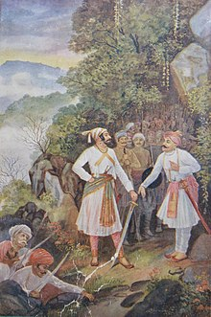

On the other hand Chhatrapati Shivaji Maharaj and his 300 soldiers had to break through the encirclement of Suryarao and Jaswantrao at Vishalgadh. A fierce battle ensued in which Maharaj himself fought wearing Dandpatta in his both hands. Seeing this fight, the commander of Vishalgadh fort sent help to Maharaj enabling him and his troops to reach the fort safely. Five to Six hours after the battle, The cannon fire announcing Maharaj’s safe return to Vishalgadh was heard. Almost 300 Marathas had been killed, Legend has it that a gravely injured Veer Baji Prabhu continued engaging the enemy and held the pass, only laying down his life once he heard the sound of cannon fire. The handful surviving Marathas then retreated and disappeared in the forest as per the plan. Shivaji Mahraj’s plan was successful. Having made his way to Vishalgadh, Rango Narayan Orpe had fresh troops at his disposal. Veer Baji Prabhu had successfully fought the rear-guard action and slowed the Adilshahis forces before they arrived at the fort having carried on pursuing Shivaji Maharaj to Vishalgadh. The vengeful fresh Maratha troops carried out a blazing and bloody attack against Siddi Masood, Jasawantaro and Suryarao's forces inflicting heavy losses upon the latter when they arrived at the fort. The Adilshahi forces fled as a result of this attack.

One Maratha chronicler describes this fierce attack by mentioning that the 'green valleys of Vishalgadh were painted in red due to enemy's blood'. Shivaji Maharaj then safely crossed the western ghats and reached his capital Rajgad via Konkan region. Shivaji Maharaj later personally visited the house of the slain Baji Prabhu, which was in the village of Kasabe Sindh in the Raigad district and honoured his family, including giving his eldest son a position of leadership and honour in the forces.The defence of the pass of Ghod Khind by about 300 Marathas led by the Baji Prabhu Deshpande was renamed **“The Battle of Pavan Khind”** which in Marathi means **“The Battle of the Sacred Pass”.**

Another history is about in 1844 it was one of the forts of Kolhapur State that initiated a rebellion against a Brahmin regent called Daji Krishna Pandit who had been installed by the British to govern the state in 1843 at a time when the natural heir to the throne was underage. He took direction from a political agent of the East India Company and among their actions were reforms to the tax of land. These reforms caused much resentment and, despite Kolhapur having refrained from involvement in the previous Anglo-Maratha Wars, a revolt against the British began in 1844. The rebellion began with soldiers locking themselves into hill-forts such as those as Panhala and Vishalgad, and then spread to Kolhapur itself.

**How to Reach:**

**By car:**

Located at around 80km from Kolhapur, Vishalgad fort could be reached within two hours of drive from the city. One has to drive on Kolhapur-Ratnagiri State Highway till Amba and then taking a left turn and head further for around 20km crossing the forest, roads and ghat section, One can park their vehicle there. Then one has to cross a bridge joining two mountains and then climb for around 20mins to reach the top of the fort.

**By Train:**

By train you can reach Chhatrapati Shahu Maharaj Terminus (officially Shri Chhatrapati Shahu Maharaj Terminus) (station code: CSMT KOP) is the main railway terminus in the city of Kolhapur, India. And then you can take local bus or cars to reach Vishalgad.

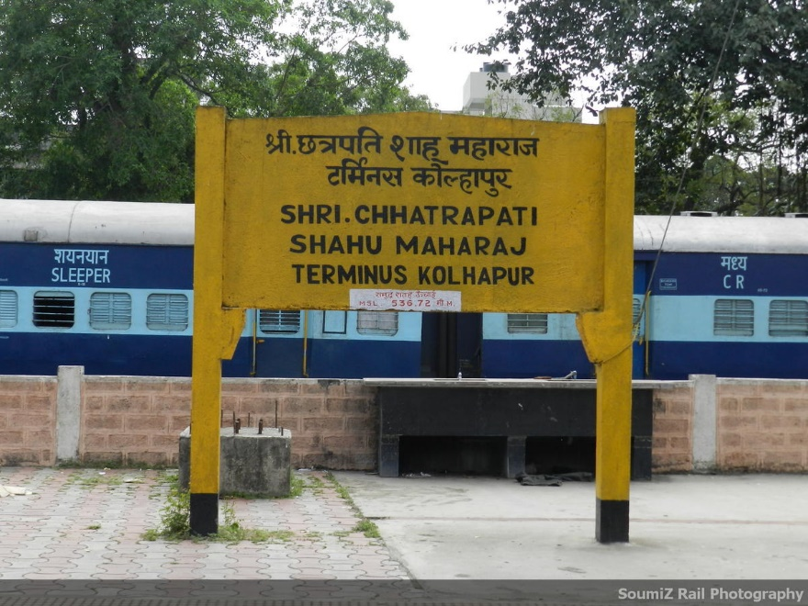

**By Air:**

Kolhapur Airport is located 9 km from the city of Kolhapur in Maharashtra, from their reach Kolhapur city and take local bus or car to reach Vishalgad

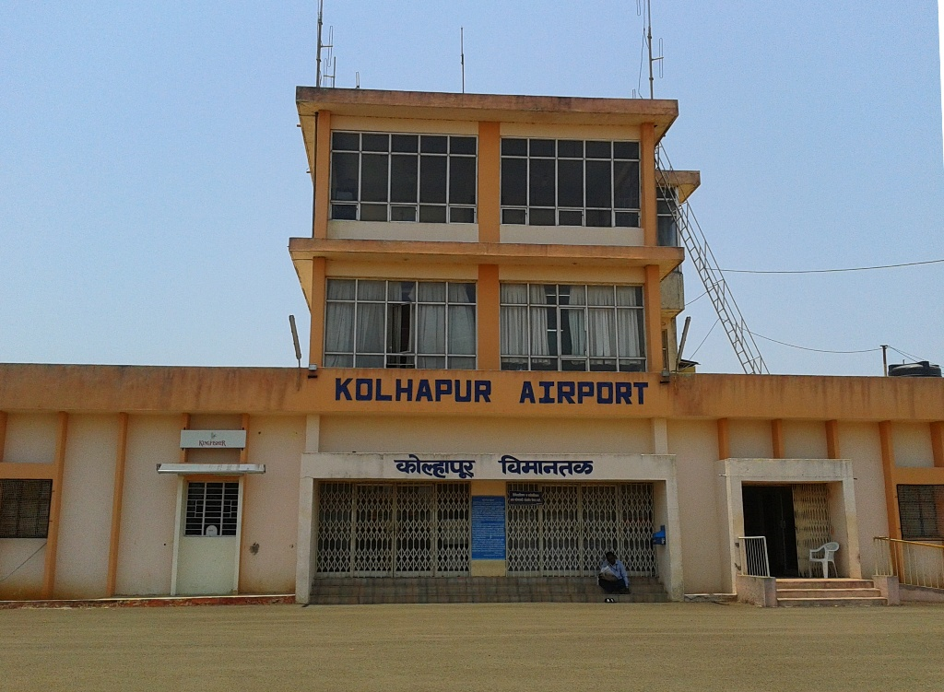

**What to see on fort: Gallery**

A Famous Dargah of Hazrat Sayed Malik Rehan Meera Saheb, which is visited by tourist is located on this fort.

Our Measures: Today the fort is in ruins and it needs to be taken care by the archaeological authorities. The fort underwent restoration work recently in which the fortification walls and the entrance arch has been fixed. Visitors and the locals should take care of the fort so that the history and heritage is conserved in a sustainable way

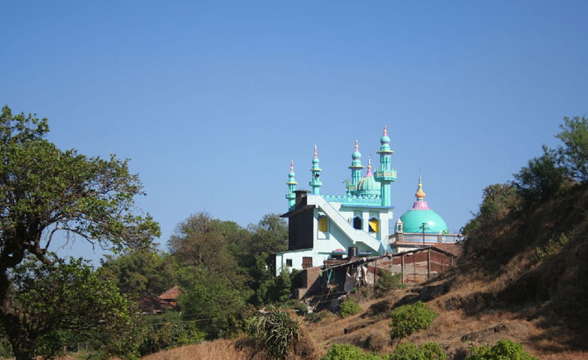

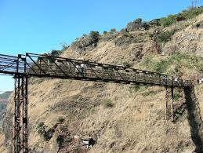

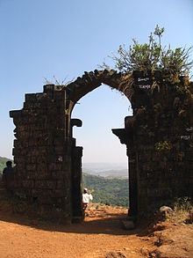

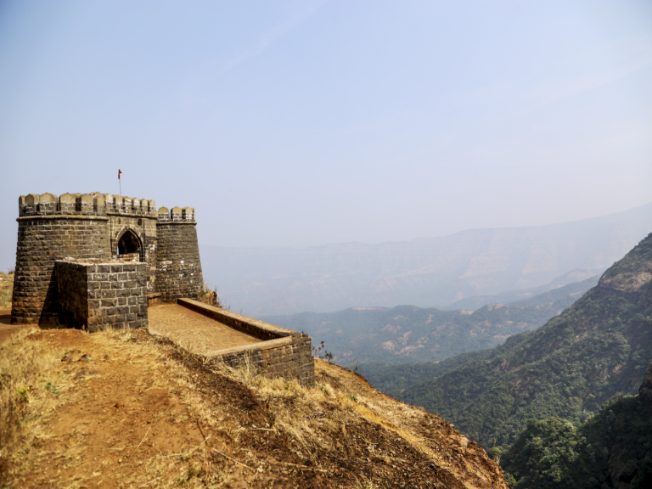

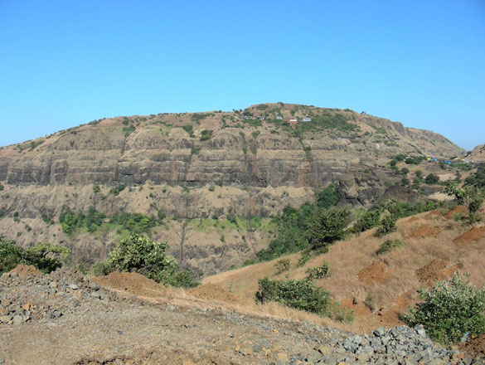

**Nearby attraction:**

1. **Panhala Fort** Built in 1100 A.C.. Historic memories of Chhatrapati Shivaji Maharaj. Hill Station. Carrying a rich heritage, Panhala Fort forms the largest of all the Deccan forts. This fort was built between the 1178-1209 AD, this is the only fort where the great ruler himself, Chatrapati Shivaji Maharaj is believed to have spent more than 500 days. The history of Panhala Fort is one of the oldest, and famous amongst Maratha warriors. Sajja Kothi, where Chhatrapati Sambhaji Maharaj was imprisoned. Ambabai Temple, where Chhatrapati Shivaji Maharaj used to seek blessings before venturing on expeditions. In addition to history, Panhala at an altitude of 977 m offers some inspiring scenery and a soothing climate. An average temperature of 25 *C. It is a must place to visit, while in kolhapur. A 45 minute journey, accompanied by beautiful landscape , a trip to Panhala will surely be a memorable one!

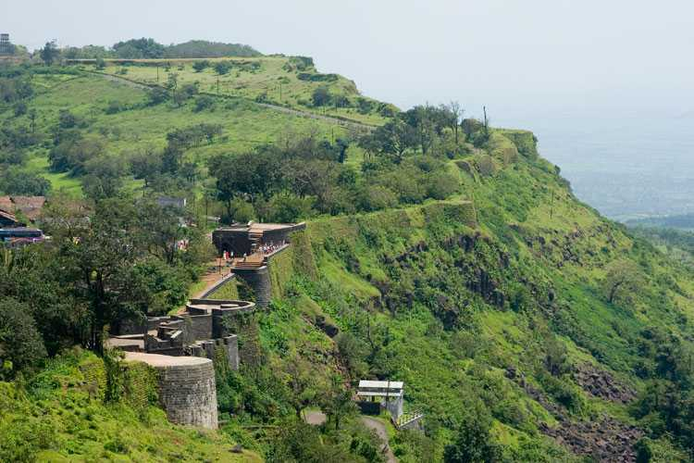

* **Jyotiba temple** Situated at a height of 3100 feet, this holy site nestles in the mountains, also known as Wadi Ratnagiri. Jyotiba is supposed to be an incarnation of three gods -- Brahma, Vishnu and Mahesh and the seer Jamadagni. A colorful fair takes place on the full moon night of the Hindu months of Chaitra and Vaishakh. During the fair, Devotees from various regions hoist "Sasan Kathi", which is the holy symbol of lord Jyotiba. Jyotiba lies 17 km to the north-west of Kolhapur.

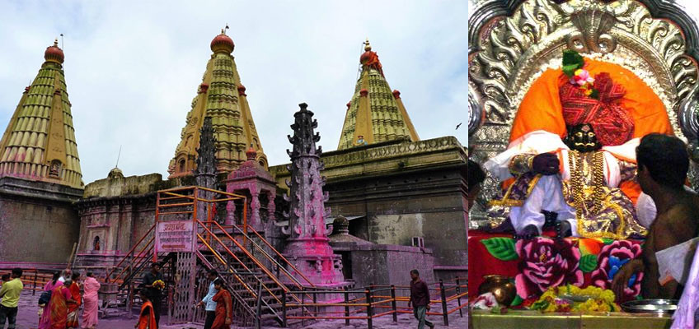

* **Narsobawadi** This holy place is situated on the confluence of the rivers Krishna and Panchaganga. It is well known for the holy padukas (slippers) of Dattaguru ( an incarnation of Brahma, Vishnu and Mahesh). Narasimha Saraswati, considered an incarnation of Dattaguru who lived here for 12 years. Recently, all the devotees have erected a temple called "Jahaz Mandir", which is unique in its own way, because it has been built in the shape of a ship with beautiful landscape. Narsobachiwadi is famour for Basundi, Kundhi Pedas, Kawatchi Barfi's.

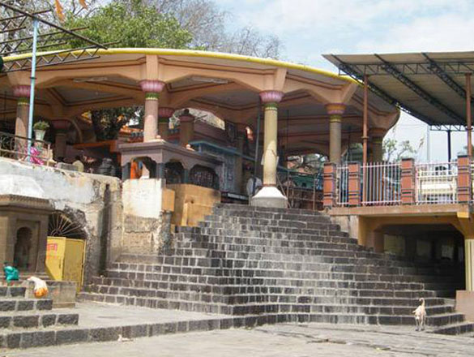

* **Bahubali** This site is revered by both Hindus and Jains. Devotees flock here to pay respect to the 28 feet tall marble statue of Bahubali and visit the temples of the 24 tirthankaras or saints. This site is 27 km to the south of Kolhapur.

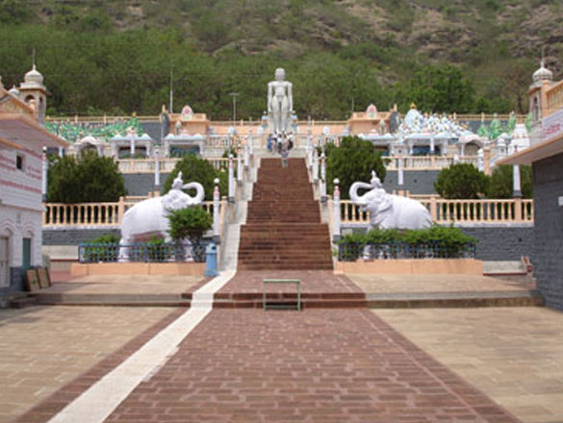

* **Siddhagiri Gramjivan Museum** A unique project, perhaps the only project in India situated at Shri Kshetra Siddhagiri Math, Kaneri, Tal. Karveer, Dist. Kolhapur. The place is near Kolhapur city on Pune Banglore Highway. Shri Kshetra Siddhagiri Math has a history of more than 1000 years, and is a holy place of worship of Lord Mahadeva. The surrounding around the museum is very calm and quiet, a hilly place with a good collection of Flora and Fauna.

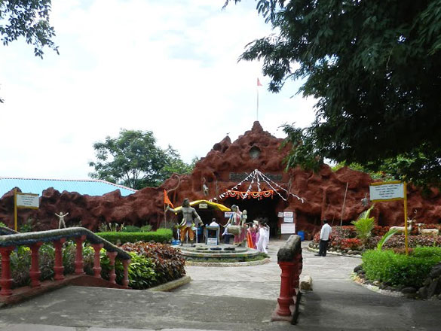

* **Gaganbawda**. A hill station about 2-3 hours from CBS(Central Bus Stand, Kolhapur) and Kolhapur Railway Station. Excellent climate during the rainy season.

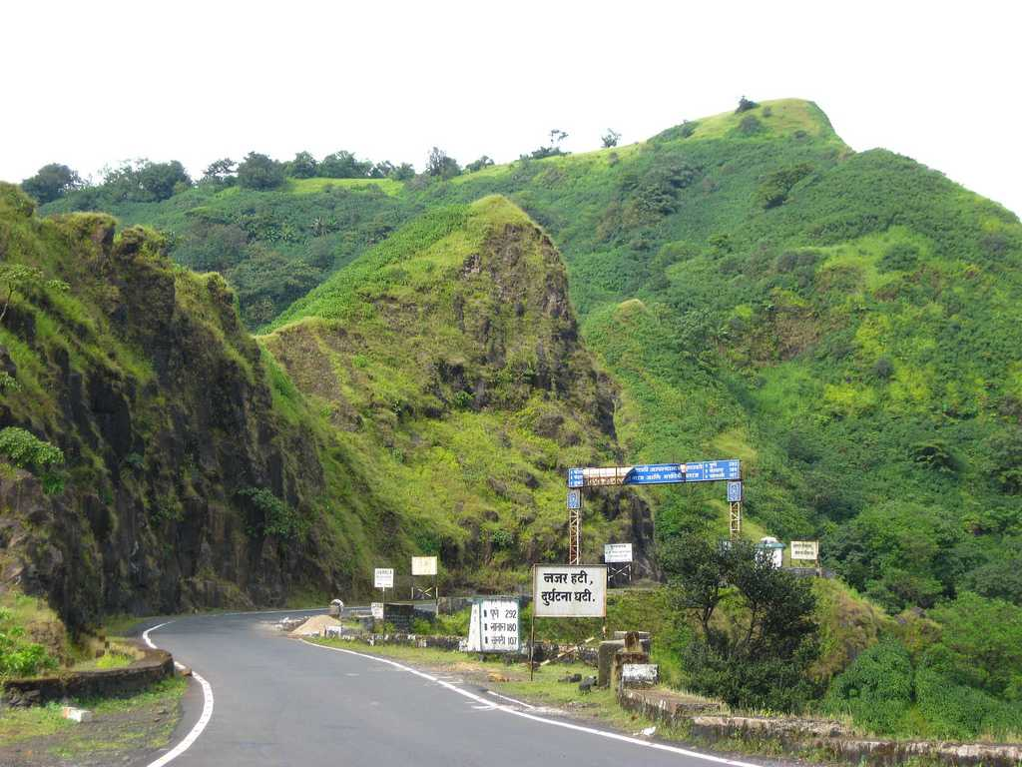

* **Gagangiri Maharaj Math** ( Temple ) at Gaganbawda. Gagangiri Maharaj was a Great Yogi. One of the few living sages having Unique Capacities, Vision and Synthesis. Gagangiri Maharaj Math is renowned as a spiritual destination for domestic and foreign travelers. The Math is located in the midst of dense forests and thick green vegetation at Dajipur nearby Kolhapur. Shri Gagangiri Maharaj was a Hindu Sanyasi (Sage) following the Nath Sampradaya.The life and history of the sage tells that Gagangiri Maharaj spent many years in this Math undergoing penance from 1932 to 1940. The Sage spent all these years in meditation in the deep jungle in this Math. This Ashram offers the Hindu teachings, yoga and meditation practices and also serves as a religious temple for the devotees. It is an attractive place for meditation, yoga and to clearly understand the Indian culture and its religious importance.

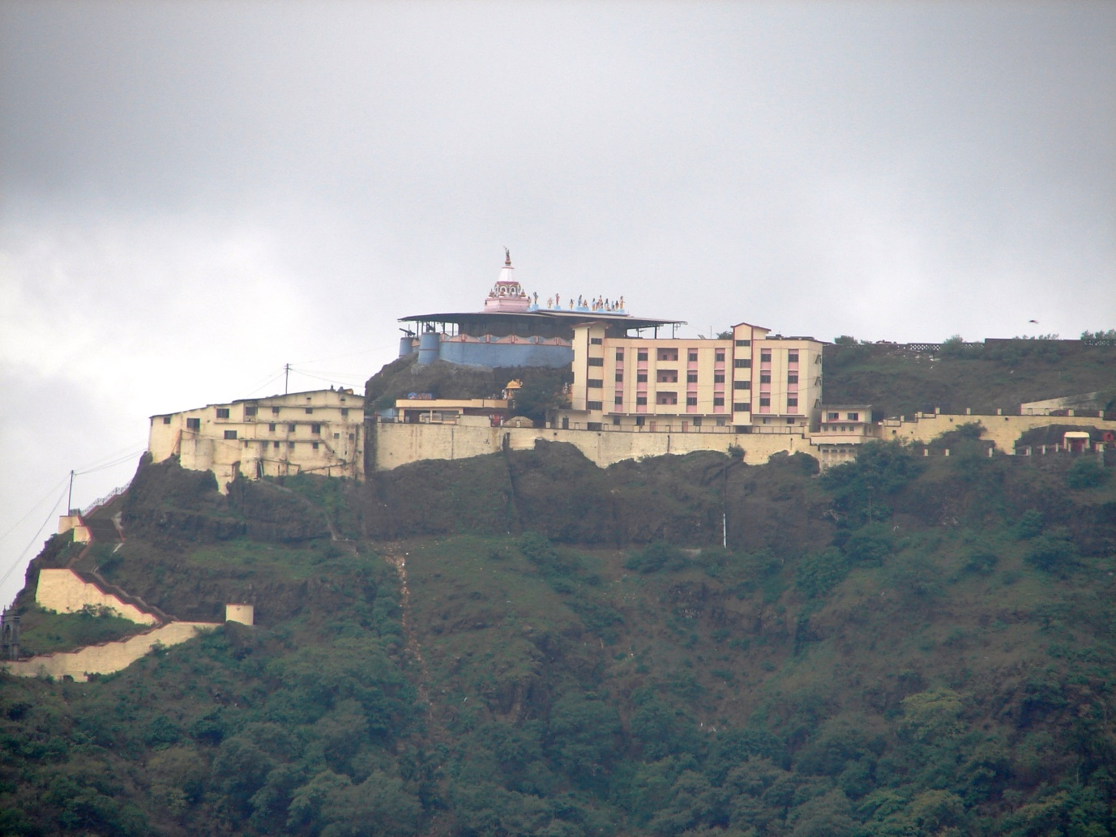

* **Khidrapur** A famous and beautiful Lord Shiva Temple built 900 years ago. The artistic temple of Kopeshwar or Mahadev at Khidrapur is a treasure-house of beautifully carved sculptures and a rare architectural marvel. The entire temple rests on a gajapeeth which is a semi-circular platform resting on the back of 92 carved elephants.

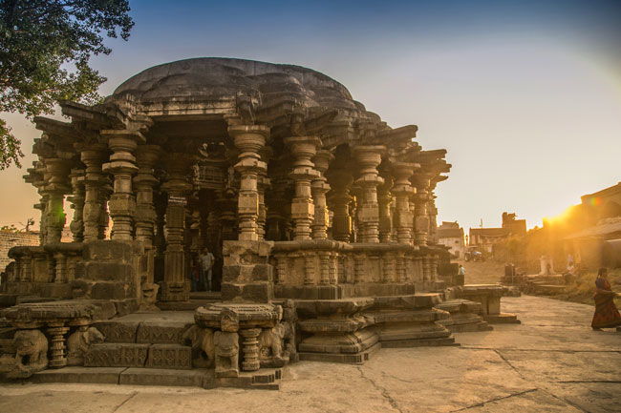

* **Dajipur Bison Sanctuary** The forest area of dajipur is situated on the border of kolhapur and sindhudurg districts. Surrounded by rugged mountains and dense forests, this secluded little place is completely cut off from human habitat. Home to bison, wild deer, gava (bison), and many more spectacular wild animals & birds. An excursion in the vicinity to the Gagangiri maharaj's Math makes for a pleasant outing. There is a scenic resort near the backwaters of Radhanagari dam which is highly recommended for wildlife lovers. Dajipur is an exciting and beautiful holiday getaway, situated 1200 meters above sea level. It is about 80 km away from Kolhapur. Radhanagari to Dajipur distance is 30 km.

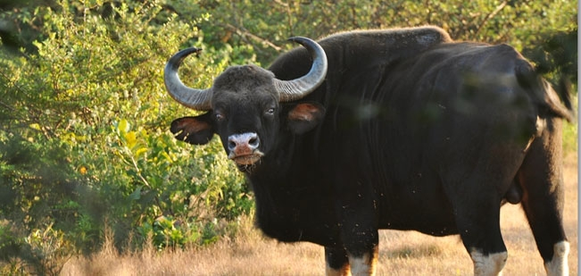

* **Ramling**

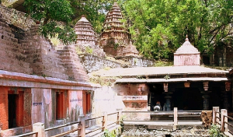

* **Radhanagari Dam**. About 15-20 km from CBS and Railway Station.

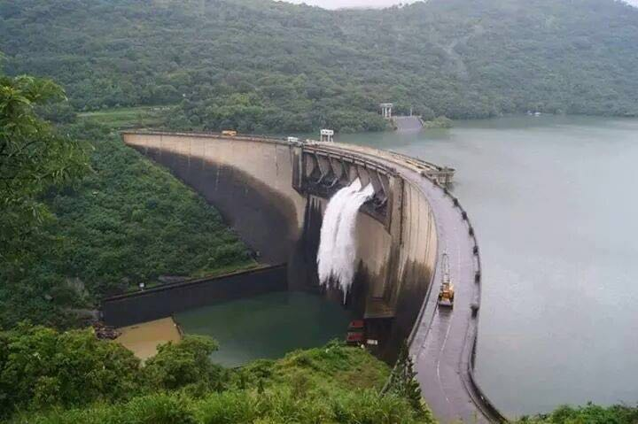

* **Amboli** Beautiful Rainy hill station, lot of clouds and Beautiful waterfall.

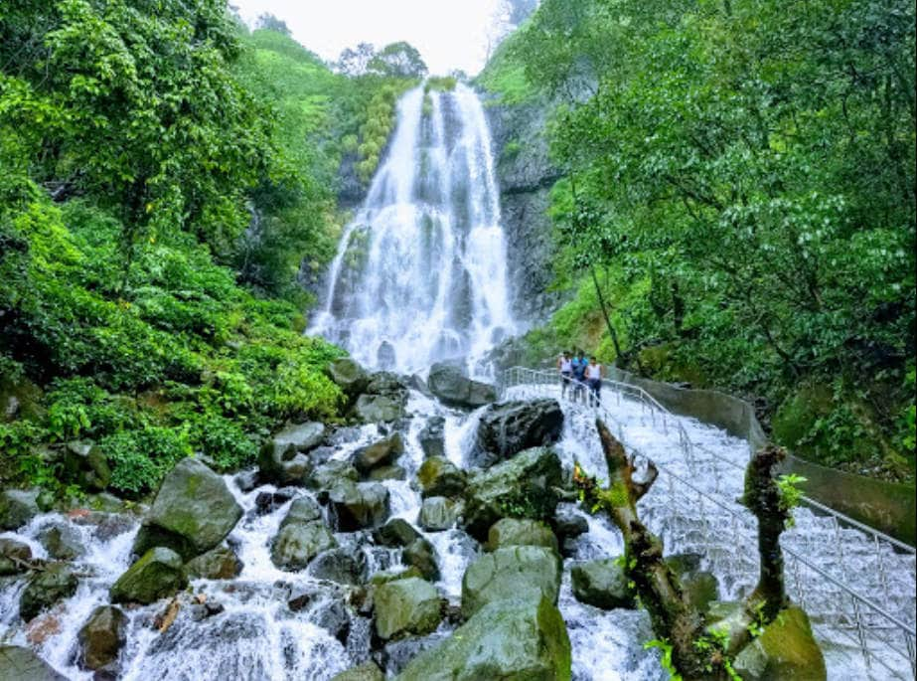

What to buy:

* Kolhapuri Chappals

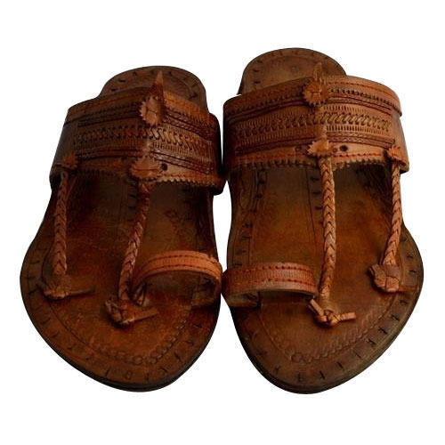

* Sarees

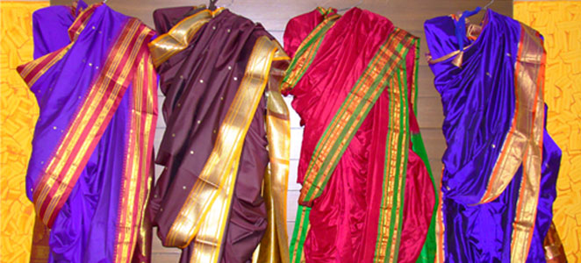

* Kolhapuri Saaj. One of the best place to buy Kolhapuri Saaj and other antique jewellery is Karekar Jewellers

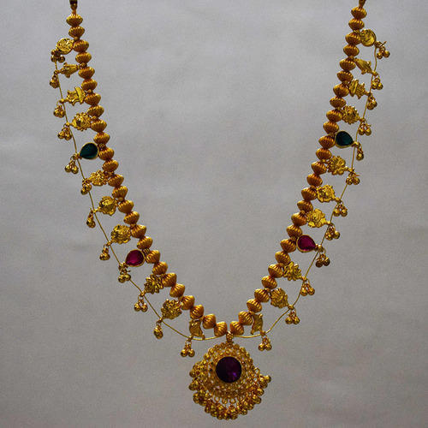

**What to eat:**

* Bawada Misal : This used to be very famous misal joint and has been visited by many celebrities, a fact easily seen from the pictures hanging on its wall.
* 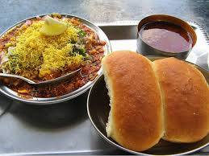
* Fadatare Misal: This is in 'Udyam Nagar' and by far the most popular misal place. It has been featured extensively in print and television media, but owners still prefer to run this place in the backyard of old factory in an industrial area. It has retained its taste for all these years, and hence it is popular among local as well as tourists.

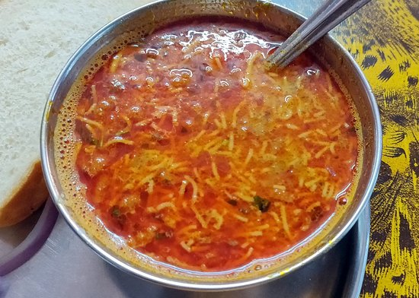

* Khasbaug Misal

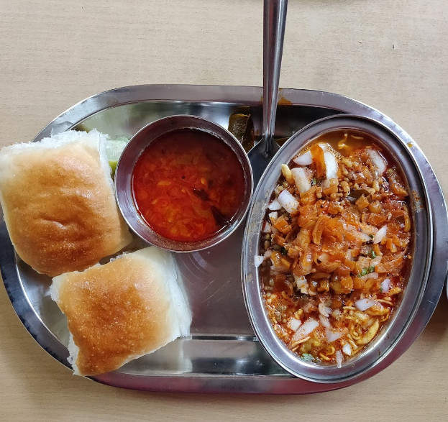

* Chorage Misal: Off Mahadwar road. Equally popular place.

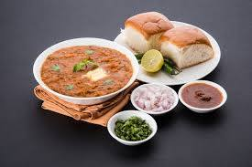

* Rajabhau-Bhel: This is a very famous Bheel place- dish made with Rice puffs, tamarind, chillis and onions.

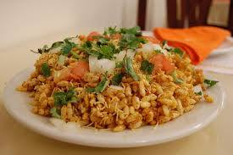

* Akkha Masur- a famous local mini-meal- red lentil curry in thick tomato-cashew base served with Bharaki (local bread) and chillis. you can find this in Bawda area -popular hawker food.

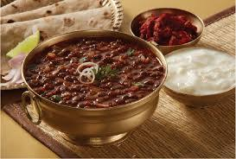

* Other good places are Datta Caffe, Ahar Vihar, Khas Bag misal, Kothawale (Laxmi) misal.

List of Restaurants:

* Hotel Victor Palace
* Hotel Raysons (24 /7 Coffee shop)
* Hotel Pearl
* Hotel Meghdoot
* Hotel Opel (best for veg and non-veg)... very process oriented and a disciplined yet upholding the charm of the garden within. [[[8]](http://www.hotelopal.co.in/)]
* Hotel Khavvaiya ( Gujrathi )
* [Lava Rocks Inn] ( Cafe, Pan America, Middle Eastern & Asian Cuisine ) Thursdays Closed!

**Accommodation:**

yatra.com/hotels/hotels-near-vishalgad-in-kolhapur

<https://www.travelguru.com/hotels/hotels-near-vishalgad-in-kolhapur>

<https://www.justdial.com/Kolhapur/Hotels-in-Vishalgad-Amba/nct-10255012>

1. **Salher**

**Introduction:**

Salher is the site of the highest fort in the Sahyadri mountains and the second highest peak at 1567 metres (5,141 ft) after Kalsubai in Maharashtra and also 32nd highest peak in Western Ghats. This fort is one of the celebrated forts of the Maratha empire.

According to a legend, Lord Parshuram did his Tapascharya at Salher Fort. After winning the earth and giving it as donation, he made land for himself to live in, by pushing the sea back with his arrows, right from this place.

Also, there is one famous battle The Battle of Salher.

The Treaty of Purandar (1665) required Chhatrapati Shivaji Maharaj to cede 23 forts to the Mughals. Strategically important forts, which were fortified with garrisons, such as Sinhagad, Purandar, Lohagad, Karnala, and Mahuli were turned over to the Mughal empire. At the time of this treaty, the Nashik region, that contained the forts Salher and Mulher, was firmly in the Mughal Empire's hands since 1636. The signing of this treaty resulted in Chhatrapati Shivaji Maharaj’s visit to Agra and after his famous escape from the same in September 1666, 2 years of ‘uneasy truce’ followed. However, the destruction of the temples of Viswanath and Benares along with Mughal Emperor Aurangzeb’s rejuvenated anti-hindu policies resulted in Chhatrapati Shivaji Maharaj declaring war against the Mughals once again.

The period between 1670-1672 saw a dramatic rise in Chhatrapati Shivaji Maharaj’s power and territory. Maharaja’s armies successfully conducted raids at Baglan, Khandesh, and Surat and retook more than a dozen forts.This culminated with a decisive victory against a Mughal army of more than 40,000 on an open field near Salher.

Sardar Moropant Pingle and along with his army of 15,000 captured the Mughal forts Aundha, Patta, Trimbak and attacked Salher and Mulher in January 1671. This led Mughal Emperor Aurangzeb to send two of his generals Ikhlas Khan and Bahlol Khan along with 12,000 horsemen to reclaim Salher. In October 1671, the Mughals laid siege on Salher. In return Chhatrapati Shivaji Maharaj commanded his two commanders Sardar Moropant Pingle and Sardar Prataprao Gujar reclaim the fort. 50,000 Mughals had besieged the fort for more than 6 months. Maharaj knew the strategic importance of Salher as it was the main fort on important trade routes. Dilerkhan had also attacked Pune in the meanwhile and Maharaj could not save Pune because his main armies were away. Chhatrapati Shivaji Maharaj devised a plan to divert Dilerkhan by forcing him reach Salher. He ordered Moropant who was in South Konkan and Prataprao who was raiding near Aurangabad to meet and attack Mughals at Salher to relieve the fort. In his letter to his commanders Shivaji Maharaj had written 'Go to the north and attack Salher and defeat the enemy’ Both the Maratha forces met near the village of Vani, they bypassed the Mughal camp at Nashik and reached near Salher. The total Maratha strength was of 40,000(20,000 infantry + 20,000 cavalry). The terrain was not suitable for cavalry battle hence the Maratha commanders decided to lure, split and finish the Mughal forces at different places. As per the plan Prataprao Gujar stormed the Mughals with 5,000 cavalry and killed many unprepared soldiers. After half an hour the Mughals became fully ready and Prataprao started to flee with his army. The entire Mughal cavalry of 25,000 started chasing the Marathas. Prataprao lured mughal cavalry in a pass 25 kms away from Salher where the 15,000 cavalries under Anand Rao Makaji was hiding. Prataprao turned his back in the pass and attacked the Mughals once again. The 15,000-fresh cavalry under Anand Rao blocked the other end of the pass and Mughals were surrounded from all sides. The fresh Maratha cavalry soundly defeated the tired Mughal cavalry in 2-3 hours. Thousands of Mughals fled the Battle.

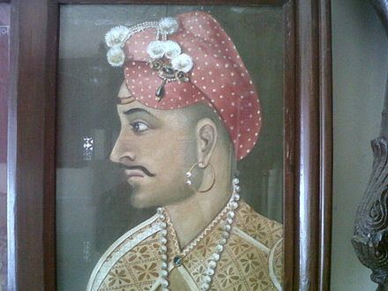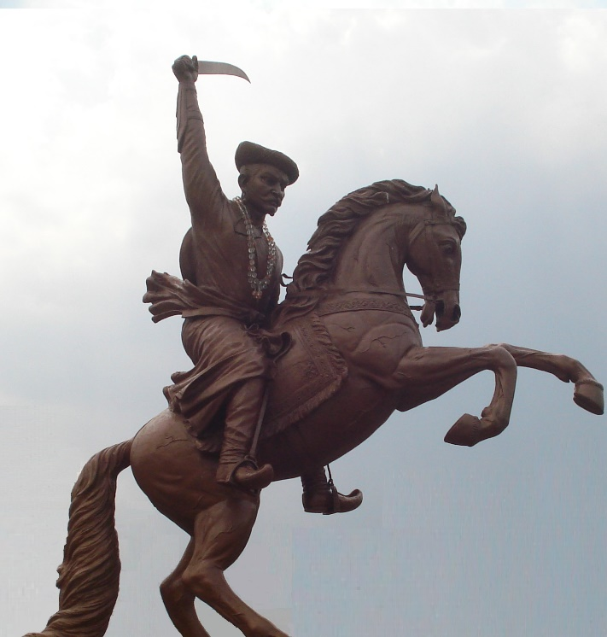

Moropant later surrounded and attacked the 25,000 strong Mughal infantries at Salher with his 20,000 infantries. Prominent Maratha sardar and Maharaja's childhood friend Suryaji Kakde was killed by a Zamburak cannon in the battle.

The battle lasted for an entire day and it is estimated that around 10,000 men were killed on both the sides. The Mughal military machines (consisting of cavalry, infantry, and artillery) were outmatched by the light cavalry of the Marathas. The imperial Mughal armies were completely routed and the Marathas gave them a crushing defeat. 6,000 horses, an equal number of camels, 125 elephants, and an entire Mughal train were captured by the victorious Maratha Army. Other than this, a large amount of goods, treasures, gold, jewels, clothes, and carpets were seized by the Marathas. Also The money acquired after raiding Surat was brought to this fort first on its way to the Maratha capital forts.

The Sabhasad Bakhar describes the battle as follows "As the fighting began, such a (cloud of) dust arose that for a space of a three-kilometre square, friend and foe could not be distinguished. Elephants were killed. Ten thousand men on the two sides became corpses. The horses, camels, elephants (killed) were beyond counting. A flood of blood streamed (in the battlefield). The blood formed a muddy pool and in it (people) began to sink, so (deep) was the mud."

The battle resulted in a decisive Maratha victory which resulted in the liberation of Salher. Further, the nearby fort of Mulher was also taken from the Mughals as a consequence of this battle. 22 wazirs of note were taken as prisoners and Ikhlas Khan and Bahlol Khan were captured. Among the Mughal soldiers who were prisoners around one or two thousand escaped. The notable Panchazari Sardar of the Maratha army Suryajirao Kakade was killed in this battle and was revered for his ferocity during the battle. Approximately a dozen Maratha sardars were gifted for their remarkable achievements in the battle and the two officers (Sardar Moropant Pingle and Sardar Prataprao Gujar) were specially rewarded.

In the 18th century, the Peshwas occupied this fort and later by the British.

**What to see on fort:**

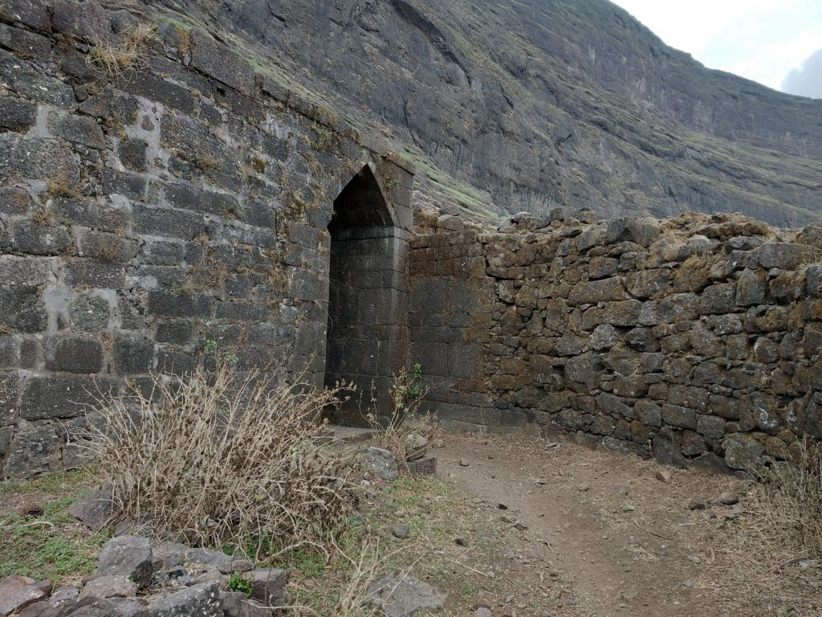

There is a Lord Parshuram’s temple present on the fort, also there are various caves where campaigning can be done, The doors or Mahadarwaja is still intact, also there is a rock cut water tanks present on the fort, and from the top of the fort, one can see the Baglan region along with the adjacent Salota fort and also panoramic view of the Sahyadris.

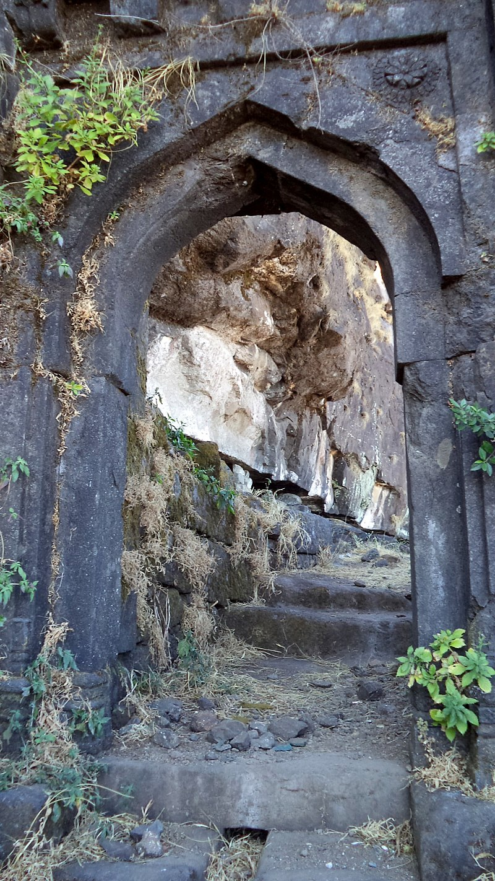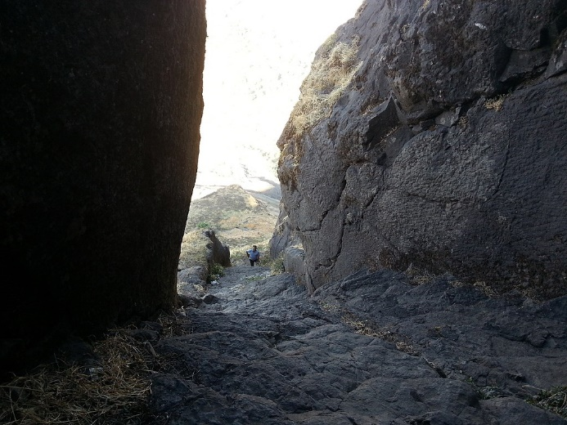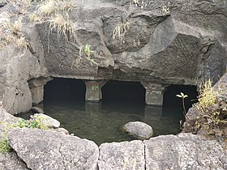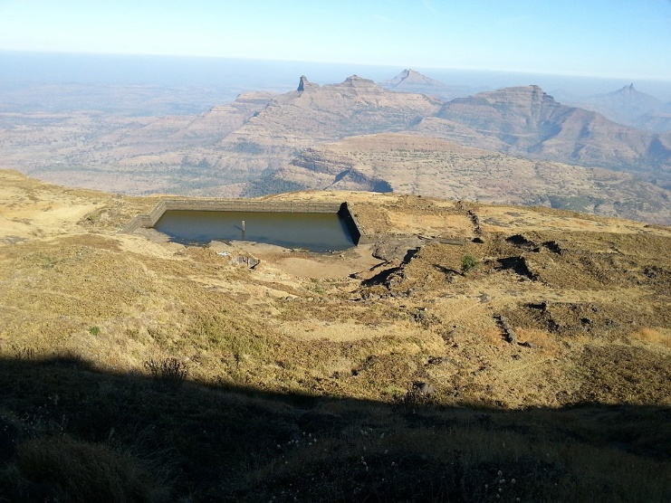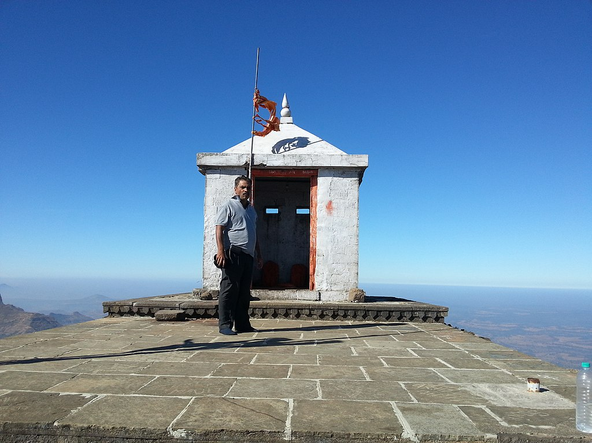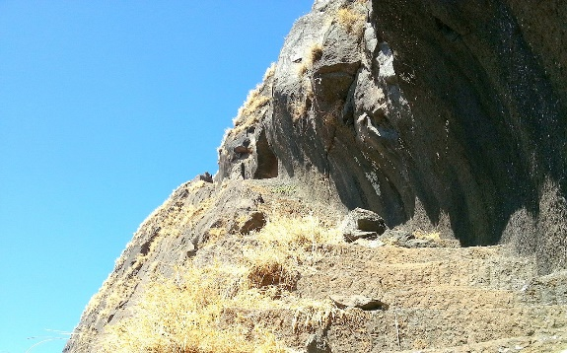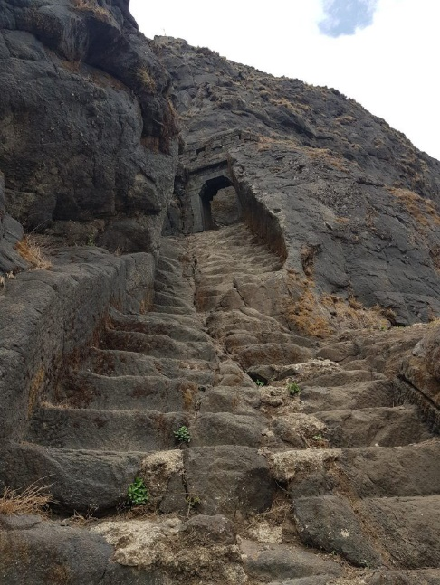

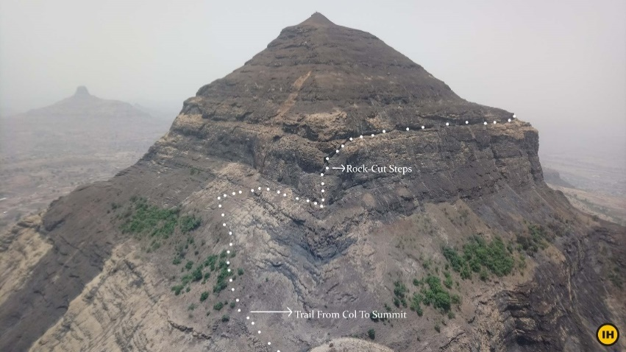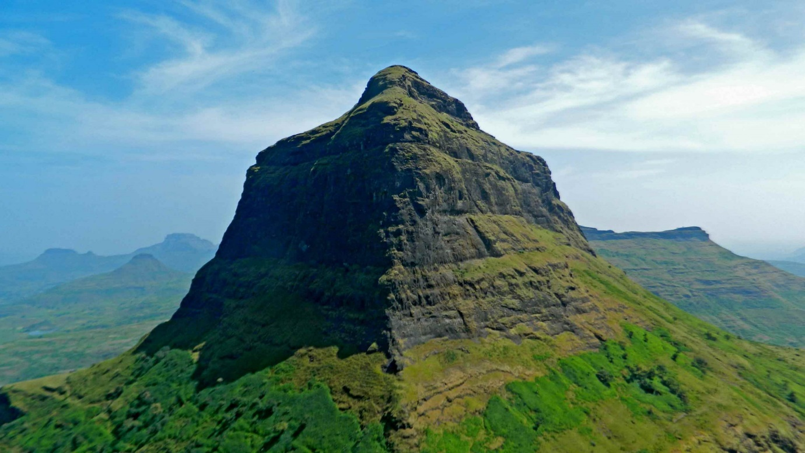

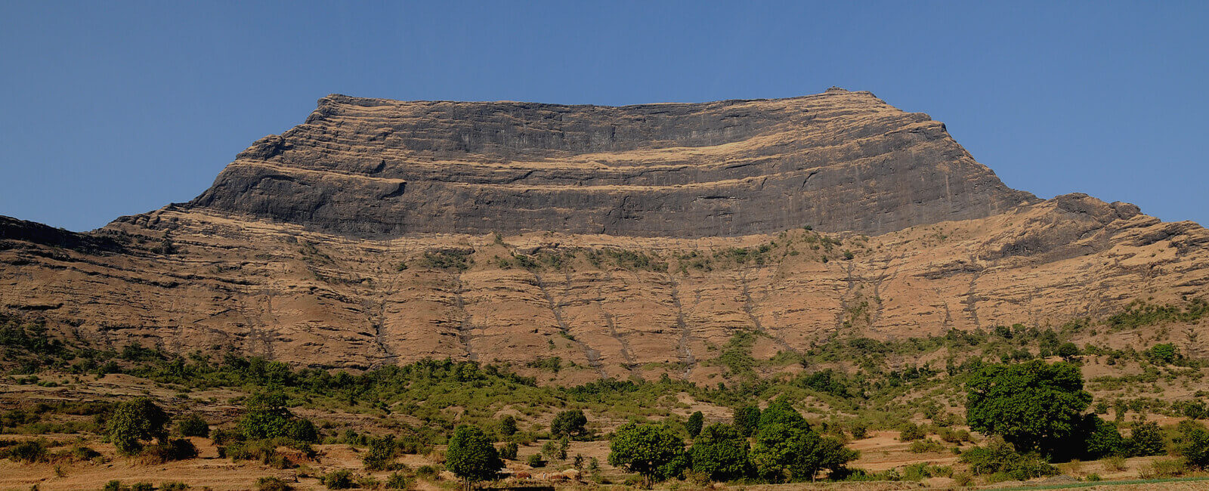

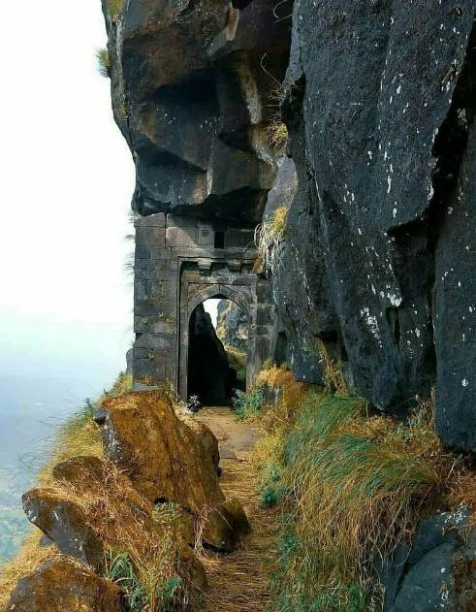

**How to Reach:**

**By car:**

The nearest town is Taharabad, it is 112 km away from Nashik via Satana. The climbing to Salher fort can be started from village-Waghambe, Salher or Maldar. It requires equal time( 2 hrs.) and effort to climb from either of the three villages. However, from Waghambe, it is a regular path that reaches in the saddle between Salota and Salher forts.

**By Train:**

By train you can reach Nasik Road railway stations And then you can take local bus or cars to reach Salher.

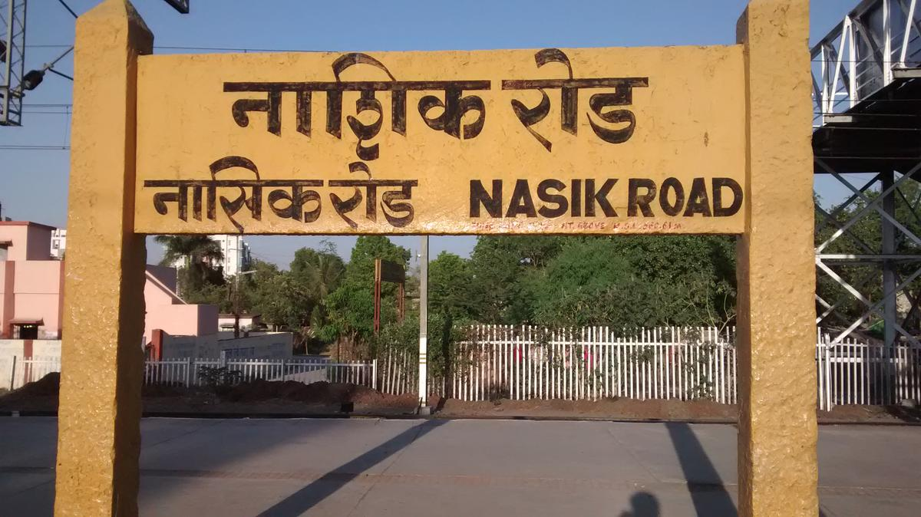

**By Air:**

The nearest airport to Nasik is Mumbai's Chhatrapati Shivaji International Airport, about 180 kilometers away. The distance between Nasik and Mumbai can be covered in about 3.5 – 4 hours by road and rail.

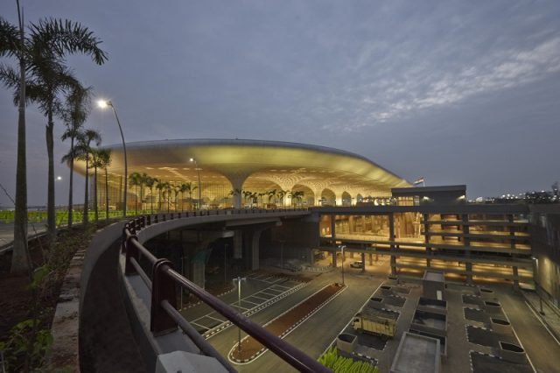

**Accommodation:**

Night camping can be done either at the top of Salher fort or in Forest Camping rest house at village Salher. There are no good hotels or shops in either of the three villages. The only option is to stay in Nashik City

**Nearby tourist attractions:**

* 1. **Salota fort :**

Salota fort is a hill fort in Maharashtra, India. It is located in the Baglan region of Nashik. It lies close to the Salher fort.

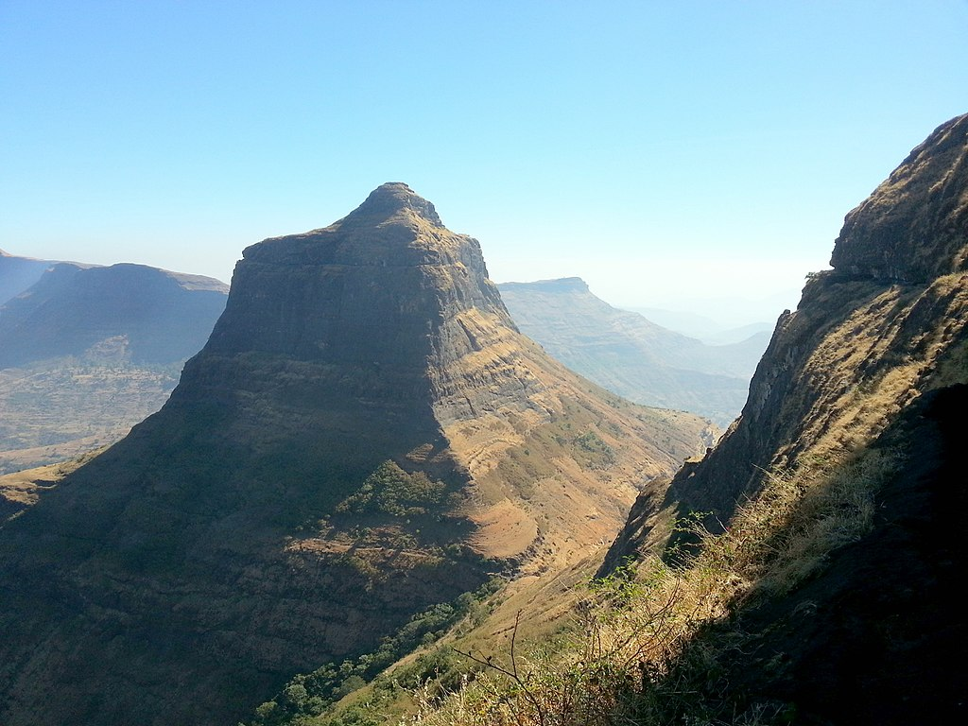

* 1. **Mulher Fort**

The Rathore dynasty of Bagul ancestry reigned Baglan between 1310 and 1638. Mulher fort was their capital. The Mughals then gained control of Baglan. For the Surat ransack of January 1664 & October 1670, Shivaji Maharaj had followed the route passing through Baglan to reach Surat. On the first occasion, the entire region from Pune to Surat was under the command of the Mughals while on the second occasion, Baglan was mainly under their control. The Mughals chased Shivaji Raje on his return journey but they were defeated in the Kanchana Pass. Soon after this, Shivaji Maharaj began a campaign in this region. In January 1671 the first assault brought the Salher fort under the Maratha rule. They then attacked Mulher fort but the Mughal Killedar repulsed the attack. However, the Marathas captured the Chaulher fort. In October 1671, the Mughals laid siege to Salher fort. But Shivaji Maharaj despatched Moropant and Prataprao to break down the siege. They not only lifted the siege of Salher, but also attacked Mulher and captured it in February 1672. This feat resulted in the assimilation of the entire Baglan region into Swarajya.

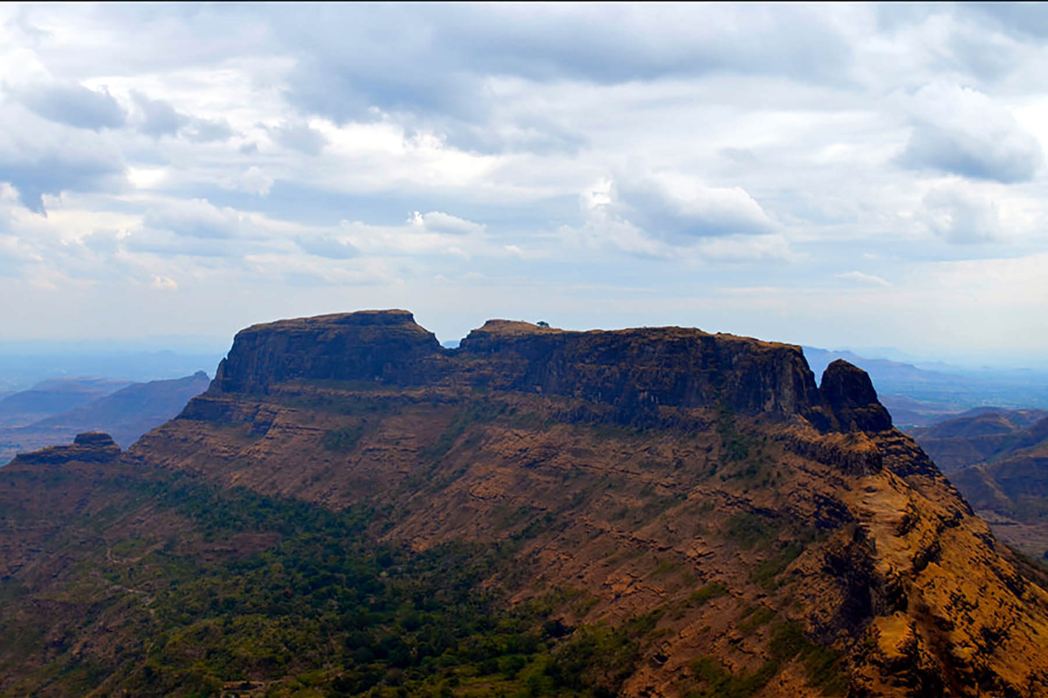

If you are staying in nashik there are many famous places some are

* 1. **Ramshej fort**

Ramsej or Ramshej Fort (Ramshej - Rama's bed)(Marathi: रामशेज किल्ला) is a small fort located 10 kilometres (6.2 mi) north-west of Nashik, in the Indian state of Maharashtra. There is a story that Lord Rama stayed for a while on this fort while going to Sri Lanka. This fort can be visited in a day from Nashik. This fort is located on the busy Nashik-Vapi Route.

The famous story revolves where under the reign of Chhatrapati Sambhaji Maharaj, Where Ramshej was defended by the Marathas against Mughals for more than Six and a Half years.

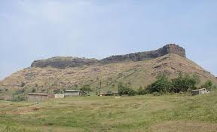

**2) Pandav Leni:**

The Nasik Caves, or sometimes Pandavleni Caves, are a group of 24 caves carved between the 1st century BCE and the 3rd century CE, though additional sculptures were added up to about the 6th century, reflecting changes in Buddhist devotional practices mainly.

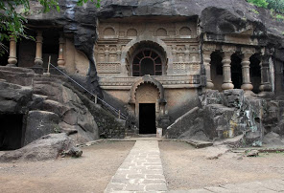

1. **Trimbakeshwar Shiva Temple**

Trimbakeshwar Shiva Temple is an ancient Hindu temple in the town of Trimbak, in the Trimbakeshwar tehsil in the Nashik District of Maharashtra, India, 28 km from the city of Nashik and 40 km from Nashik road. It is dedicated to the god Shiva and is one of the twelve Jyotirlingas, where the Hindu genealogy registers at Trimbakeshwar, Maharashtra are kept. The origin of the sacred Godavari river is near Trimbak. Kusavarta kunda (sacred pond) in the temple premises, built by Shrimant Sardar Raosaheb Parnerkar who was the Fadnavis of Indore State, is the source of the Godavari River, the longest river in peninsular India. A bust of Sardar Fadnavis and his wife can be seen on the edge of the kunda. The current temple was built by Peshwa Balaji Baji Rao (Nanasaheb).

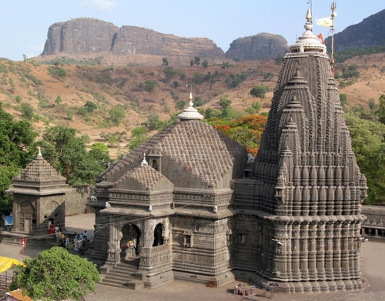

1. **Bhandardara :**

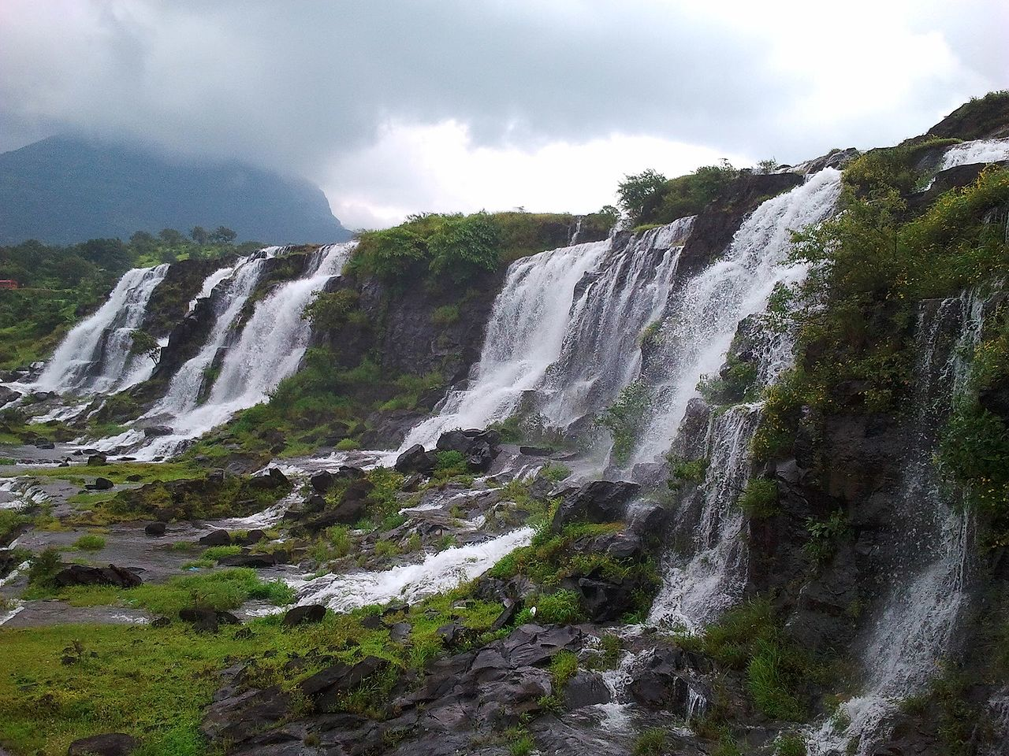

Bhandardara is a holiday resort village near Igatpuri, in the western ghats of India. The village is located in the Akole tehsil, Ahmednagar district of the state of Maharashtra, about 185 kilometers (115 mi) from Mumbai and 155 kilometers (96 mi) from Ahmednagar.

This region is home to Mount Kalsubai, the highest peak (5,400 ft or 1,600 m) in Maharashtra. Another tourist attraction is the Wilson Dam on the Pravara River, which was built in 1910. The Umbrella Falls also draw visitors, although it can be seen only during the monsoons between July and October. About 10 km away from Shendi Village is the Randhaa Waterfalls. The Ratangad fort is around 22 km from Shendi/ Bhandardara, and is connected by both roadway, and ferry across the Lake Arthur. On the Kalsubai side, at the far end of a 22 km roadway across forests and tribal villages, is Konkankada from where there are views of the plains.[citation needed] Harishchandragad is another nearby mountain hiking spot with ancient temples on top.

1. **Shirdi:**

**also known as Sainagar is a city in the Indian state of Maharashtra. It is located in the Rahata taluka of Ahmednagar District. It is accessible via the Ahmednagar–Malegaon State Highway No.10, approximately 83 km from Ahmednagar and 15 km from Kopargaon. It is located 185 km east of the Western Seashore line (the Ahmednagar–Manmad road), a very busy route.**

**Shirdi is famously known as the home of the late 19th century saint Shri Sai Baba. The Shri Saibaba Sansthan Trust located in Shirdi is one of the richest temple organisations.**

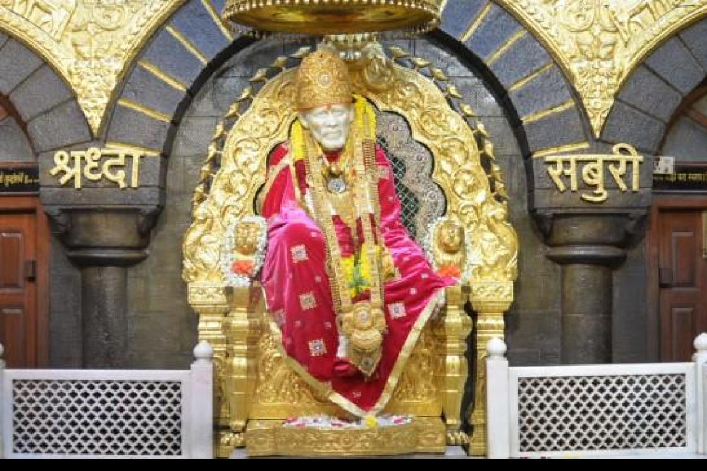

**What to eat and buy:**

* 1. The Wine Capital of India, Nashik is famous for **grapes**. Nashik is biggest supplier of **grapes** in India and also home to many vineyards and orchards.

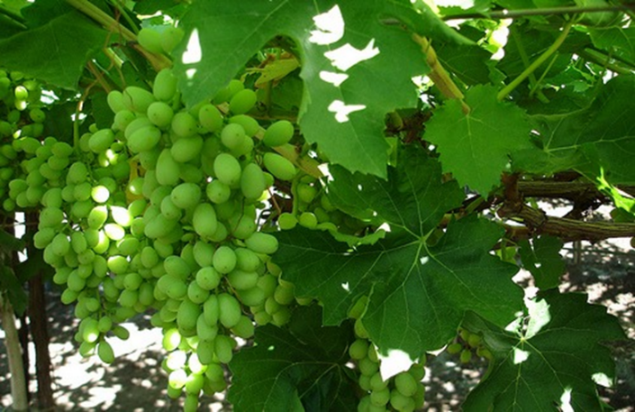

1. **Misal**

Misal is a must have when you are in Nashik. The famous destinations in trend these days for having Misal are *Sadhana Chulivarchi Misal, Tushar’s*.

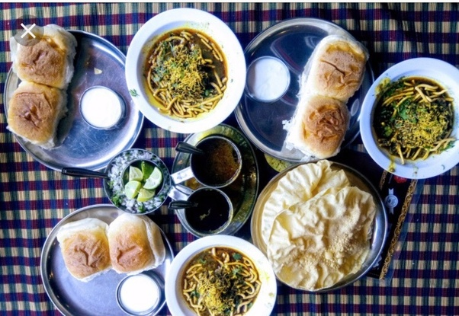

2. **Chaat**

chaat from *Bhagawati Chaat Bhandar*in Nashik. *Dahi puri*from *Nandan Sweet Shop*at College Road.



**Best Shopping Places in Nashik: Bazaars**

**1. Saraf Bazaar**

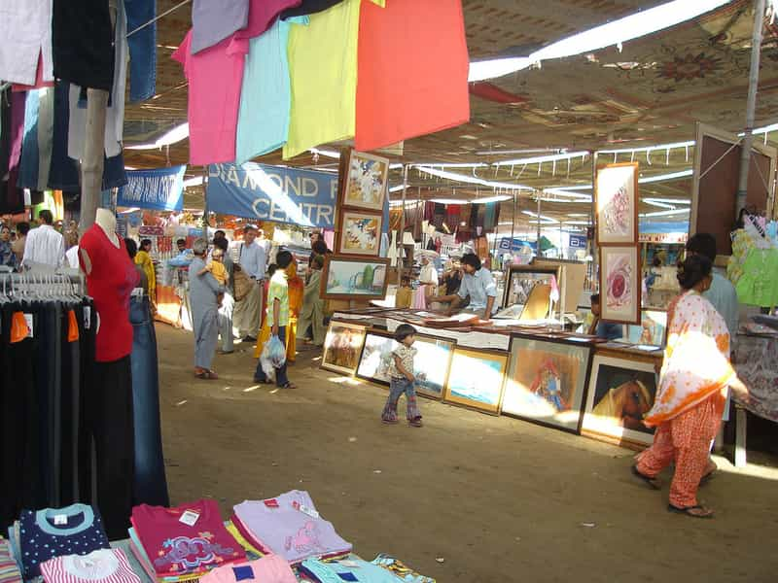

Saraf Bazaar

One of the busiest places in the entire city, Nashik’s Saraf Bazaar gleams and glistens with all sorts of jewellery and bijouterie, with necklaces and earrings, rings and bracelets – Saraf Bazaar is teeming with people buying all sorts of small treasures. The market offers you a variety of gifts and souvenirs, which make sentimental, pretty presents.

**2. Tibetan Bazaar**

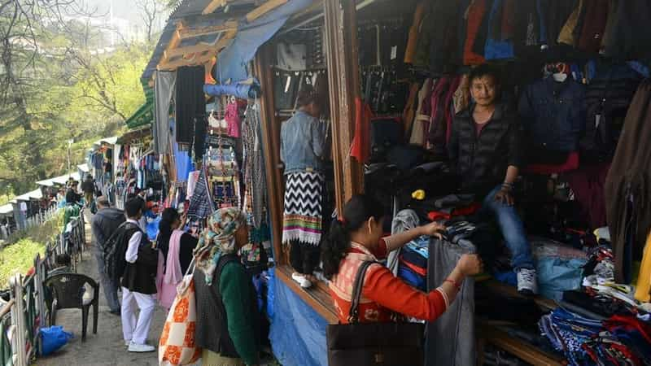

A Tibetan Bazaar in Nashik

If preparing for a cold winter, head to the Tibetan Bazaar in Nashik to buy all sorts of woollens from tiny stalls and shops. This list includes socks and gloves, scarves and mufflers, sweaters and jackets at reasonable prices. The bazaar is a perfect place to satiate hunger, with Maharashtrian delicacies lined up in rows at the food stalls. The marketplace offers chaat, vegetarian and non-vegetarian cuisine. Everything is economical, too.

**3. Deolali Camp**

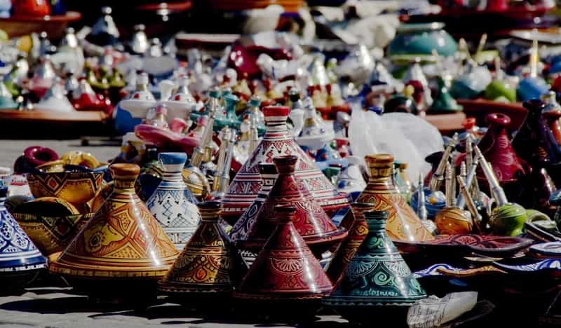

Handicrafts at Deolali Camp

Nashik’s Deolali Camp is a tourist attraction for the military base and temples found there. However, Deolali Camp contains shops and markets, and is perfect for picking up a variety of souvenirs, presents and artifacts.

* + 1. **Korigad**

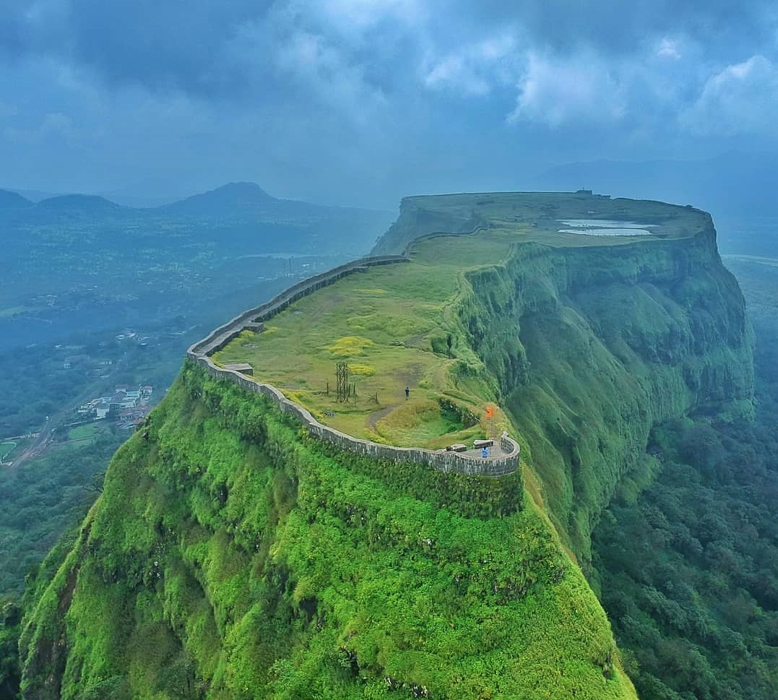

**Introduction:**

**Korigad** (also called Koraigad, Koarigad or Kumwarigad) is a hill fort located about 20 km (12 mi) south of [Lonavla](https://en.wikipedia.org/wiki/Lonavla) in [Pune district](https://en.wikipedia.org/wiki/Pune_district), [Maharashtra](https://en.wikipedia.org/wiki/Maharashtra), India. Its date of construction is not known but likely predates 1500. It is about 923 m above sea level. The planned township of [Aamby Valley](https://en.wikipedia.org/wiki/Aamby_Valley_City) is built over the fort's southern and eastern foothills.

The closest village is Peth Shahpur, about 1 km (0.62 mi) north of the fort.

The fort is located about 923 m (3,028 ft) above sea level, rising over 200 m (660 ft) higher than the neighboring valleys. To the east, there lie two artificial lakes part of the Aamby Valley project which later drain into the [Mulshi reservoir](https://en.wikipedia.org/wiki/Mulshi_Dam). There are two lakes on the top of the fort

Not much information is known about Korigad. But Chhatrapati Shivaji Maharaj incorporated this fort in Swarajya along with Lohgad, Visapur, Tung and Tikona in 1657.

On March 11, 1818, Col. Prother invaded this fort but could not succeed even after prolonged fighting. Finally, he succeeded on 14th March, by dropping a cannon ball where the ammunition was stored. Along with this fort the English also conquered Ghangad.

**What to see on Fort**

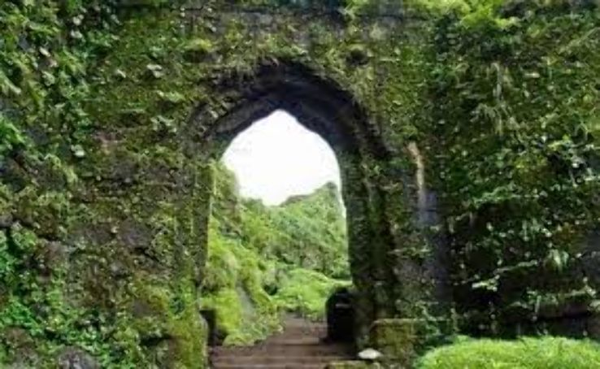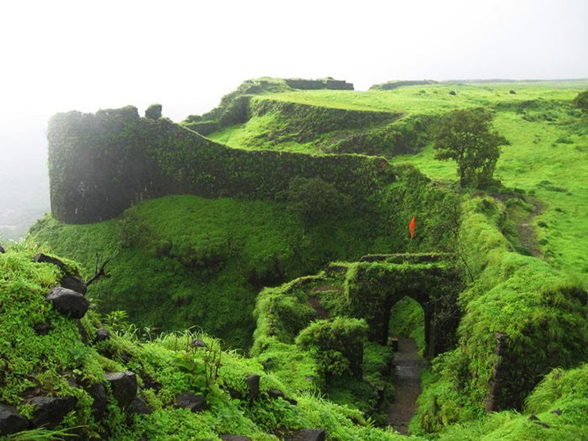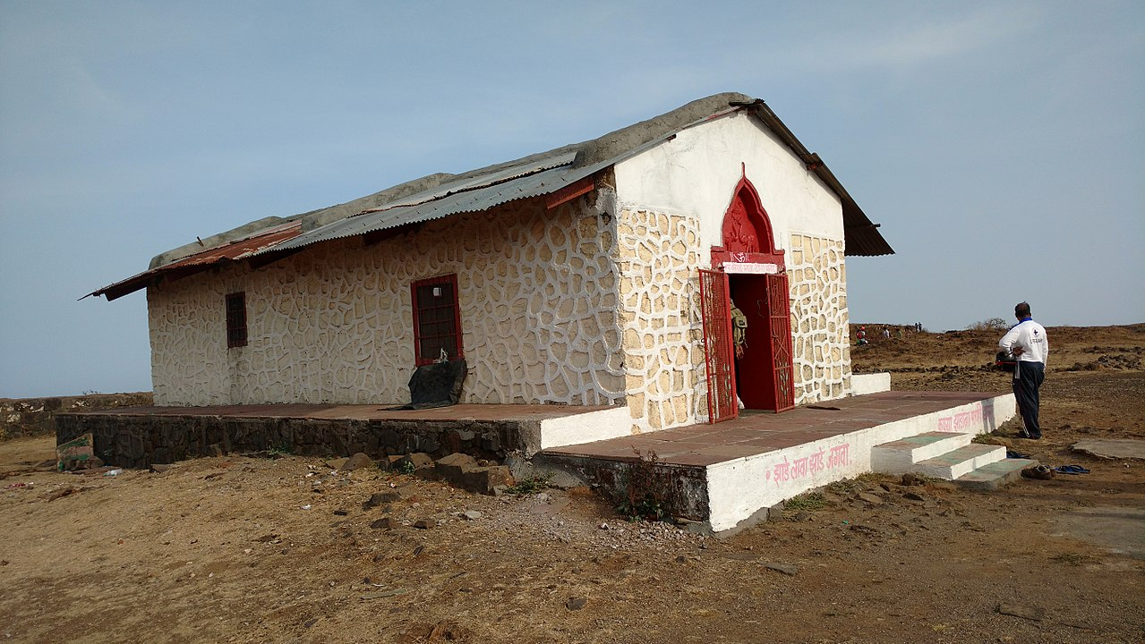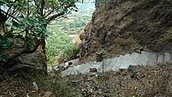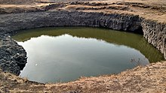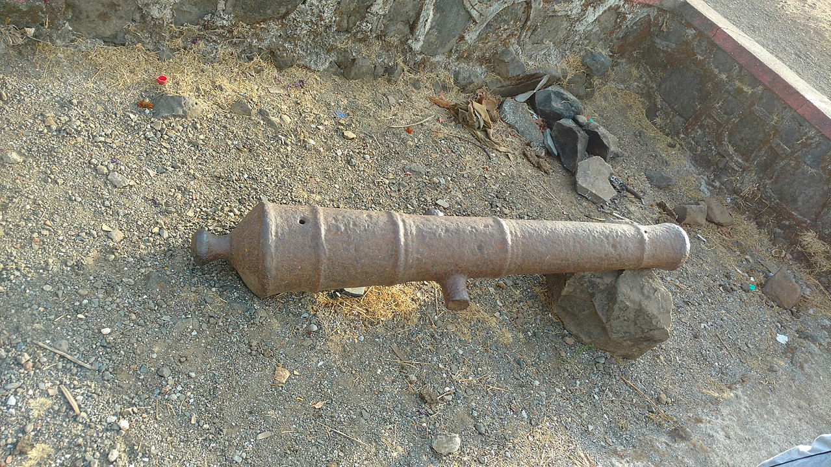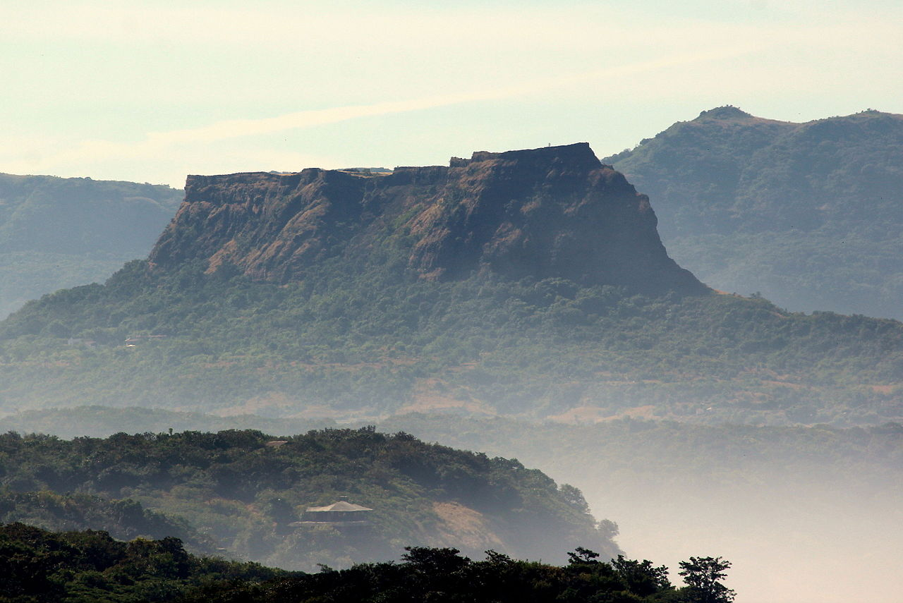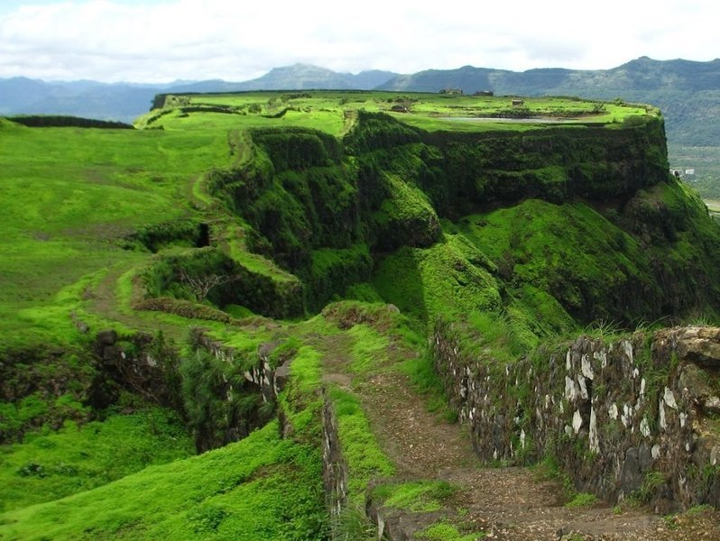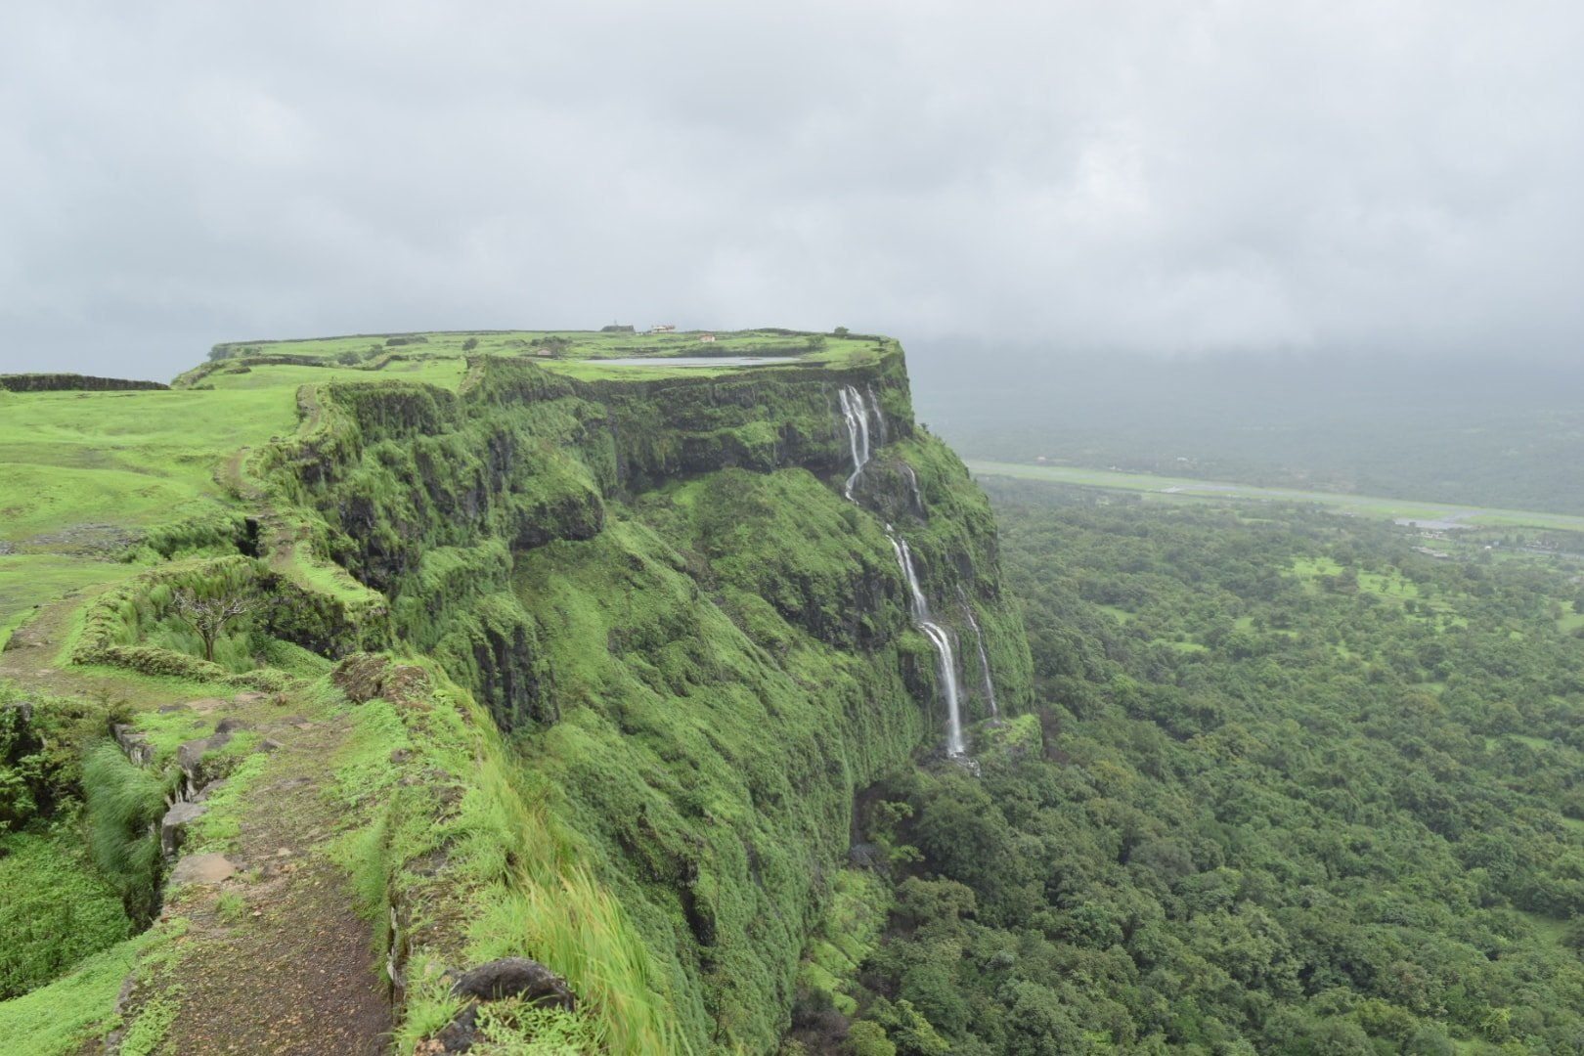

A temple to its patron goddess Koraidevi also exists along with several smaller temples to dedicated to Vishnu and Shiva. The former has been recently renovated and has a 3-foot-high Deepmala (tower of lamps). The interesting part of the fort is that its wall is completely intact and one can walk along its entire perimeter (about 2 km). Its massive gate is also intact. Several ruins of older structures within the fort still exist. It has six cannons - the largest of which called the Laxmi Toph is located near the Korai Devi temple.

**How to reach:**

**By road**

Lonavala is on the Mumbai-Pune Expressway and is well-connected to several towns of Khopoli, Karjat, Talegaon Dabhade, etc.

**By train**

Further information: Lonavla railway station

Lonavala is well-connected by train. Local trains run from Pune at 2-hour intervals. Those originating from Mumbai along the central line have Khopoli as their last station. Buses are available at regular intervals to complete the remaining 15 km of the journey to Lonavla from Khopoli bus station. It takes 2.5 hours by train from Mumbai and 1 to 1.5 hour from Pune. All trains, travelling between Mumbai and Pune, halt at Lonavala. Before the push-pull technology, trains from Mumbai used to halt at Karjat in Raigad District to attach banker locomotives before the train started the journey up the western ghats to reach Lonavala.

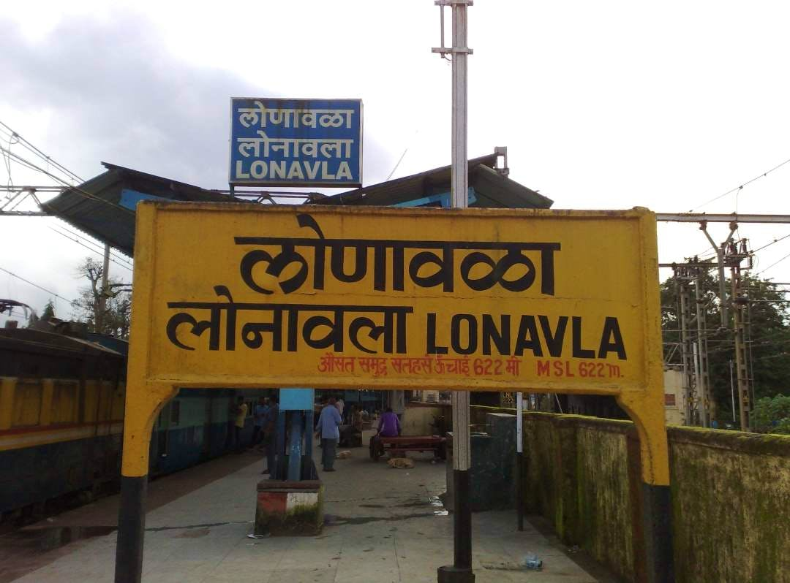

**By air**

Lonavla does not have an airport, though the Indian Air Force station is situated on the way to Aamby Valley City. The city of Aamby Valley has its own private airport. The nearest commercial airports are Pune International Airport at 64 km and Chhatrapati Shivaji International Airport at 104 km. A seaplane service is also available between Juhu and Pawana Dam, which is 14 km away from Lonavala.

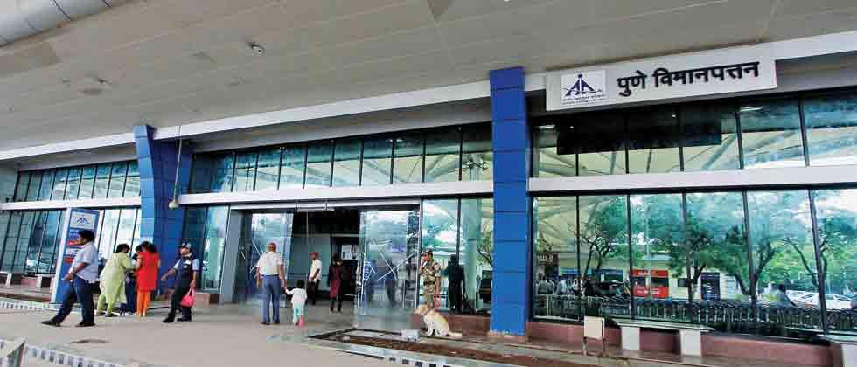

**Tourist attractions:**

**Rajmachi Point**

Rajmachi Point is located about 6.5 km from Lonavala. This point commands a view of Chhatrapati Shivaji maharaj's fort, Rajmachi (Royal terrakouioce) and the surrounding valley. Regular State Transport buses ply between Rajmachi Point and Lonavala from the State Transport Bus Stand. The Vaghjai Dari is also located here.

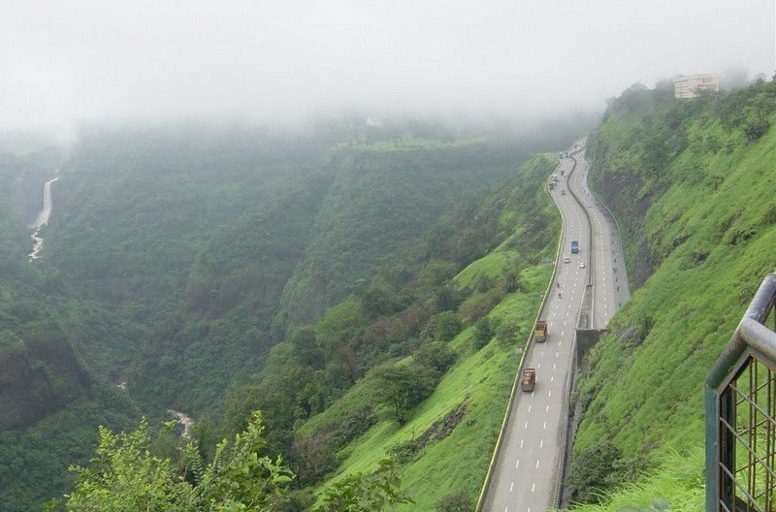

**Sunil wax museum**

Sunil wax museum Sunil wax museum is wax statue museum. which contains a statues of celebrities and politicians. this museum is 600 meters from lonavala railway station. the time of the museum is from 9am to 9:30pm and the entry fee is 200 for adults and fro children'sits free. and for the children's they created gaming zone which have 100 RS fee for 30 mins.

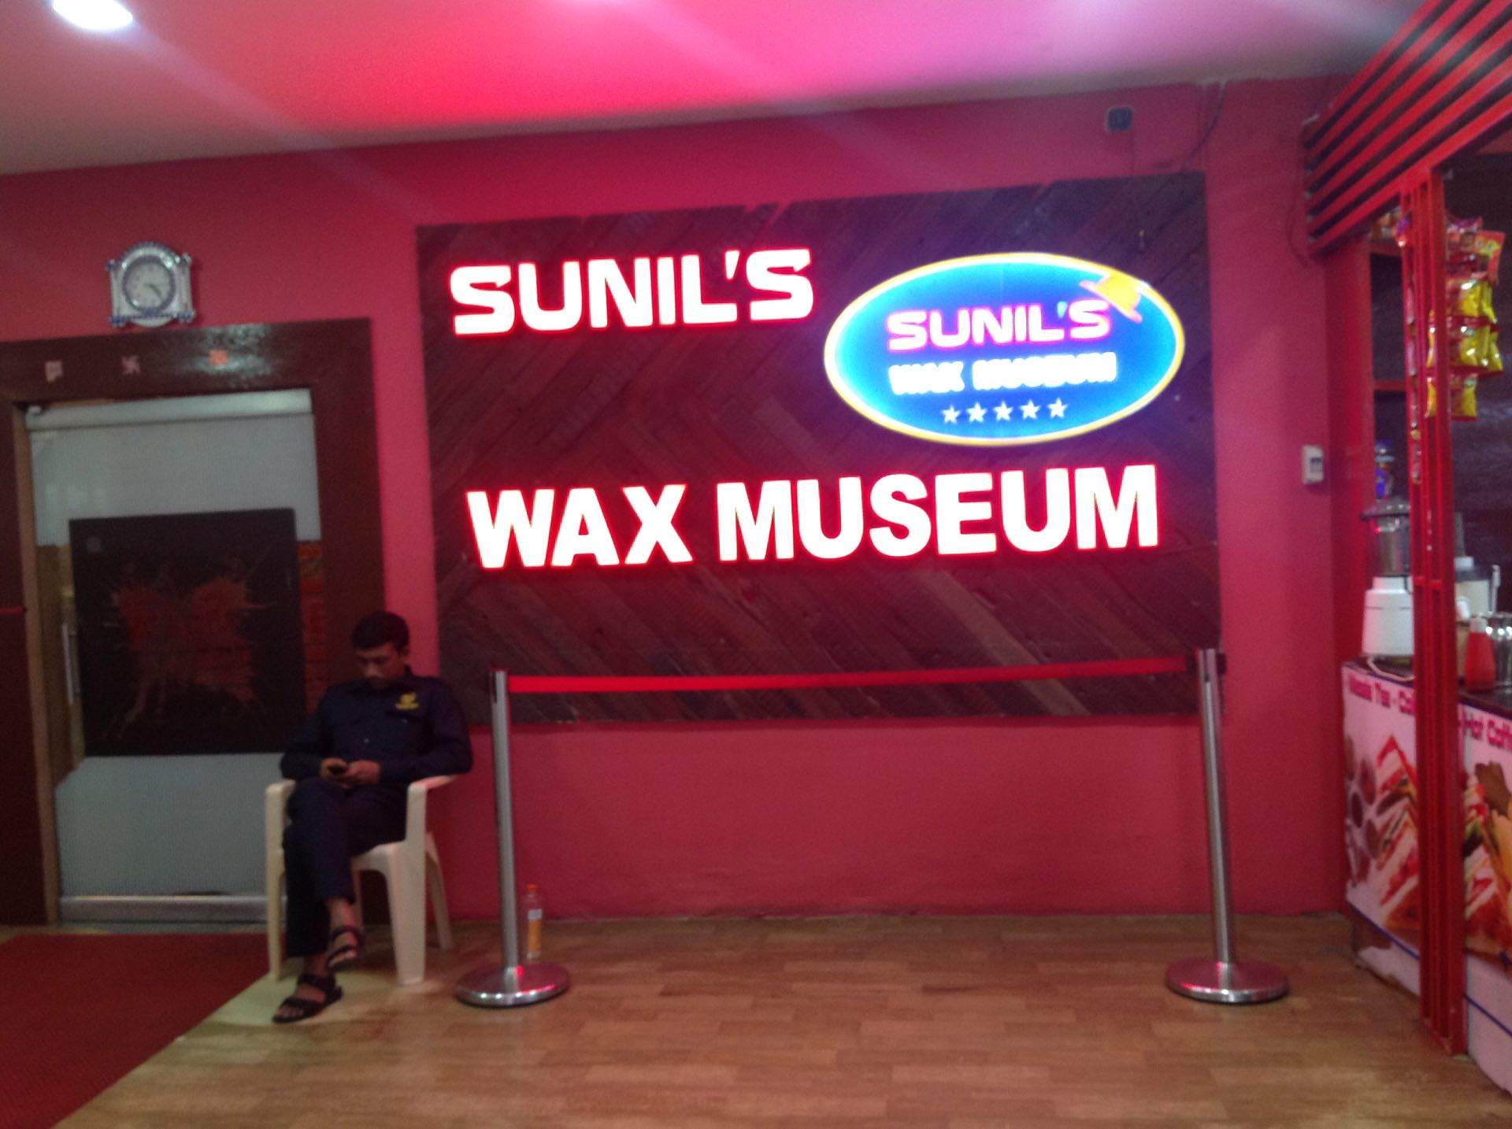

**Rajmachi Fort**

Rajmachi Fort is a historic fort close to Lonavala and attracts a lot of trekkers during the monsoon season. The fort also comprises two other forts - Shrivardhan Fort and Manaranjan Fort. Besides, the fort is known for the fireflies that lit up the surroundings in night

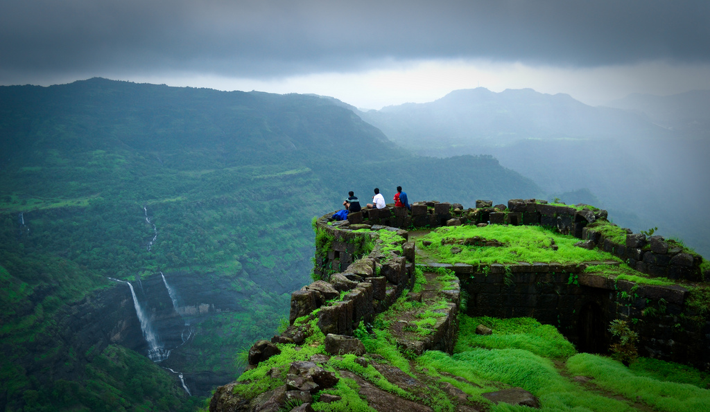

**Ryewood Park & Shivaji Udyan**

This is an extensive garden situated in Lonavla. The garden has a number of tall trees - some of which are very old. There is an old Shiva temple in the park.

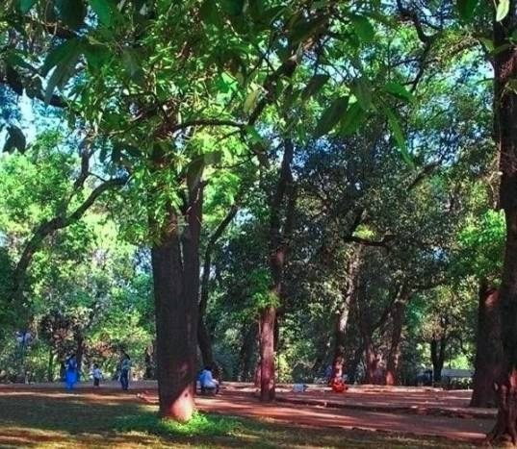

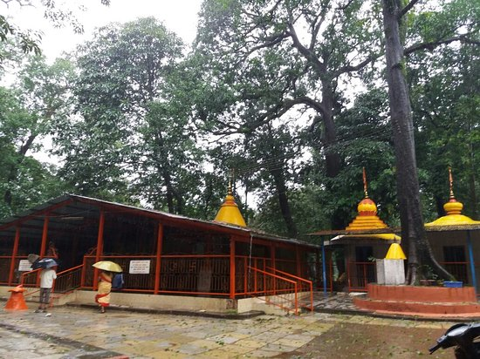

**Valvan Dam**

Valvan Dam is a Britisher built garden and is more than a century old. This dam has a garden at the foot of its wall, and is 2 km from the town. The dam supplies water to the Khopoli power station at the foothills of the Sahyadris for generating electricity. The Kundali River feeds into the dam's reservoir.

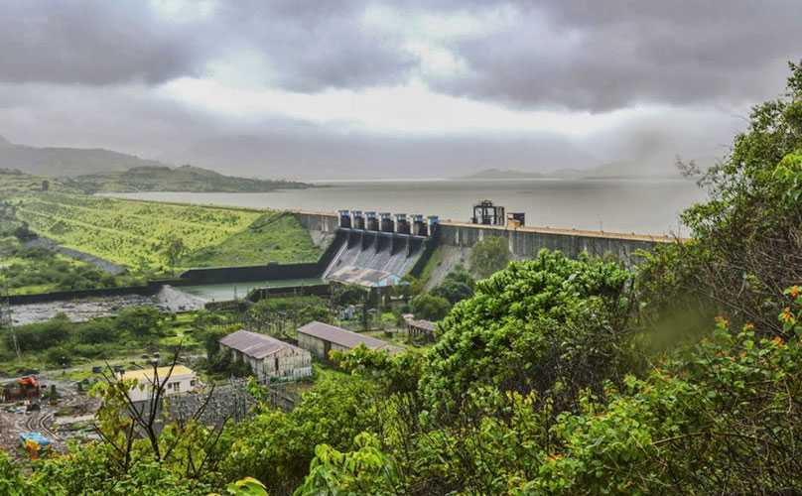

**Della Adventure Park**

Della Adventure Park is India's largest adventure park situated in Lonavala hill station. It is a big theme park/resort. It also serves as a corporate training destination for companies in Mumbai & Pune. The park has spread over an area of 36 acres. It is located at about 3000 feet height above MSL (mean sea level). Della Adventure Park offers close to 52 adventure activities.

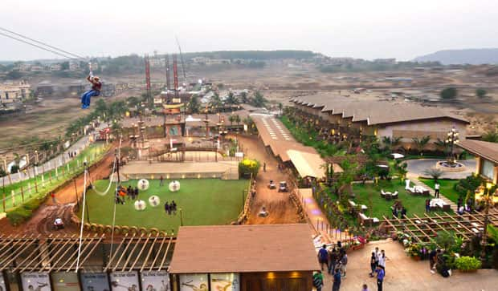

**Lonavala Lake**

Lonavala Lake is surrounded by natural scenery, about 1.6 km from the town. The lake dries up during the winter and summer months offering an expanse of green grass which is used by walkers and joggers. This place attracts tourists for its street food, including convenience food items like smoked corn on the cob, shaved ice (gola), vada pav, chaat, and hot ginger tea.

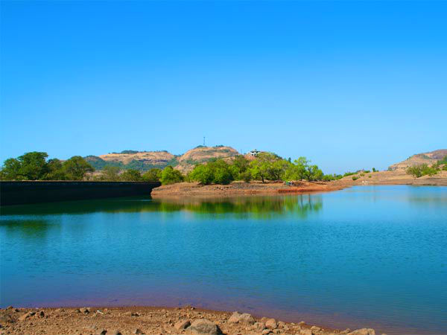

**Duke's Nose**

Duke's Nose stands 12 km from Lonavla, clearly visible from the highway while driving towards Mumbai. This landmark in Khandala is visited by hikers. Also known locally as Naagphani (Cobra's Hood), the cliff owes its name to the Duke of Wellington, whose ample nose it resembles.

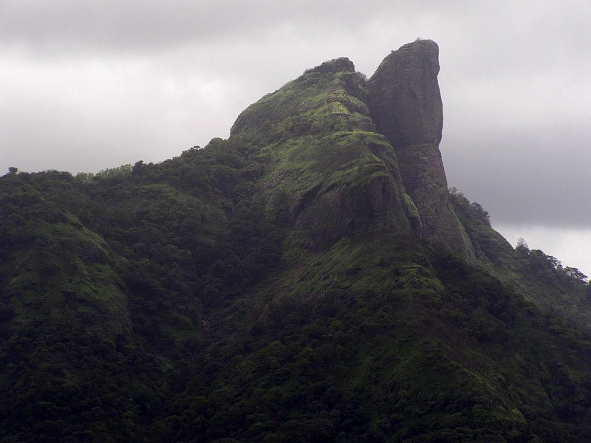

**Tiger's Leap**

Tiger's Leap also known as Tiger's Point is a cliff-top with a sheer drop of over 650 m, giving an extensive view. Buses are available up to INS Shivaji and the remaining distance of about 1.6 km has to be covered on foot. Legend has it that while being chased by a tiger once, the Maratha Empire king Chhatrapati Shivaji Maharaj jumped into a ditch on the hill and the tiger leaped off it into the valley giving it the name of tiger's leap.

Just around tiger's leap, there is a small waterfall active only during the monsoon. It serves the purpose of relaxing in the water better than Bushi dam, as the force of the fall is higher. Also, after the brief steep descent, the fall becomes a stream with a fair amount of force to go all the way down to the base of the Tiger's Leap. Adventurers can trek down the stream whilst intermittently stepping back on land where the water current is too strong and the fall is steep.

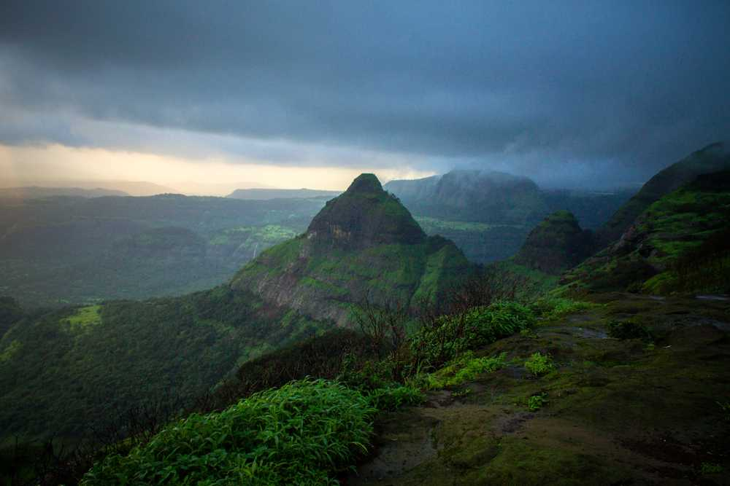

**Karla Caves**

Karla Caves, located near Lonavala, is a complex of cave shrines built by Buddhist monks around 3rd to 2nd century B.C. A temple of Goddess Ekvira Devi is also present here.

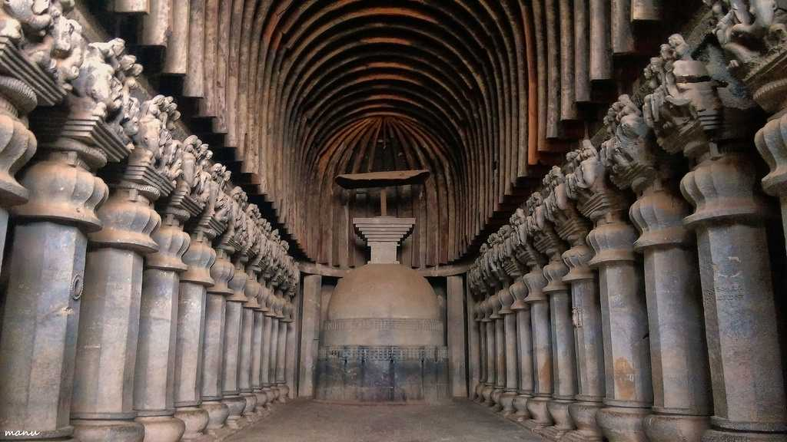

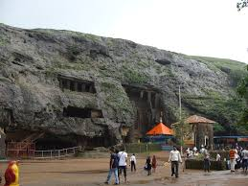

**Lohagad Fort**

A robust climb of about 11.2 km from Malavali railway station takes you to the 'Iron Fort', once a formidable battle-station of Chhatrapati Shivaji Maharaj. The fort commands a view of the surrounding hills and hamlets.

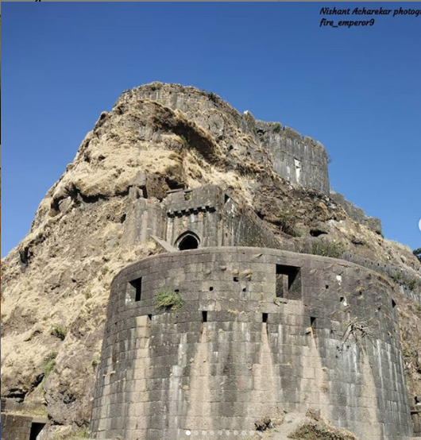

**Visapur Fort**

Adjacent to the Lohagad fort lies the visapur fort which is part of the Lohagad-Visapur fortification. Visapur Fort is larger and at a higher elevation than its twin- Lohagad. It was built during 1713-1720 CE by Balaji Vishwanath.

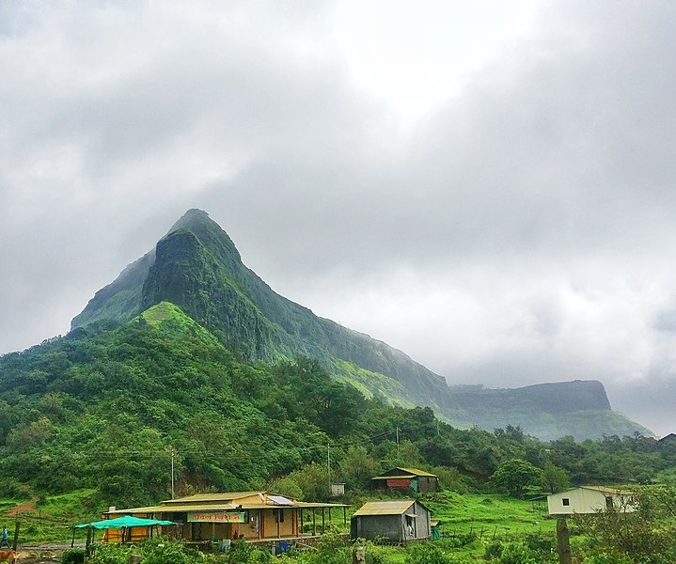

**Bhushi Dam**

A waterfall near the dam is located between Lonavala and I.N.S. Shivaji. Buses running on the I.N.S. Shivaji Road stop here.

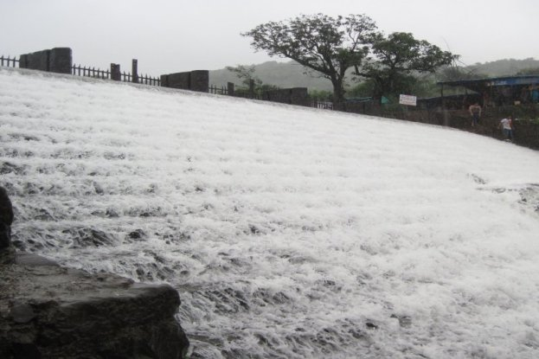

**Lion Point**

This is a viewpoint midway between Bhushi Dam and Aamby Valley which overlooks a deep valley and mountains known for its roasted corn and onion fritters. This point does not have any lions but is named so because it is associated with the Lions Club of Lonavala.

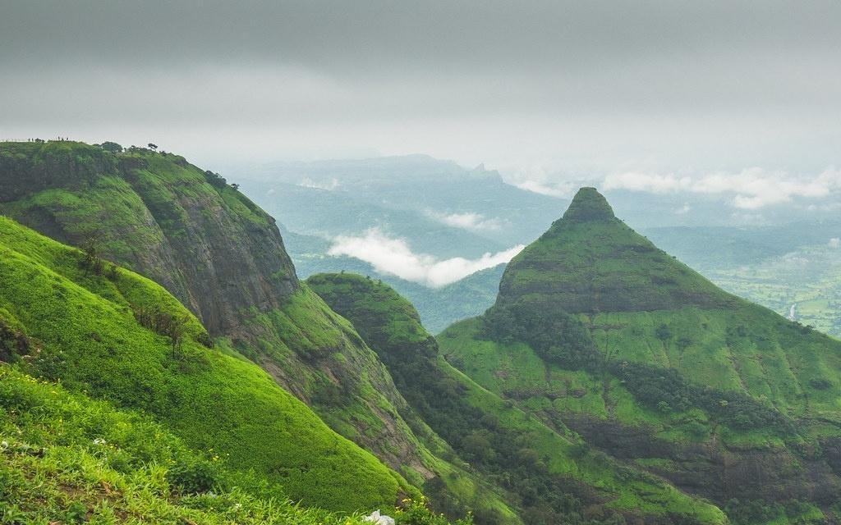

**Narayani Dham**

Narayani Dham is a temple constructed in 2002 in honor of the Hindu Goddess Narayani. It is at a distance of 2 km from the Lonavla railway station. The temple has idols of Durga Mata, Salasar Balaji (Hanuman) and Ganapati housed in a marble structure.

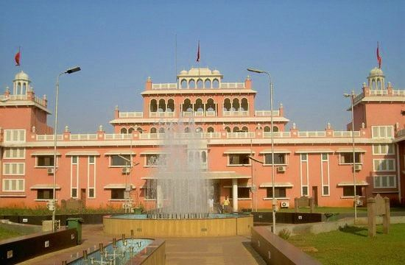

**Tungarli Dam**

This lake and Dam comes to life during the Monsoon season, where some people climb the mountain top to the Dam. This dam was built during the British era and features a serene surrounding of trees and hillocks.

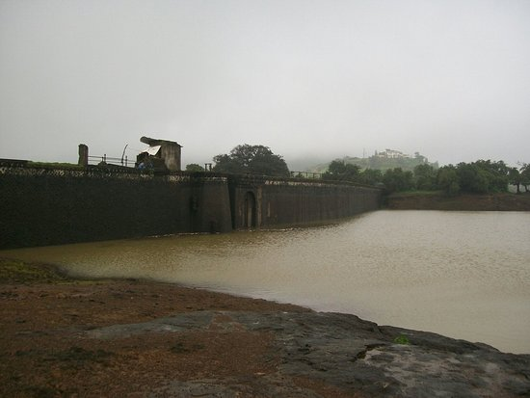

**Shooting Point**

Another viewpoint in the town of Khandala (Bazaar peth), provides views of the Rajmachi Fort and the valley. Also the home for the St. Mary's villa.

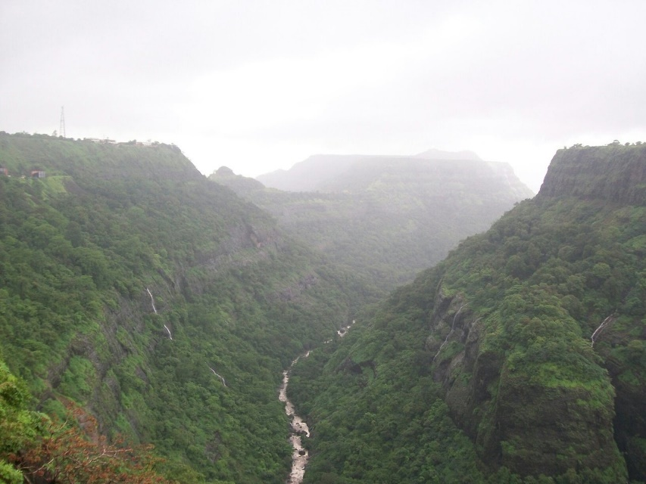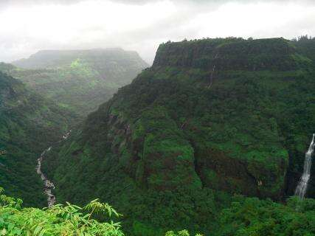

**Seven villas**

One of the most iconic plots in Lonavala, seven Villas is an iconic landmark of the new developing Lonavala.

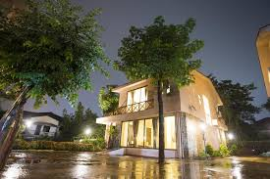

**What to Buy and Eat:**

**Lonavala Bazaar**

Lonavala Bazaar is undoubtedly one of the most sought-after places in the hill station for its unique offerings and matchless energy. You will always find the market to be full of people shopping, talking or just adoring the color and vibrancy of this place. The market is full of tiny shops selling attractive, colourful trinkets, gorgeously-made wooden figurines and various products made of cane. It is a great place to buy some souvenirs for your dear ones, or just take back some of the decorative stuff for your home. The market is also lined with several shops that sell various types of snacks. You can spend some time at these shops to please your stomach in between the shopping spree.

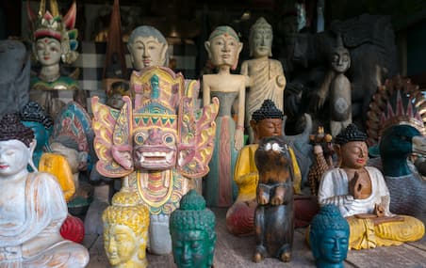

**About National Chikki**

If you have visited Lonavala or heard about this hill station enough, you will know how people fall in love with its chikkis. And one of the biggest reasons for this love is the National Chikki Shop. Located in the main bazaar of the city, this shop has come a long way and established itself as one of the best. It is known for the wide variety of chikki you get here. Not only chikki, but National Chikki Shop is also famous for its other snacks including the delicious fudge, namkeens, chocolates, jellies, and syrups. There is top-notch quality maintained in the preparation of all the snacks offered, with the purest of sugar and ghee used. The shop, today, has a loyal customer base which vouches for its services and offerings.

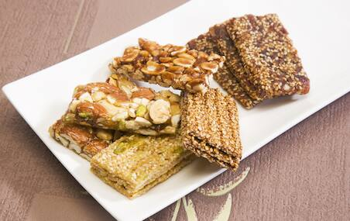

**About Maganlal Chikki Center**

If we are asked to name one place in Lonavala that is as famous as the hill station itself, if not more, we wouldn’t have to think twice before bestowing the title to Maganlal Chikki Center. This place has almost become synonymous with the existence of Lonavala. Whenever one thinks of visiting this spectacular city or has someone visiting it, it would be taken for granted that chikkis are going to be just around the corner. The shop is always swarmed by tourists and locals alike who come here to taste the divine chikkis offered here. There is a huge variety of ingredients these chikkis are available in, including dry fruits, coconut, cashew crush, etc. So, choose your own taste, and don’t forget to get some packed for your home.

Pro Tip: The famous Maganlal Chikki Center has its roots back in the year 1888 when Shri Bhewrajji Agarwal set up this shop in the name of his son. Shri Maganlal. Shri Maganlal. Then. Started selling gud-dani in this shop with his two sons. He died a few years later. But his legacy is being continued by the two sons.

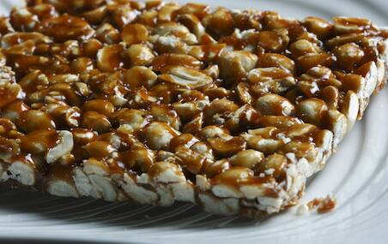

**About Shoe Centre**

Lonavala has something to offer to everyone, whether you are a foodie, a nature-lover, or someone interested in fashion. One of the most famous offerings of this hill station is the Kolhapuri slippers. You just cannot return from Lonavala without buying at least one pair of these. The Shoe Centre, located in the main bazaar of Lonavala, is widely famous for these slippers. There are several wonderful designs and colors available in the Kolhapuri slippers offered at this shop. Almost all the colors you can think of when you think of wearing these slippers on your favorite traditional outfit are available here. Apart from these, there are branded shoes as well as various types of footwear including sandals, sneakers, running shoes, and so much more available at the Shoe Centre.

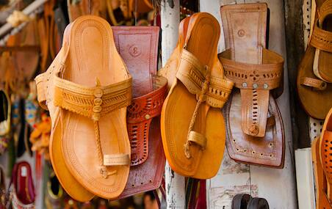

**Eat:**

**Rama Krishna**  
If there ever was a better, breaking fast and meeting point than this landmark 26-year-old, highway-touch Udipi eatery, we can’t say. But as of 2016, just about anyone visiting Lonavala or driving through on the old Mumbai-Pune highway, ends up stretching and eating at least one piping hot portion of RK’s idli sambar. On weekends, come rain or shine, the Shetty-run establishment plates up a staggering 500 steaming rice roundels drowned in spicy-hot sambar served with freshly grated, green coconut chutney (Rs 55), says manager Somnath Shetty. Finally, contrary to popular belief, RK serves meat and in fact, makes a mean butter chicken besides for housing a well-stocked domestic bar.

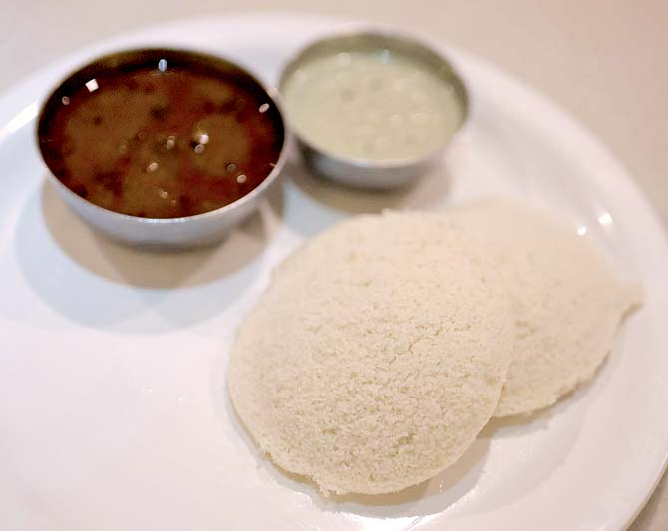  
***Idli***

**From:**7 am to 11 pm  
**Call:** +91 2114 273600  
**Address:** Golwada, Mumbai-Pune Road

**Rudra**  
If you’re having difficulty getting your friends and family out of the house, we suggest you lean over and whisper: Kailash Parbat and chole bhature, in no particular order. Thirty minutes later, you may find yourself seated in front of two greasy, globe-size bhaturas accompanied by a big bowl of spicy curried chickpeas. This somewhat unofficial dish of New Delhi finds countless takers in plateau country simply because KP ensures that their bread is delicious on its own: crisp yet soft. So… make no ceremony, rip off a piece and scoop up the well-spiced chole to eat well.

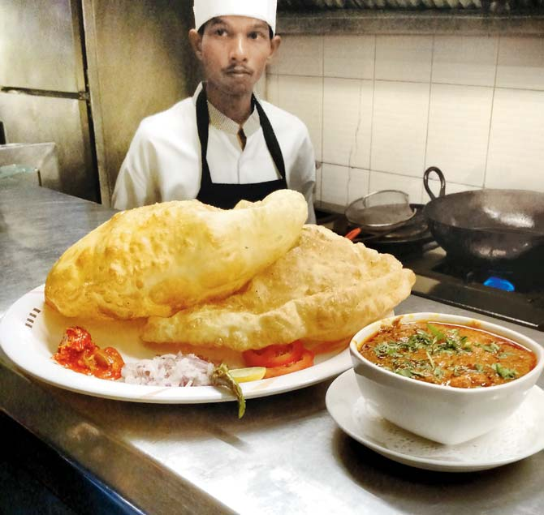  
***Chole***

**From:**11 am to 3.30 pm and 7 pm to 11 pm   
**Call: +**91 2114 273085  
**Address:** Kailash Parbat, Mumbai-Pune Road

**Hotel Sainath**  
There’s a three-decade-old adage that’s been doing the rounds of the valleys between Lonavala and Khandala. It goes something like this: “They checked into Fariyas but they breakfasted at Buwa’s.” Buwa, being the proprietor of Buwachi missal. No one calls it Hotel Sainath’s misal. Historically speaking, authentic Maharashtrian misal is made of usal (a curried sprouted lentil and bean jus), poha, chivda, farsan, onions and tomato. And that’s exactly what you get here for R50, with two pavs. Those who can’t handle spice, ask owner Ashok Gaikwad to hold the usal and add extra farsan. Be warned, the weekend wait can be long and painful.

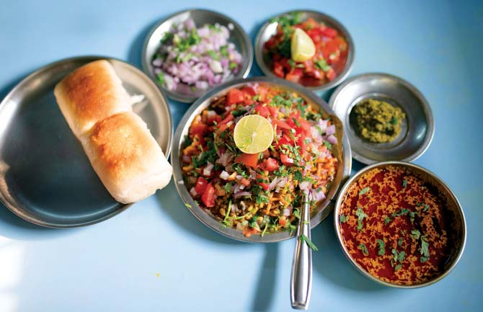  
***Misal***

**From:** 9 am to 7.30 pm or till food lasts, on Sundays 7 am to 11 pm  
**Call:** +91 2114 270078  
**Address:** Above Fariyas, near Silver Hills Resort

### Maganlal Chikki (Since 1880) : Rating 4.4/5

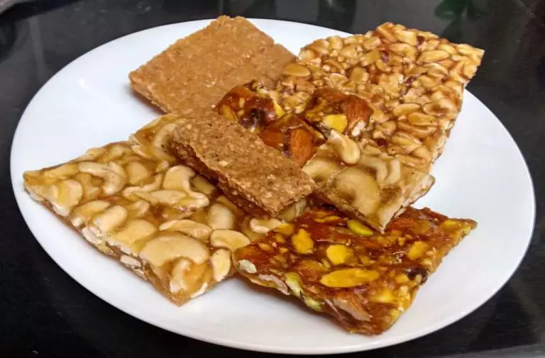

An ultimate after-meal companion for western India, Chikki products are tempting and mouth-watering compelling one to gulp again and again. Maganlal Chikkis is one such brand famous for manufacturing amazing quality of Chikkis with unique varieties to eat. Starting from groundnut chikkis to healthy dry fruit chikkis, Magalal chikkis serves the best of its products to its customers. Maganlal Chikki, which has dozens of outlets there, is among the biggest manufacturers of the sweet.           
The pioneers of Chikki, Maganlal Chikki started manufacturing crispy and unputdownable Chikkis way before independence and the rest is history. Their offerings have evolved over time and now serve the world. However, what sets them apart is their high-quality and the ability to curate unique flavors of Chikki to eat.

### 2) Live Fudge Factory (New)

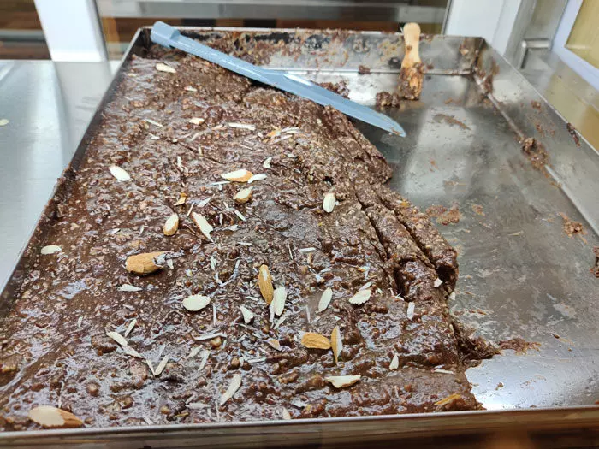

Lonavala is famous for many things, hills, waterfalls, treks, chikki and of course fudge! There are few very famous chikki and fudge manufacturing stores like Cooper’s fudge, Maganlal’ Fudge, etc.  
       Beyond this, the first time in Lonavala, a live fudge factory is one of the main attractions for peoples from Lonavala and all other travelers. Live manufacturing, live packaging and free sampling available to eat. Everything in front of you. As we know Lonavala is a very crowded place but nothing to worry about because this fudge factory provides you free parking. They also provide home delivery.  
         Here you can eat six different varieties of fudges namely chocolate walnut, chocolate almond, plain chocolate, custard apple, strawberry, and mango, and all varieties cost Rs 300 for 250 gm.  Nevertheless, their upcoming varieties are rose, vanilla, butterscotch and all are sugar-free fudges.

### 4) Golden Vadapav : Rating 4.1/5

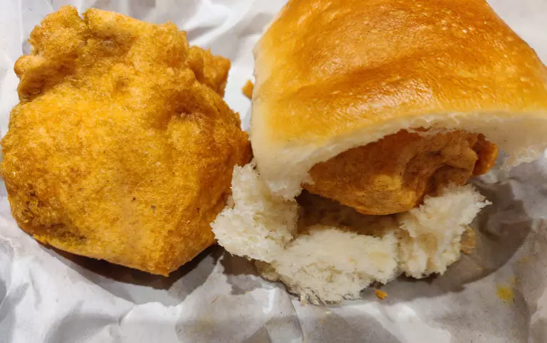

Golden Vada Pav on Old Mumbai-Pune highway is perhaps the most sought after street-food joint in Lonavala. There is no doubt about its popularity. At any given time, the place is crowded with patrons while the staff fries fresh vadas in front of them.            
          Vadapav with incredible Chutney is the star of the dish! The Thecha is flavorsome and further enhances the taste of the hot, crispy Vada Pavs, made right in front of you in a large batch. Golden Vada Pav serves the tastiest Vada Pav that you crave to have again and again.

<https://pawnacamp.com/places-to-eat-in-lonavala-restaurants>

<https://www.mid-day.com/articles/going-to-lonavala-heres-a-guide-to-the-best-eateries-on-the-way/16913158>

**4) Raigad**

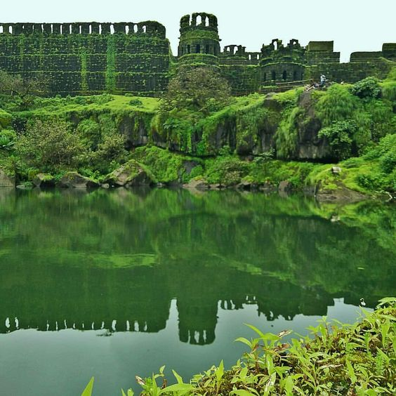

**History:**

**“तक्तास जागा हाच गड करावा”**

Raigad is a hill fort situated in Mahad, Raigad district of Maharashtra, India. Many constructions and structures that we see on raigad were built by chatrapati Shivaji when he made it his capital in 1674 when he was crowned the King of the Maratha Kingdom which later developed into the Maratha Empire, eventually covering much of western and central India. The fort rises 820 metres (2,700 ft) above the sea level and is located in the Sahyadri mountain range. There are approximately 1737 steps leading to the fort. The Raigad Ropeway, an aerial tramway exists.The height of this ropeway is 400 meters in height and 750 meters in length and takes only 4 minutes.

In 1656 Chhatrapati Shivaji Maharaj Seized the fort, then known as the fort of Rairi from Chandraraoji More, the king of javali (jawali).   
  
After capturing this fort Chhatrapati Shivaji Maharaj seeing the natural protection this fort had and also strategically important place in future as From Rairi one can keep an eye on Panvel and the Konkan region and seeing the adjoining mountains surrounding and protecting the fort from all sides, Maharaj said **“तक्तास जागा हाच गड करावा”** andrenamed the fort as Raigad and renovated and Expanded the fort, Hiroji Indulkar a skilled engineer and architect of his times, was given the task to build this fort. And announced this fort as the second capital of Swarajya.

**Coronation of Chhatrapati Shivaji Maharaj:**

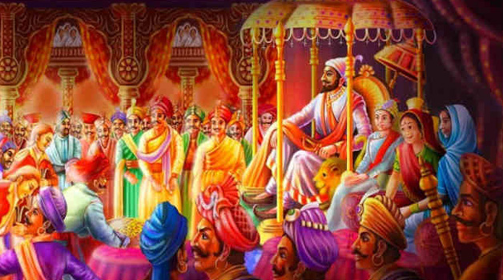

On 6th June 1674 Shivaji Maharaj was crowned as the king of Maratha Swaraj in a lavish ceremony, In the Hindu calendar it was on the 13th day (trayodashi) of the first fortnight of the month of Jyeshtha in the year 1596.[97] Gaga Bhatt officiated, holding a gold vessel filled with the seven sacred waters of the rivers Yamuna, Indus, Ganges, Godavari, Narmada, Krishna and Kaveri over Shivaji's head, and chanted the Vedic coronation mantras. After the ablution, Shivaji bowed before Jijabai and touched her feet. Nearly fifty thousand people gathered at Raigad for the ceremonies. Maharaj was entitled Shakakarta ("founder of an era") and Chhatrapati ("paramount sovereign"). He also took the title of Haindava Dharmodhhaarak (protector of the Hindu faith). Chhatrapati Shivaji Maharaj sat on the throne, ornamented with emblems and auspicious materials. Gaga Bhatt, a Hindu scholar conducted the ceremony. Maharaj was bestowed upon the title of ‘Kshatriya Kulavantas Chhatrapati Raje Shivaji’. It is also said that the Throne was made up of Gold, diamonds and various other ornaments.

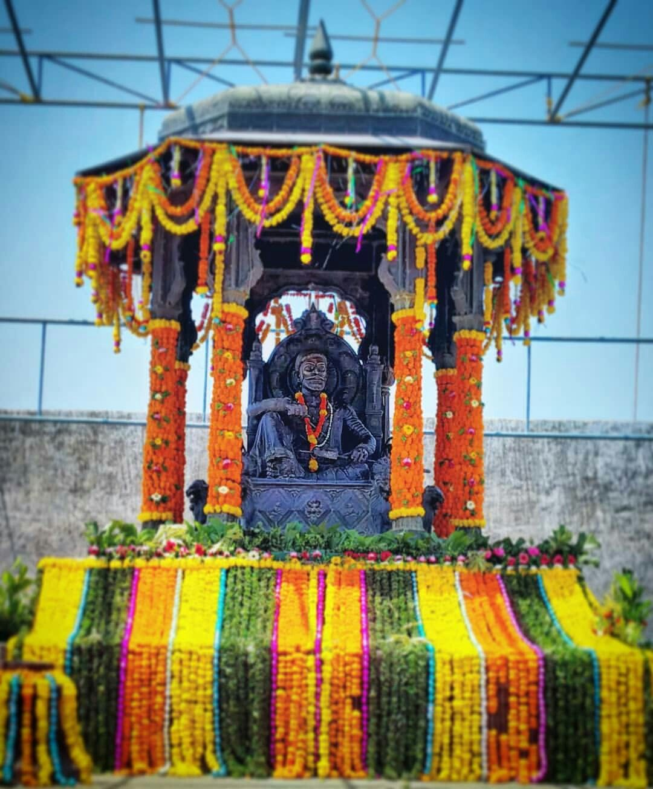

After 12 days of the Coronation ceremony Rajmata Jijabai died on 18th June 1764. The Marathas summoned Bengali Tantrik goswami Nischal Puri, who declared that the original coronation had been held under inauspicious stars, and a second coronation was needed. This second coronation on 24 September 1674 had a dual use, mollifying those who still believed that Shivaji Maharaj was not qualified for the Vedic rites of his first coronation, by performing a less-contestable additional ceremony.

**Campaign to south**

In the mid of 1674, the Marathas undertook an aggressive campaign, raiding Khandesh (October), capturing Bijapuri Ponda (April 1675), Karwar (mid-year), and Kolhapur (July). In November the Maratha navy skirmished with the Siddis of Janjira, but failed to dislodge them. Having recovered from an illness, and taking advantage of a conflict between the Afghans and Bijapur, Chhatrapati Sambhaji Maharaj in the guidance of Chhatrapati Shivaji Maharaj raided Athani in April 1676.

In the run-up to his expedition Maharaj appealed to a sense of Deccani patriotism, that Southern India was a homeland that should be protected from outsiders. His appeal was somewhat successful, and in 1677 Chhatrapati Shivaji Maharaj visited Hyderabad for a month and entered into a treaty with the Qutubshah of the Golkonda sultanate, agreeing to reject his alliance with Bijapur and jointly oppose the Mughals. In 1677 Chhatrapati Shivaji Maharaj invaded Karnataka with 30,000 cavalry and 40,000 infantry, backed by Golkonda artillery and funding. Proceeding south, Shivaji seized the forts of Vellore and Gingee; the latter would later serve as a capital of the Marathas during the reign of his son Rajaram I.

Chhatrapati Shivaji Maharaj intended to reconcile with his half-brother Venkoji (Ekoji I), Shahaji Maharaj’s son by his second wife, Tukabai (née Mohite), who ruled Thanjavur (Tanjore) after Shahaji Maharaj. The initially promising negotiations were unsuccessful, so whilst returning to Raigad Chhatrapati Shivaji Maharaj defeated his half-brother's army on 26 November 1677 and seized most of his possessions in the Mysore plateau. Venkoji's wife Dipa Bai, whom Shivaji Maharaj deeply respected, took up new negotiations with Maharaj, and also convinced her husband to distance himself from Muslim advisors.

After successfully completing the Campaign to south, after some years In late March 1680, Shivaji Maharaj fell ill with fever and dysentery, and died on 3rd April 1680 on the eve of Hanuman Jayanti.

**Chhatrapati Sambhaji Maharaj:**

After Chhatrapati Shivaji Maharaj’s death, Maharani Soyarabai made plans with various ministers of the administration to crown her son Chhatrapati Rajaram Maharaj rather than her stepson Chhatrapati Sambhaji Maharaj. On 21 April 1680, ten-year-old Chhatrapati Rajaram Maharaj was installed on the throne.

However Chhatrapati Sambhaji Maharaj acquired control of Raigad and on 16th January 1681 the coronation ceremony of Chhatrapati Sambhaji Maharaj took place and was know as the second ruler of the Maratha Swarajya.

He was successor of the realm after his father's death, and ruled it for nine years. Sambhaji maharaj’s rule was largely shaped by the ongoing wars between the Maratha kingdom and Mughal Empire as well as other neighbouring powers such as the Siddis, Mysore and the Portuguese in Goa. As the Mughals Invaded Deccan which started a 27year war between Marathas and Mughals, Chhatrapati Sambhaji Maharaj Protecting Swarajya for almost 9 YEARS from Mughals but in 1689, Chhatrapati Sambhaji Maharaj was captured near Sangameshwar and then was took as a prisoner where he was brutally tortured and executed by the Mughals.

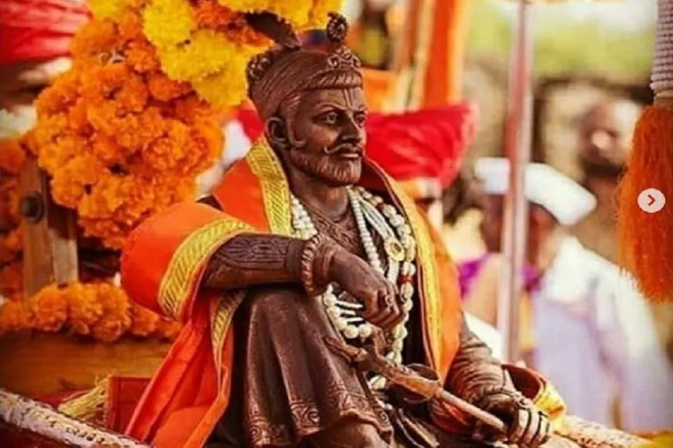

**Chhatrapati Rajaram Maharaj:**

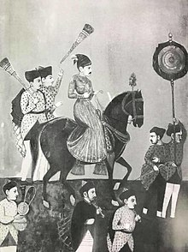

After the death of Chhatrapati Sambhaji Maharaj, Rajaram Maharaj was crowned at Raigad on 12 March 1689. As the Mughals started laying siege to the region around Raigad on 25 March 1689, the widow of Chhatrapati Sambhaji Maharaj (Maharani Yesubai) and her minister Ramchandra Pant Amatya sent young Rajaram to the stronghold of Pratapgad through Kavlya ghat. The Maratha army fought with the Mughals and led the new Maratha king, Chhatrapati Rajaram Maharaj to escape through Kavlya ghat to the fort of Jinji in present-day state of Tamil Nadu via Pratapgad and Vishalgad forts, Chhatrapati Rajaram Maharaj reached Keladi (Near present-day Sagar in Karnataka) in disguise and sought refuge from Keladi Chennamma - The brave Kannada queen fought the Mughals and ensured safe passage and escape of Chhatrapati Rajaram Maharaj to Jinji where he reached after a month and a half on 1 November 1689, Keladi Chennamma fought the guerrilla warfare which frustrated the Mughals and the Mughals proposed peace accord for the first time with an Indian ruler, Keladi Chennamma. Details of this escape are known from the incomplete poetical biography of Rajaram, the Rajaramacharita written by his Rajpurohit, Keshav Pandit, in Sanskrit.

**Aftermath:**

In 1689, Zulfikhar Khan captured Raigad and Aurangzeb renamed it as Islamgad. He captured Maharani Yesubai and Shahu maharaj son of Chhatrapati Sambhaji maharaj,

In 1707, Siddi Fathekan captured the fort and held it until 1733. After 1733 maratha sardar captured raigad again and hold it until 1818. Under the reign of Chhatrapati Shahu maharaj and also Peshwa bajirao 1 the Maratha rose to prominence where they expanded their territories till Attock (city in Pakistan) capturing almost whole India under Maratha reign.

In 1765, The fort of Raigad along with Malwan in present Sindhudurg District, the southernmost district of Maharashtra, was the target of an armed expedition by the British East India Company, which considered it a piratical stronghold. In 1818, the fort was bombarded and destroyed by cannons from the hill of Kalkai. And on 9 May 1818,the fort was looted and destroyed and as per the treaty, it was handed over to the British East India Company.

**Gallery:**

The Raigad Fort was built by Chhatrapati Shivaji Maharaj and the chief architect/engineer was Hiroji Indulkar. The main palace was constructed using wood, of which only the base pillars remain. The main fort ruins consist of the queen's quarters, six chambers, with each chamber having its own private restroom. In addition, ruins of three watch towers can be seen directly in front of the palace grounds out of which only two remain as the third one was destroyed during a bombardment. The Raigad Fort also has ruins of a market which was accessible to horseback riders. The fort also overlooks an artificial lake known as the Ganga Sagar Lake.

The only main pathway to the fort passes through the "Maha Darwaja" (Huge Door) which was previously closed at sunset. The Maha Darwaja has two huge bastions on both sides of the door which are approximately 65–70 feet in height. The top of the fort is 600 ft above this door.

The King's Darbar, inside the Raigad Fort has a replica of the original throne that faces the main doorway called the Nagarkhana Darwaja. This enclosure had been acoustically designed to aid hearing from the doorway to the throne. A secondary entrance, called the Mena Darwaja, was supposedly the private entrance for the royal ladies of the fort that lead to the queen's quarters. The convoy of the king and the king himself used the Palkhi Darwaja. To the right of Palkhi Darwaja, is a row of three dark and deep chambers. Historians believe that these were the granaries for the fort.

From the fort, one can view the execution point called Takmak Tok, a cliff from which sentenced prisoners were thrown to their death. This area has been fenced off.

The statue of Chhatrapati Shivaji Maharaj is erected in front of the ruins of the main market avenue that leads to the Jagdishwar Mandir and his own Samadhi and that of his loyal dog named Waghya. The Samadhi of Jijabai, Chatrapati Shivaji's mother, can be seen at base village of Pachad.

Additional famous attractions of the fort include the Khubladha Buruj, Nane Darwaja and the Hatti Talav (Elephant Lake).

**Hirakani Buruj**

The fort has a famous wall called "Hirakani Buruj" (Hirakani Bastion) constructed over a huge steep cliff. The legend goes "that a woman by the name of Hirakani from a nearby village had come to sell milk to the people living at the fort. She happened to be inside the fort when the gates got closed and locked at sunset. Hearing the cries of her infant son back at the village echo after nightfall, the anxious mother couldn't wait till dawn and courageously climbed down the steep cliff in pitch darkness all for the love of her little one. She later repeated this extraordinary feat in front of Chhatrapati Shivaji Maharaj and was bravely rewarded for it." In appreciation of her courage and bravery, Chhatrapati Shivaji Maharaj built the Hirakani Bastion over this cliff.

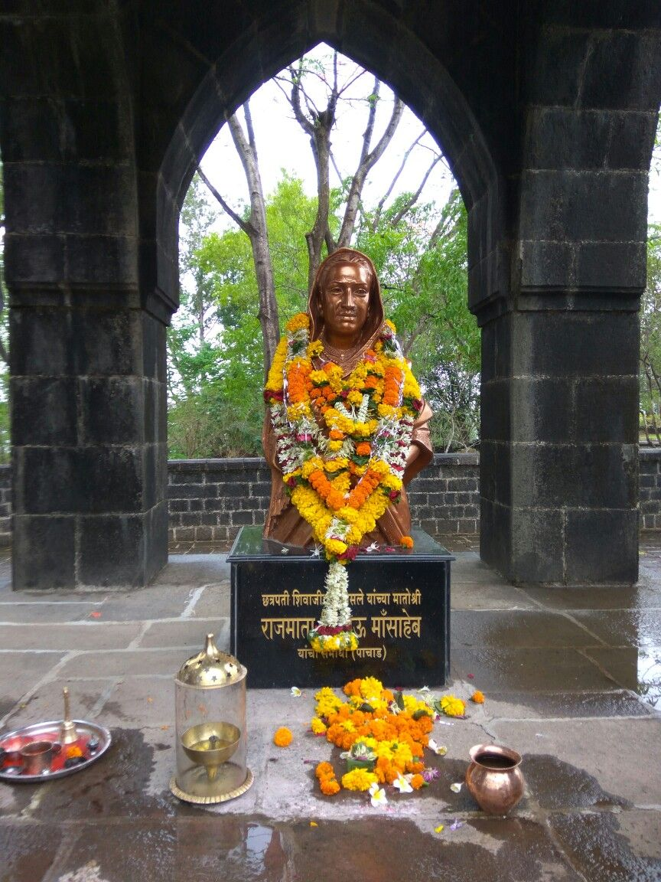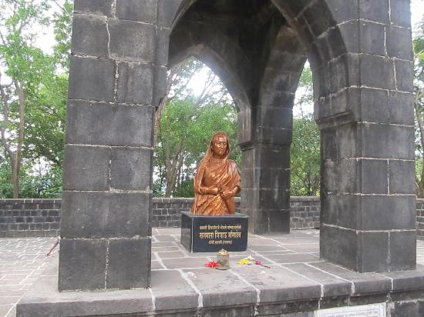

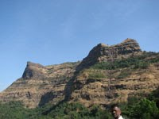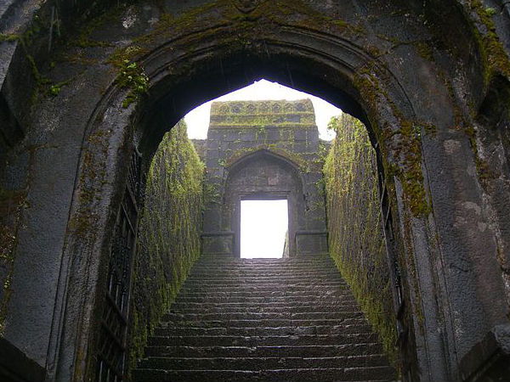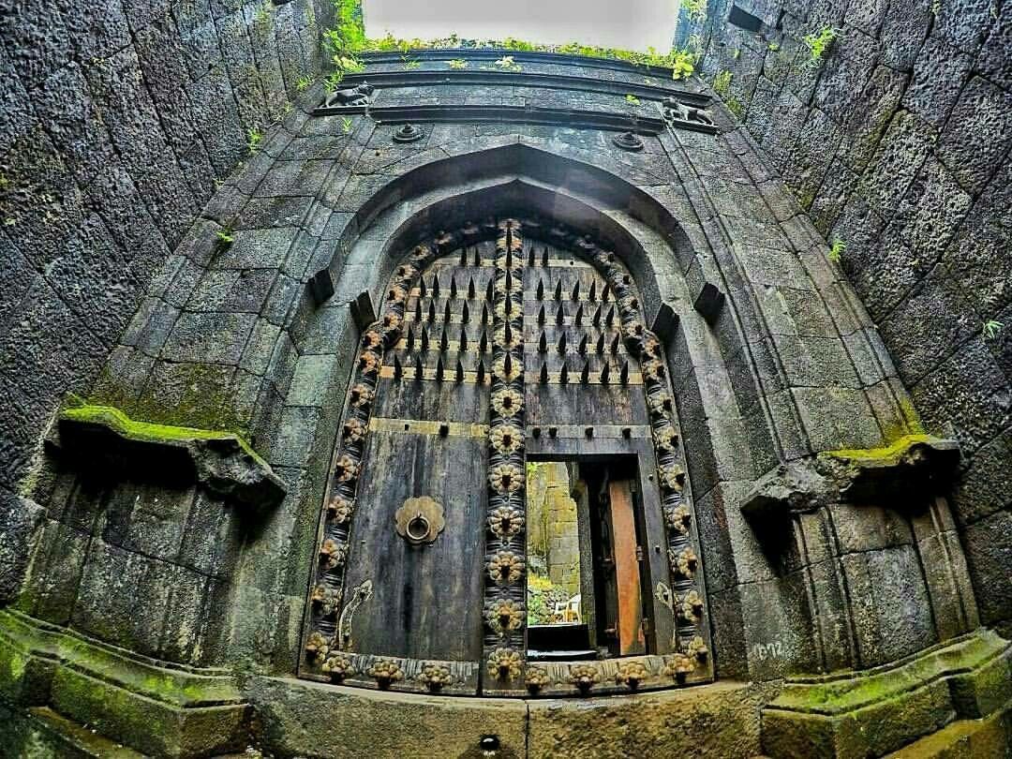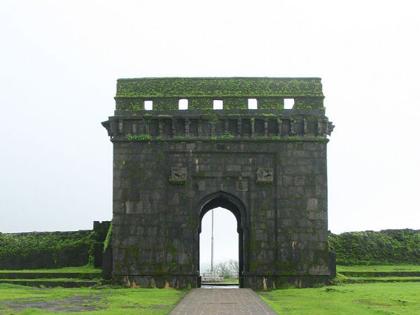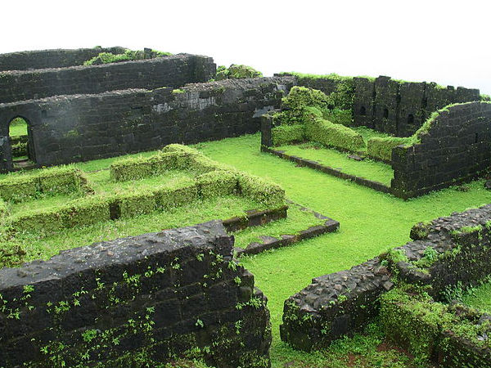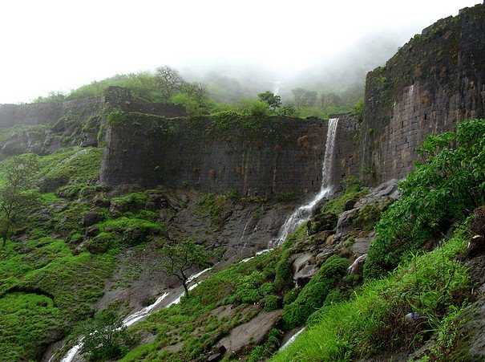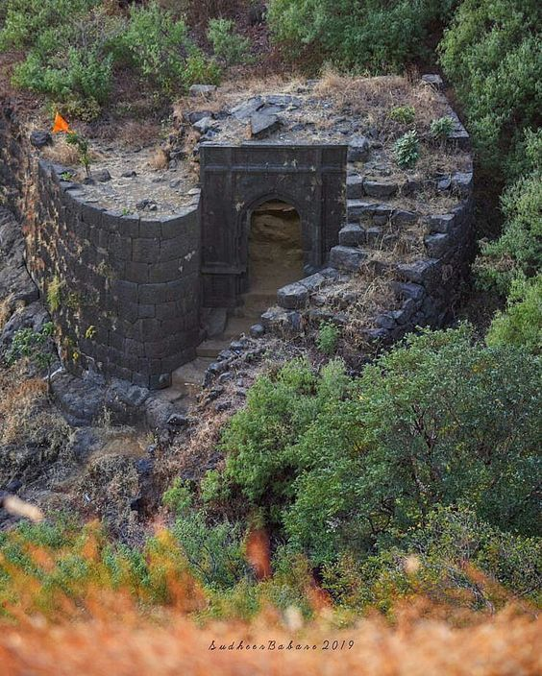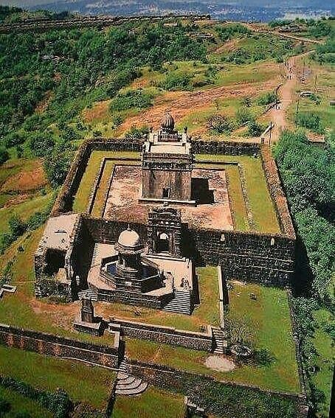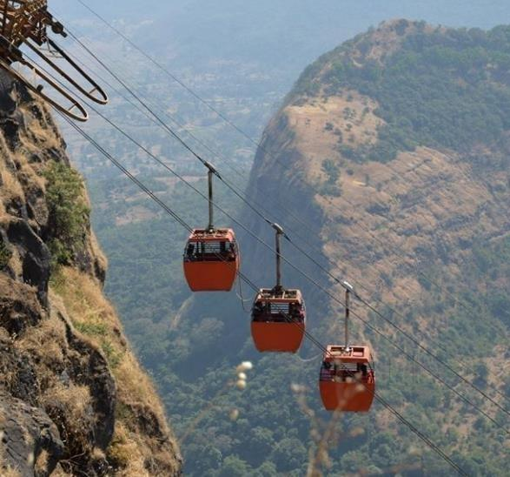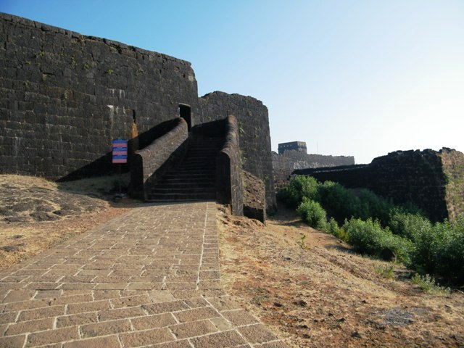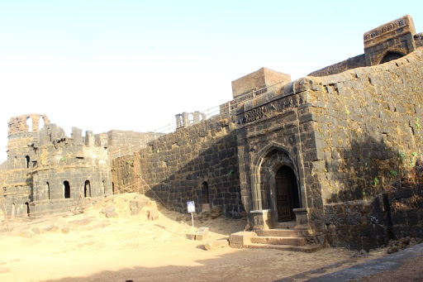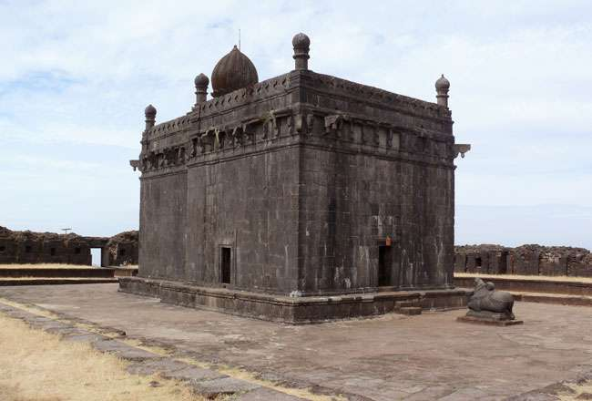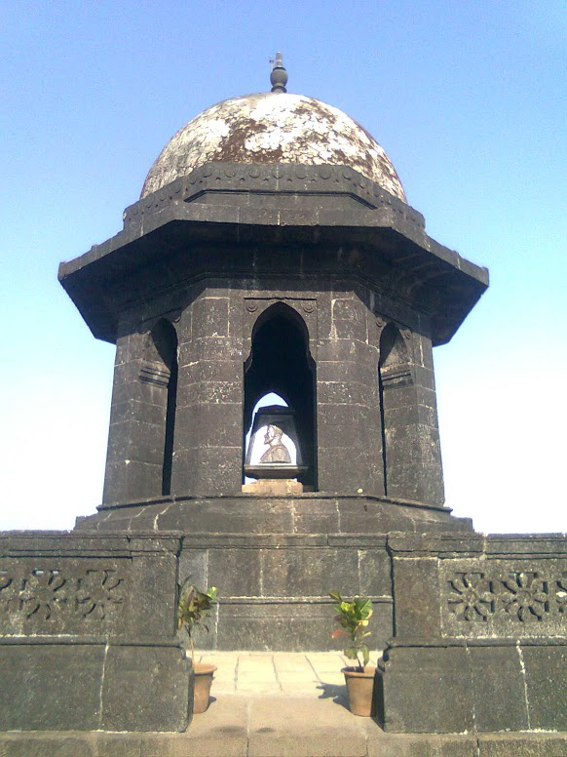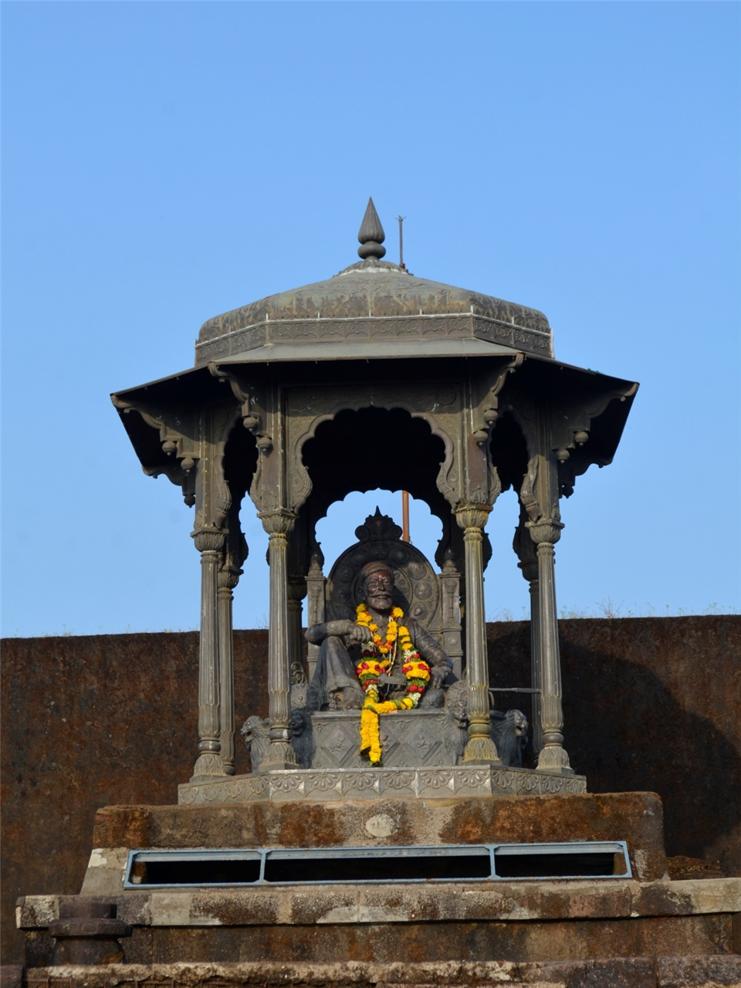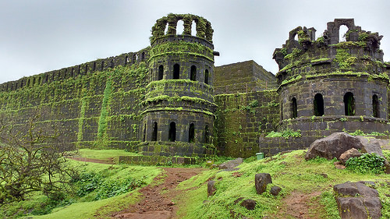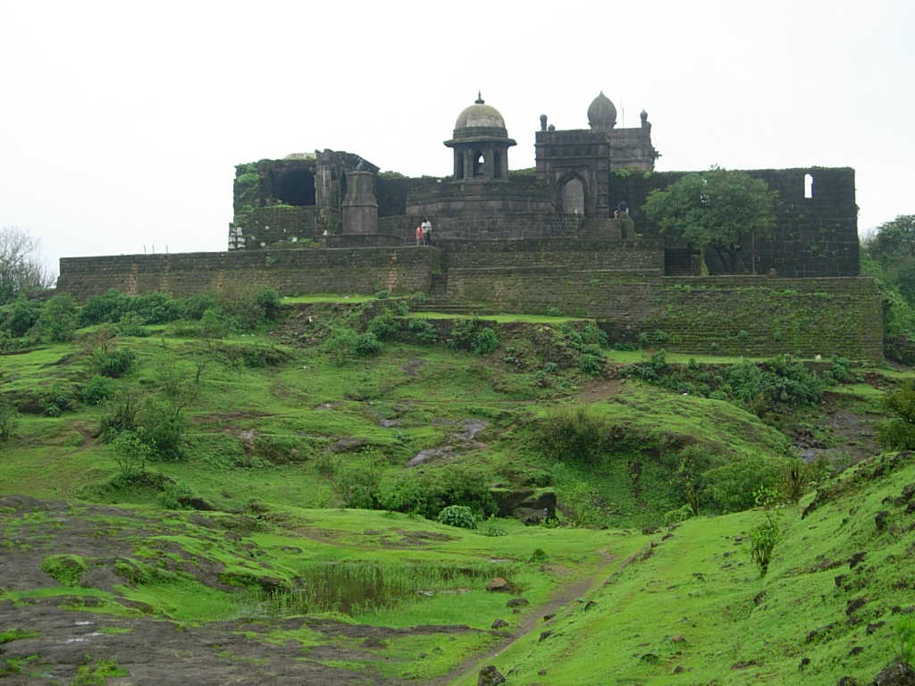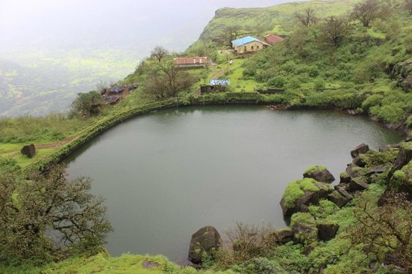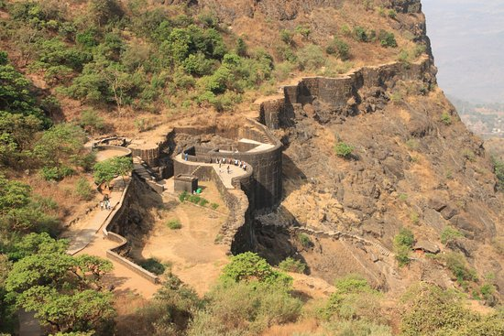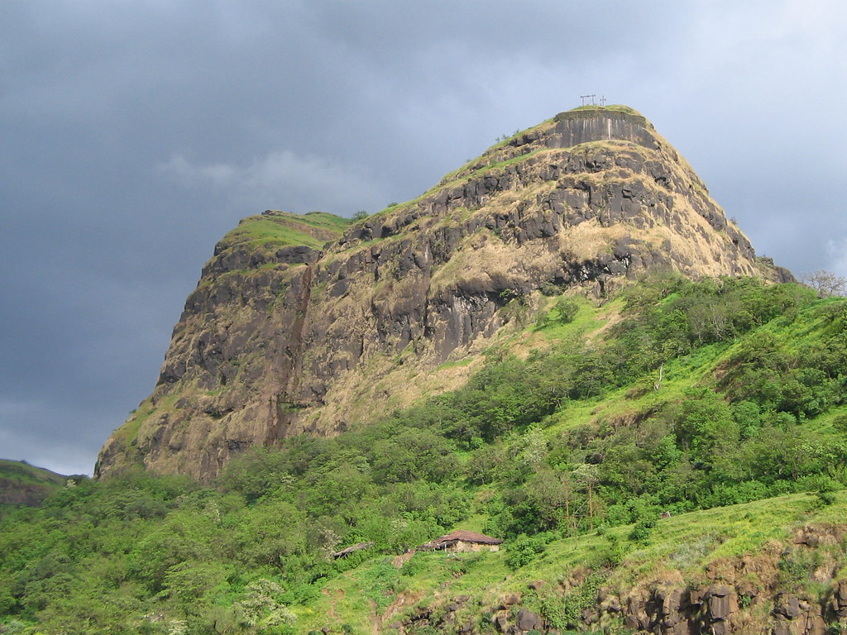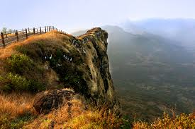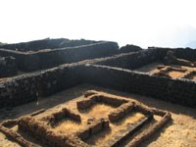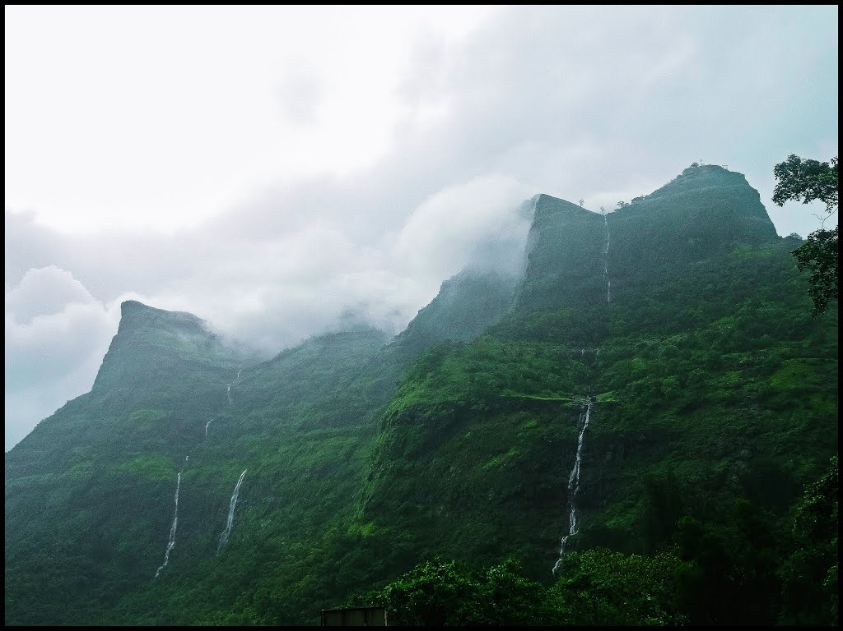

**How to reach:**

## How to Reach Raigad Fort by Road

The busses connecting important cities terminate at one of the three important bus stands in Raigad. These are Alibaug bus stand, Panvel State transport bus depot, and Mangaon State Transport Stand. You can avail many private busses apart from the government owned Maharashtra State Road Transport (MSRTC) busses. You can book your bus tickets online and select your choicest seats for comfortable journey.

Take NH17 to reach Raigad Fort from Mumbai. Reach Panvel- Mahad via Lonera Phata and Dasagon and reach Raigad. Ropeway is available from the foothills to the top of the Raigad Fort.

## How to Reach Raigad Fort by Train

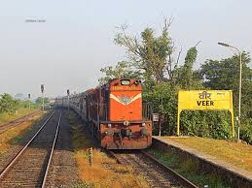

The nearest railway station that is connected to Mumbai and Pune is Veer railway station, about 40 km away from Raigad and has regular trains connecting the destination. From the railway station, you can also hire a taxi to Raigad.

So, what are you waiting for? Hop on a bus, or book a flight/train ticket or take the ropeway to reach this majestic fort situated on a cliff.

## How to Reach Raigad Fort by Air

The nearest airport to reach Raigad Fort is Mumbai Shivaji International airport, located at a distance of 140 km from Raigad. All major airlines ply from other cities and international cities to Mumbai. Many cities abroad like Singapore, Colombo, Hong Kong and gulf countries are connected to Mumbai. The other nearest airport is at Pune, located 126 km and is also well connected to other major cities.



**Tourist attractions**

**Varadavinayaka**

Mahad Ganpati Temple or Varad Vinayak, also spelt as Varadavinayaka, is one of the Ashtavinayak temples of the Hindu deity Ganesha. It is located in Mahad village situated in Khalapur taluka near Karjat and Khopoli of Raigad District, Maharastra, India.

The Varad Vinayak Mahad Ganpati Temple is the Seventh Ganesha temple to be visited during the Ashtavinayak Darshan tour. The idol at the Varad Vinayak Mahad Ganpati Temple is Swyambhu and the temple is actually recognised as a Math.

The temple is very simply designed with a tiled roof, a dome 25 feet high with golden pinnacle and a golden summit (Kalas) which has a carving of a cobra (also a deity revered by Hindus). The Temple is 8 feet long & 8 feet broad.

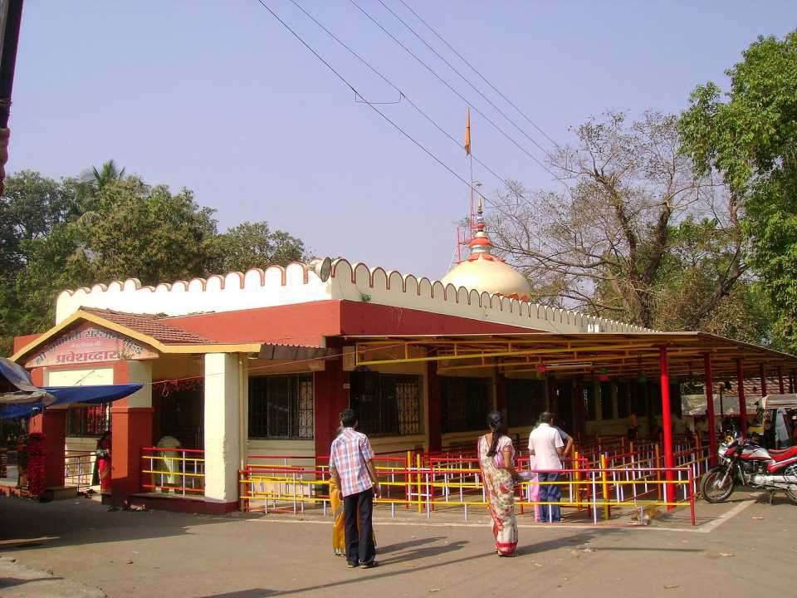

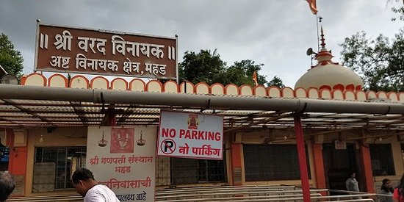

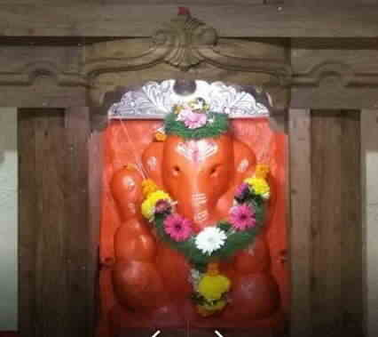

**Lingana Fort:**

**Lingana** is a massive pinnacle on the mainline of the Sahyadris between [Raigad](https://en.wikipedia.org/wiki/Raigad_fort) and Torna. It is in the Mahad Taluka of Raigad district. It is 35 km away from Mahad town. It takes its name from its shape which is like a [linga](https://en.wikipedia.org/wiki/Linga). It is 2969 feet high with an ascent of four miles, the first half is easy to climb while the second is difficult. Its rock cut steps have been destroyed and the fort is almost completely inaccessible. The top of the fortified rock is 2500 feet square. No fortifications or buildings remain but there are traces of a grain store and some cisterns. Lingana fort was built by Chhatrapati [Shivaji Maharaj](https://en.wikipedia.org/wiki/Shivaji_Maharaj) in 1648 to secure central Konkan against the Sidis. Under the Marathas, Lingana was used as a penal settlement. The prisoners were confined to rock dungeons with one dungeon holding 50 prisoners. Lingana was captured by a Colonel Prother in 1818.

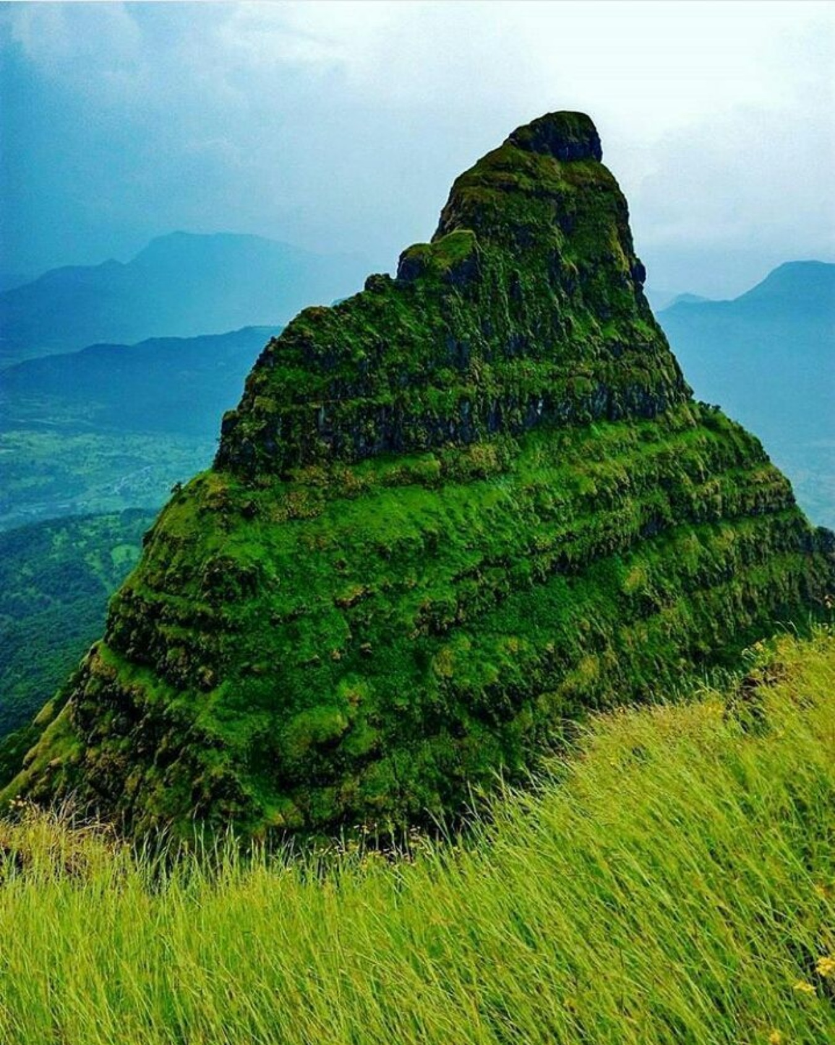

**Gandharpale Caves**

**Gandharpale Caves**, also called **Mahad caves** or **Pandava Leni**, is group of 30 [Buddhist](https://en.wikipedia.org/wiki/Buddhist) [caves](https://en.wikipedia.org/wiki/Caves), 105 km south of [Mumbai](https://en.wikipedia.org/wiki/Mumbai) on Mumbai-Goa Highway near [Mahad](https://en.wikipedia.org/wiki/Mahad).[[1]](https://en.wikipedia.org/wiki/Gandharpale_Caves#cite_note-AHIR-1) The caves are located near the NH-17 and well connected by road.

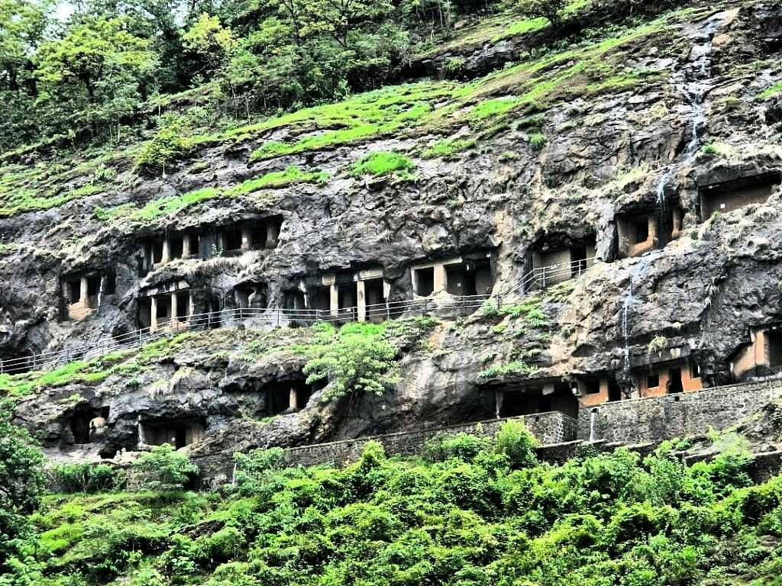

What to eat and shopping and accommodation:

Altough near fort there is no place to do shopping, You can buy local items near raigad fort like Keychains, Pictures of Raigad fort, and many more local stuffs. You can visit Mahad where you can buy various unique items the village offers.

You can stay on top of the raigad fort as it provides accommodation facilities, there is also a hotel present on fort. Try Junkar bakar, Kandabhaji, Misal as it is the best food to eat on fort, also Non-veg is served as well but depends on the availability of food.

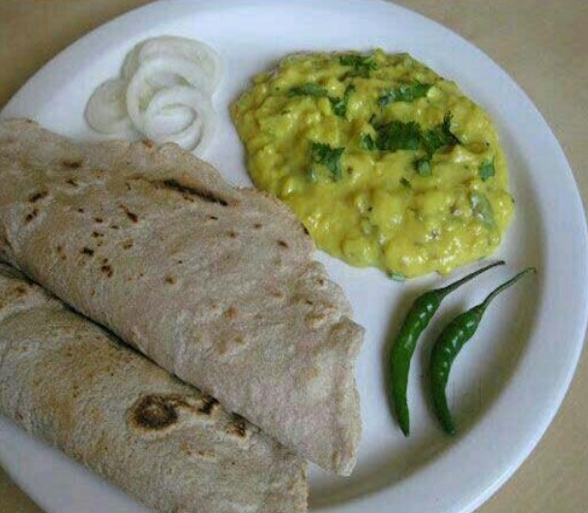

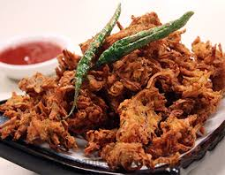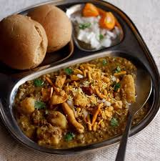

5) Rajgad:

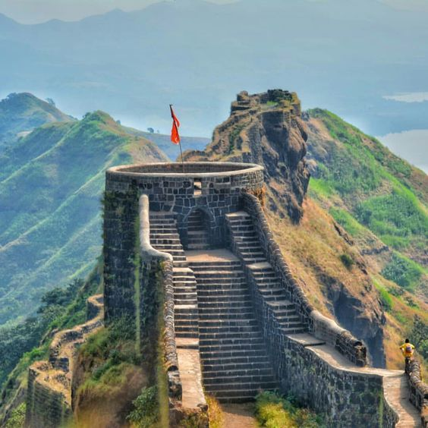

Rajgad (literal meaning Ruling Fort) is a hill fort situated in the Pune district of Maharashtra, India.

The Rajgad Fort is located around 60 km (37 mi) to the south-west of Pune and about 15 km (9.3 mi) west of Nasrapur in the Sahyadris range. The fort lies 1,376 m (4,514 ft) above the sea level. The diameter of the base of the fort was about 40 km (25 mi) which made it difficult to lay siege on it, which added to its strategic value. The fort's ruins consist of palaces, water cisterns, and caves. This fort was built on a hill called Murumbadevi Dongar (Mountain of the Goddess Murumba). Rajgad boasts of the highest number of days stayed by Chhatrapati Shivaji Maharaj on any fort.

**History:**

Formerly known as Murumdev, the fort was the first capital of the Maratha Empire under the rule of Chhatrapati Shivaji Maharaj for almost 26 years, after which the capital was moved to the Raigad Fort. Treasures discovered from an adjacent fort called Torna were used to completely build and fortify the Rajgad Fort.

The fort has stood witness to many significant historic events including the birth of Shivaji's son Rajaram I, the death of Shivaji Maharaj’s Queen Saibai, the return of Shivaji Maharaj from Agra, the burial of Afzal Khan's head in the Mahadarwaja walls of Balle Killa, the strict words of Sonopant Dabir to Shivaji Maharaj and many more.

The Rajgad Fort was also one of the 17 forts that Shivaji kept when he signed the Treaty of Purandar in 1665, with the Mughal general Jai Singh I, leader of the Mughal forces. Under this treaty, 23 forts were handed over to the Mughals.

First the fort was under the hands of Ahmed Bahiri Nizamshah in 1490, later in 1626 During the Nizam's last struggle, Adilshah captured the fort. In 1630 The fort was recaptured by Nizamshah with the help of Shahaji Maharaj, and until 1642 the fort was in the jagir of Shahaji Maharaj.

Later in 1647, Under the age of 16, Chhatrapati Shivaji Maharaj captured fort Torna (later renamed as Prachandagad ) and adjacent Murumdev (later renamed as Rajgad) In 1649 Repairs on the fort began and Shamrao Neelkanth Ranzekar was appointed as the Peshwa. In 1654 The fort was renamed as "Rajgad". Construction on new fortifications and buildings commenced.

On 14 January 1658 Chhatrapati Shivaji Maharaj returned to Rajgad after conquering North Konkan and on 11 July 1659 Chhatrapati Shivaji Maharaj went to Pratapgad in order to battle with Afzal Khan. On 5 September 1659 Maharani Saibai (Chhatrapati Shivaji Maharaj's wife) died in the Rajgad Fort.

In July 1660 Chhatrapati Shivaji Maharaj escaped from Siddi Jouhar's siege of Panhala and came to Rajgad. Later in July 1661 The idol of Bhavanimata, which was to be established in Pratapgad, was first brought to Rajgad to be inspected by Rajmata Jijabai. In January 1662 the construction of the Rajgad fort was completed and Chhatrapati Shivaji Maharaj returned to the fort after capturing Pen and Kalyan.

In February 1664 The booty of Surat was brought to Rajgad and On 30th April 1665 the Mughals attacked Rajgad fort but were unsuccessful. In June 1665 during the battle of Purandar, Chhatrapati Shivaji maharaj sent a letter of accepting defeat against Mirja Raje Jaisingh.

After 5 years on 24th February 1670 Chhatrapati Rajaram was born on the fort, and in 1671 the repairing of the fort began at an expected cost of 10,000 hons.

After that Chhatrapati Shivaji Maharaj Moved his capital to Raigad Fort.

Later in June1689 The fort was captured by the Mughals after Chhatrapati Sambhaji Maharaj was executed. And after 1692 Shankarji Narayan captured the fort from the Mughals, and later in 1697 Chhatrapati Rajaram Maharaj returned to Maharashtra and made Rajgad his new capital.

On 4th August 1701 Shahaji Mohite was made the havaldar of Padmavati Machi. And on 18th February 1704 The fort was handed over to Aurangzeb as part of a treaty. The fort was renamed to Nabishahagad.

SarSenapti Sidojirao Thopte and Santaji Shilimkar were killed here by Aurangzeb. But later on 29th may 1707 Gunaji Sawant captured the fort and The Maratha War of Independence ended. In 1709 Chhattrapati Shahu Maharaj made provisions for the repairs of the fort.

Later in 1818 The Rajgad fort was passed into the hands of the british.

**Gallery:**

The fort has ruins of palace, also there is a temple of Murumbadevi (the fort was named from the goddess and the fort was built on this hill called Murumbadevi Dongar (Mountain of the Goddess Murumba)).

Also there a mahadarwaja, legends has it that the head of afzalkhan was buried inside this wall. The fort also had two machi’s known as Suvela machi and Sanjivani Machi, also the fort has a water tanks and Chilkathi Buruj and Lord Shiva Temple and Padmavati temple

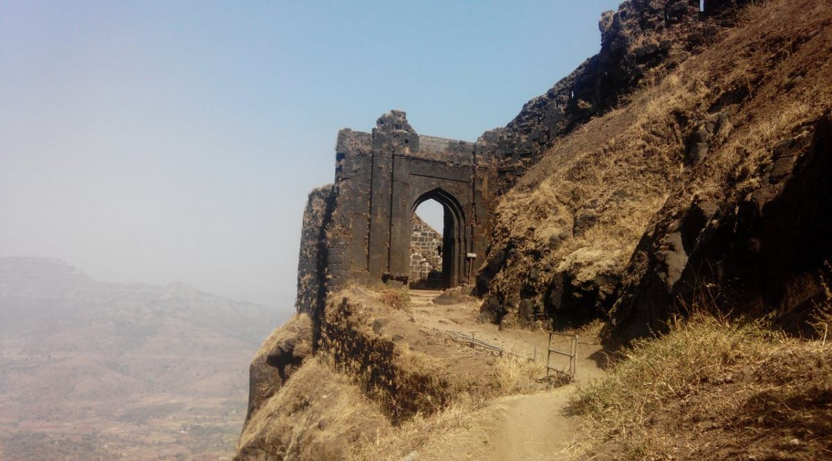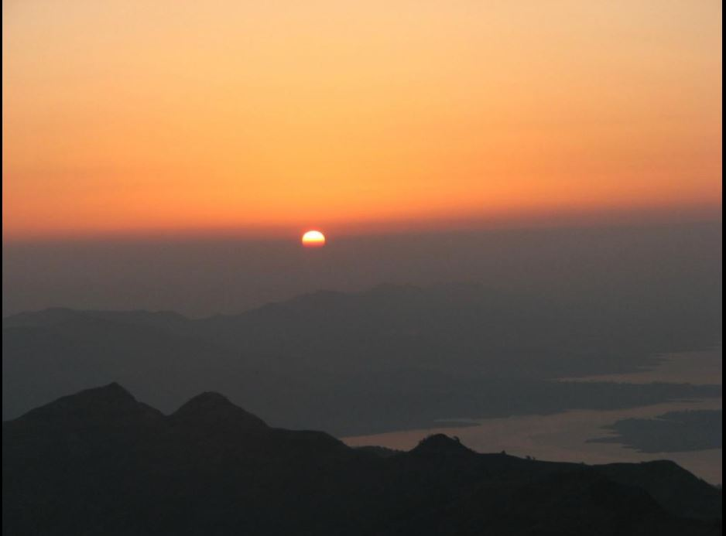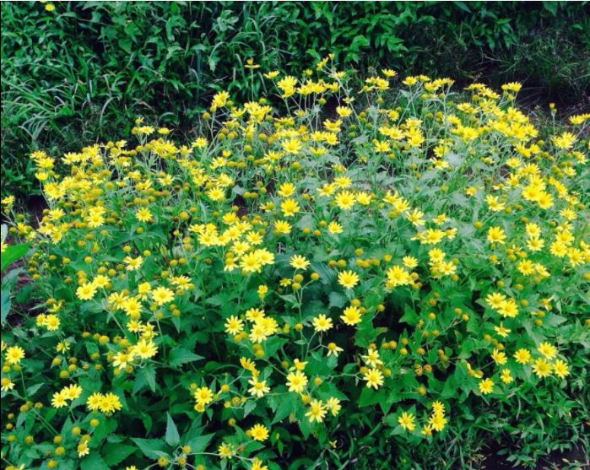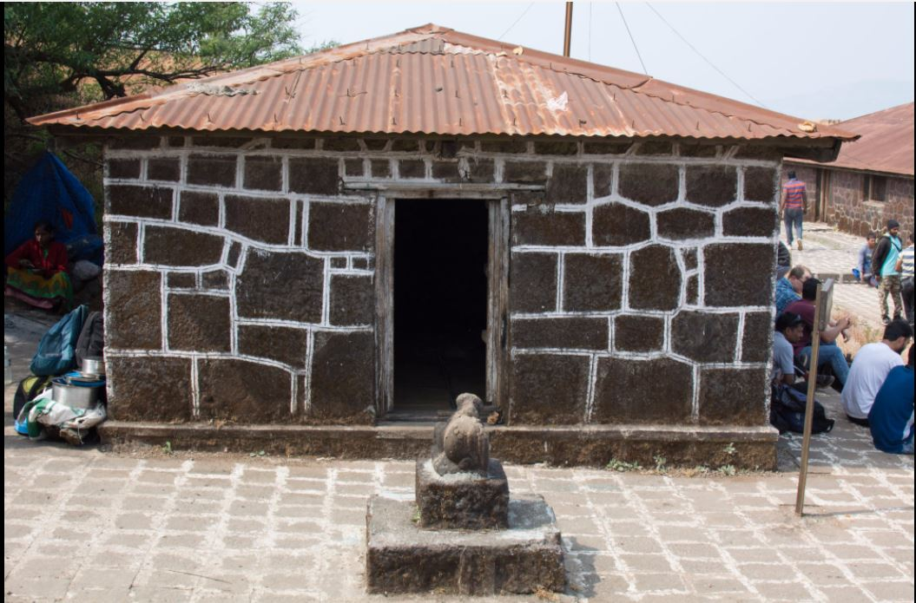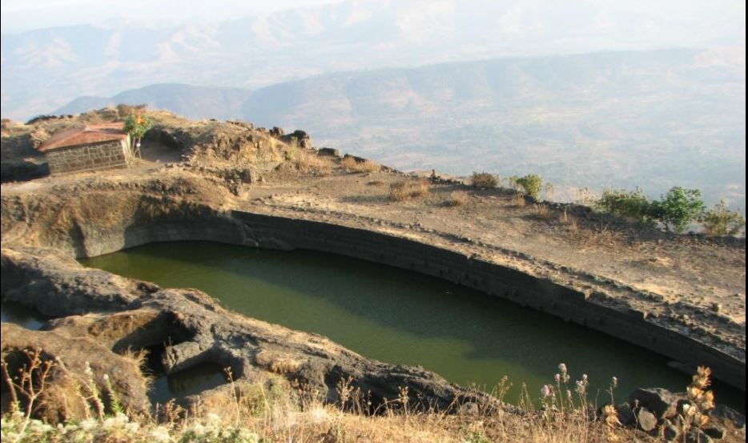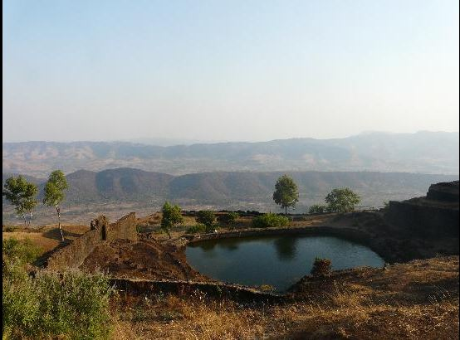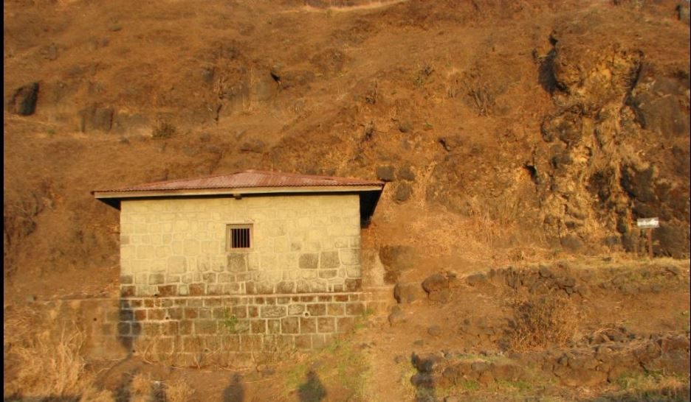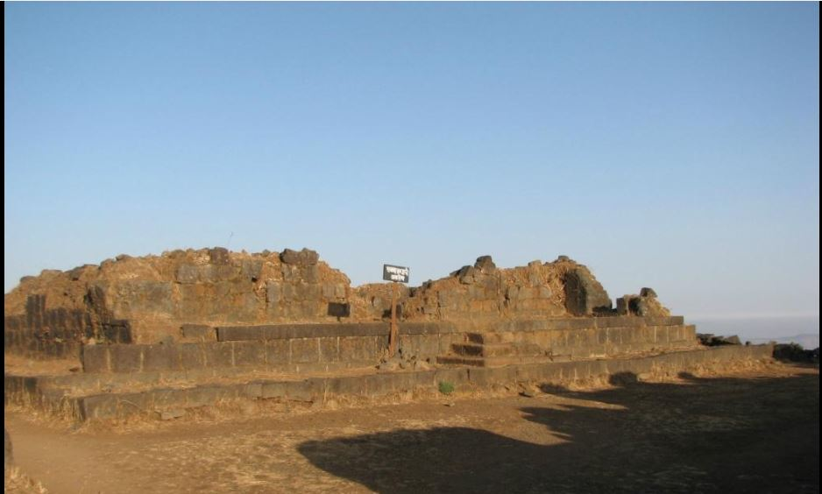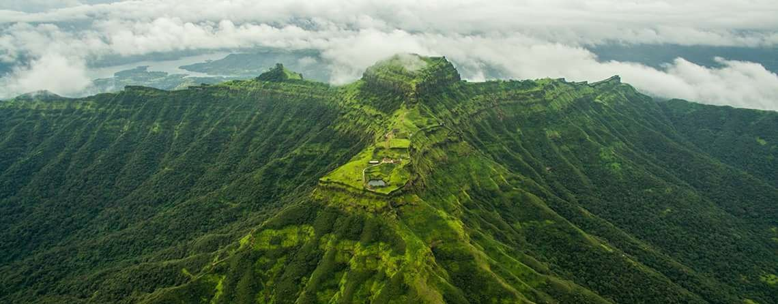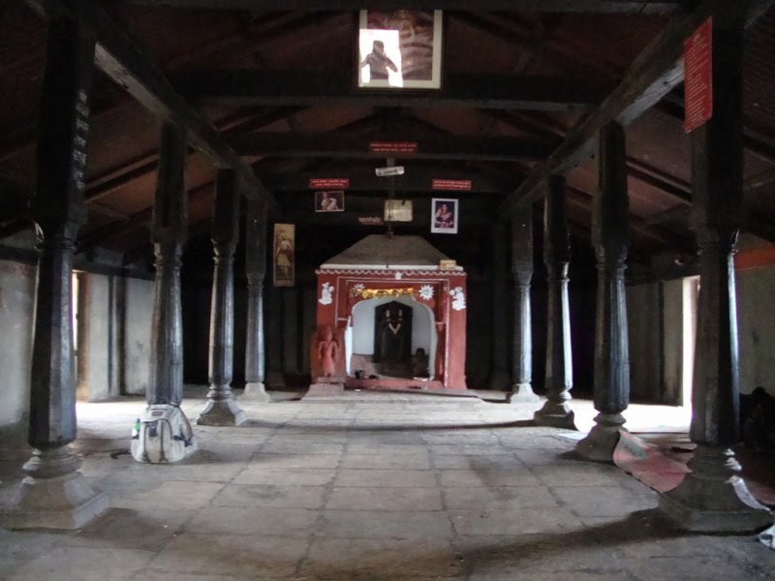

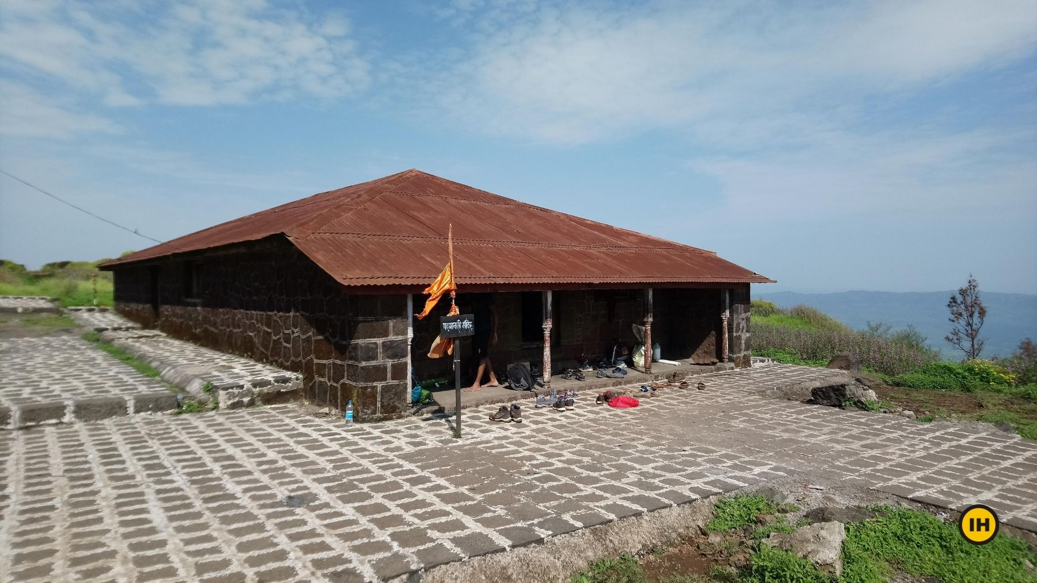

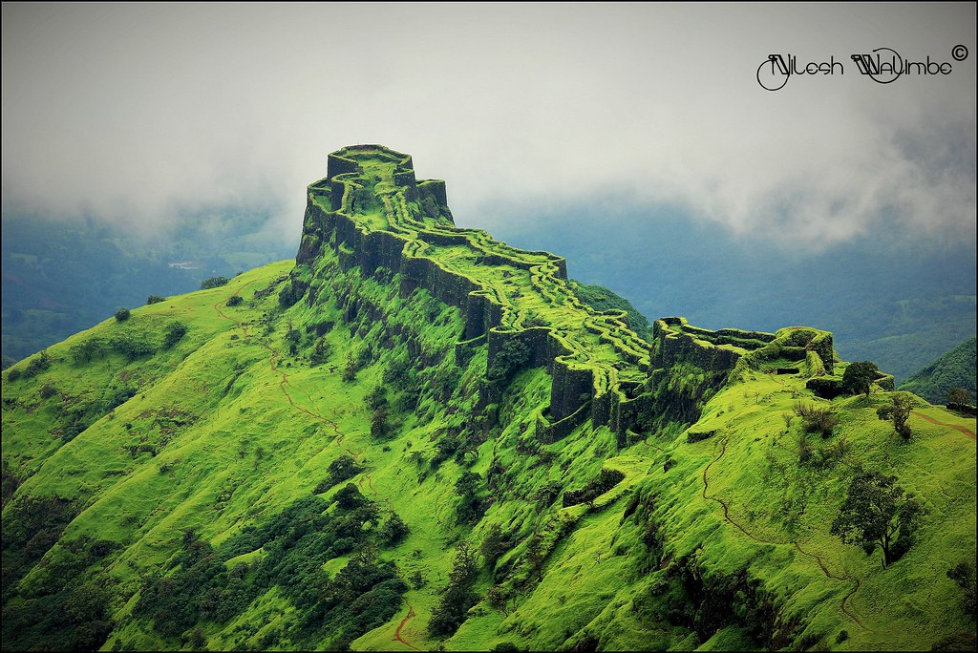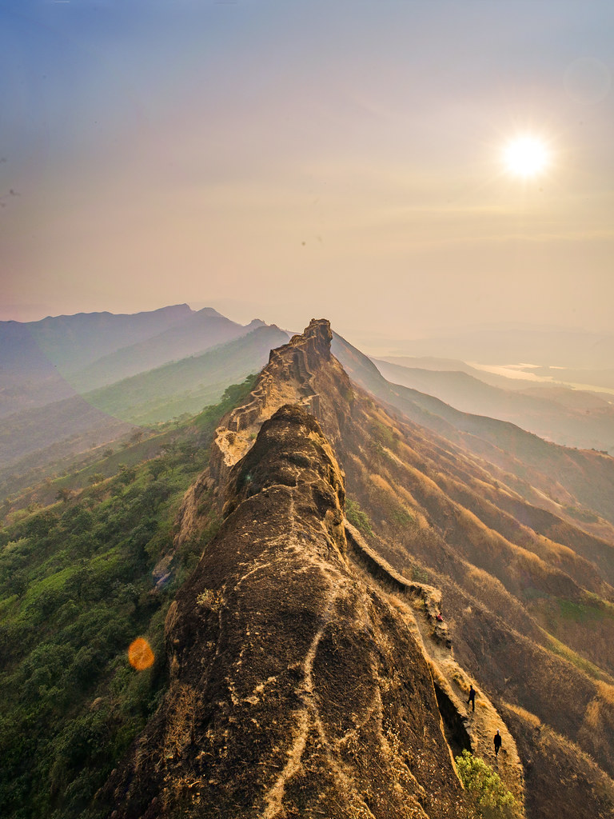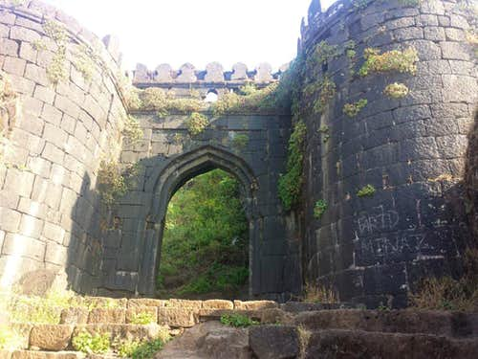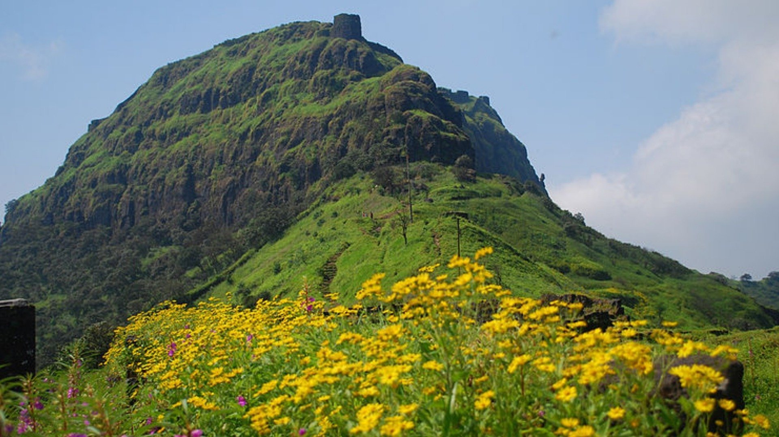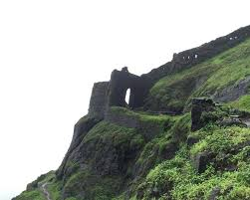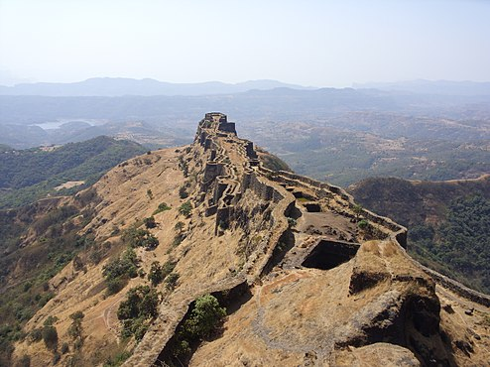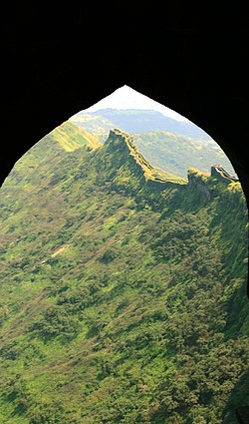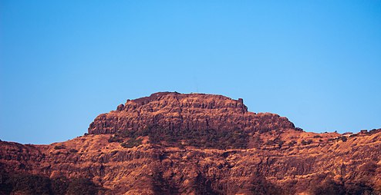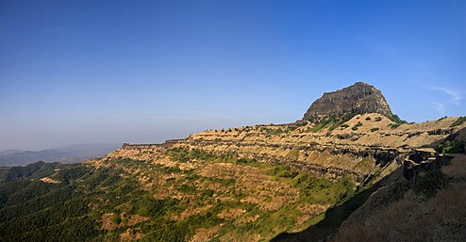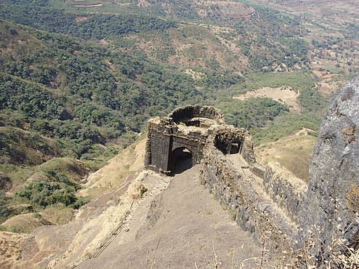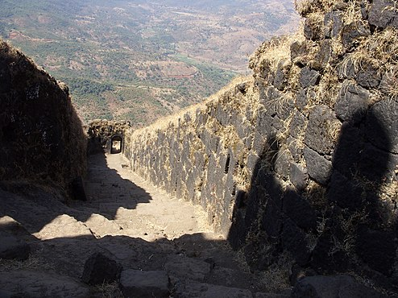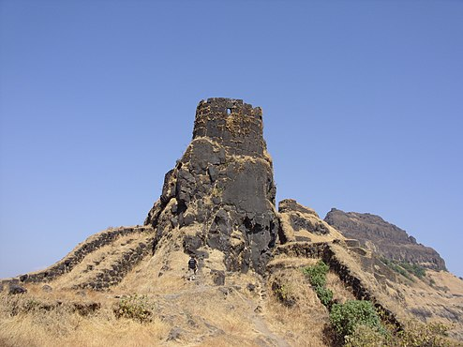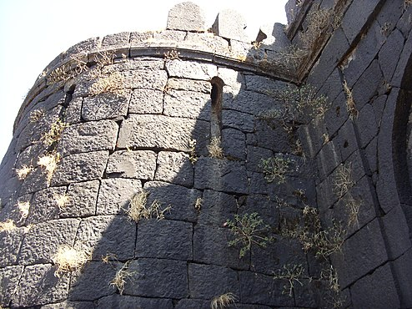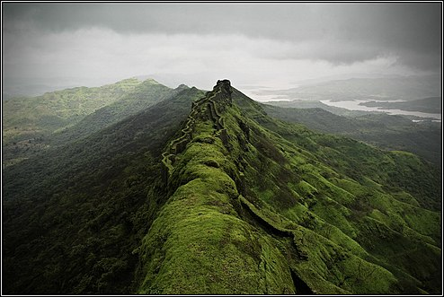

**How to reach:**

By Air: The nearest airport to the fort is located in Pune at a distance of around 75 km. Once you have reached Pune, you can either hire a direct cab or use public transport to reach Pali, which is a small village at the base of the hills and it is the place from where one needs to trek up the hill.



By Rail: You can catch a direct train to Pune railway station and then from there, you can either hire a direct cab or public transport to reach Pali. The distance between Pune railway station and Pali village is 68 km.

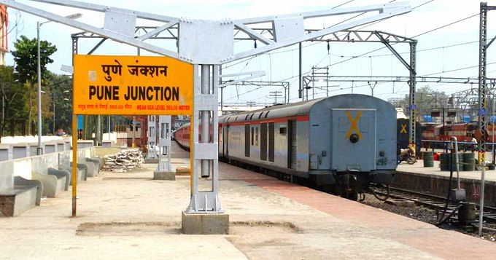

By Road: The village of Pali is easily accessible by road. From the village, you need to trek up the hill to reach the fort.

**Nearby tourist attractions:**

* 1. **Torna fort**

Torna Fort, also known as Prachandagad, is a large fort located in Pune district, in the Indian state of Maharashtra. It is historically significant because it was the first fort captured by Chatrapati Shivaji Maharaj in 1646, at the age of 16, forming the nucleus of the Maratha empire. The hill has an elevation of 1,403 metres (4,603 ft) above sea level, making it the highest hill-fort in the district. The name derives from Prachanda (Marathi for huge or massive) and gad (Marathi for fort).

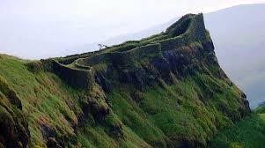

* 1. Mahabaleshwar

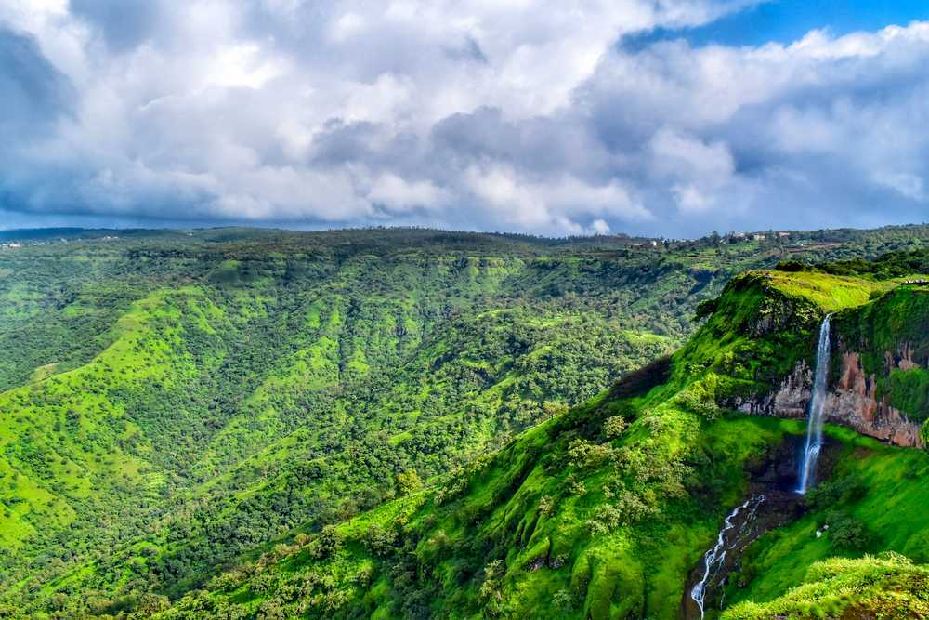

The famous hill station near pune, it is 109.2km from Rajgad.

* 1. **Sinhagad**

Sinhagad is a hill fortress located at around 35 km southwest of the city of Pune, India. Some of the information available at this fort suggests that the fort could have been built 2000 years ago. The caves and the carvings in the Kaundinyeshwar temple stand as proofs for the same.

Previously known as Kondhana, the fort had been the site of many battles, most notably the Battle of Sinhagad in 1670. Perched on an isolated cliff of the Bhuleswar range in the Sahyadri Mountains, the fort is situated on a hill about 760 metres above ground and 1,312 metres above mean sea level.

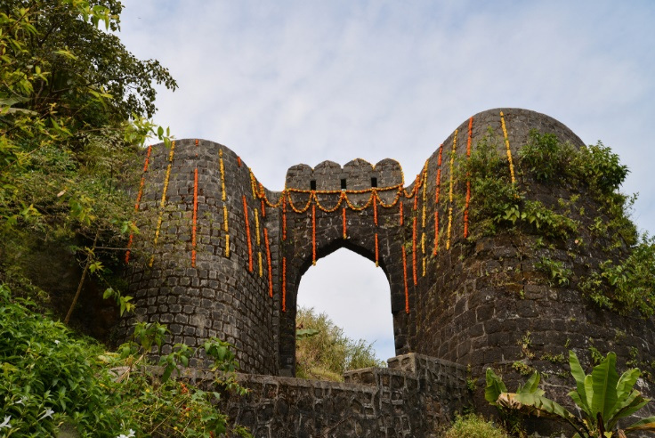

**What to eat and shoping places near rajgad**

There are no hotels near Rajgad fort, although various trekkers do campaign near the temple. There are various restaurants near fort   
also on fort you can get lemon juice, junka bakhar and pohe and misal provided by locals also you can get Vadas and bhaji too

Note: Images are added only for reference purposes)

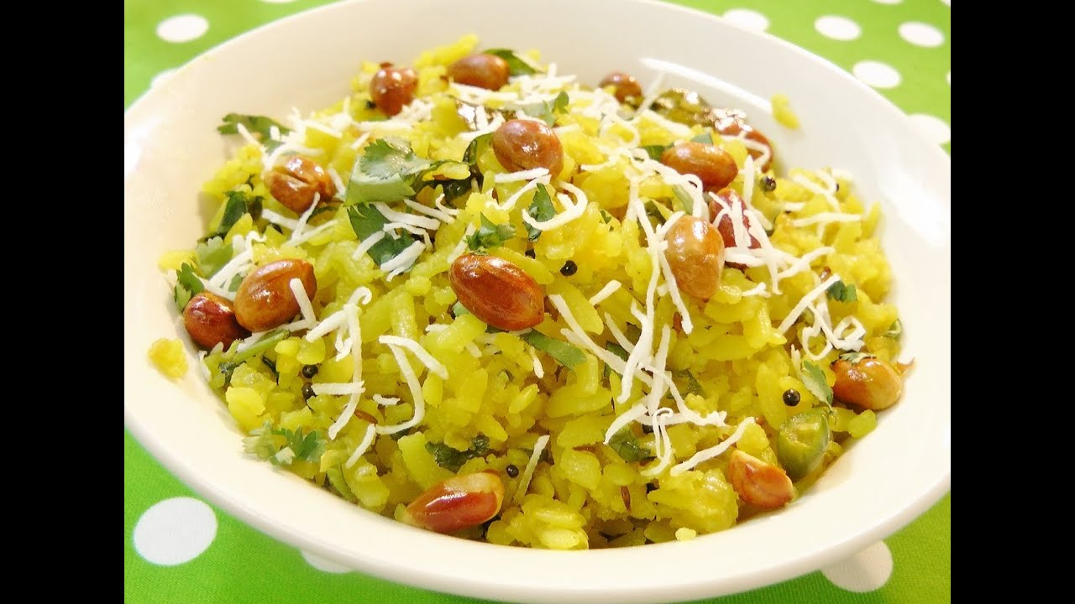





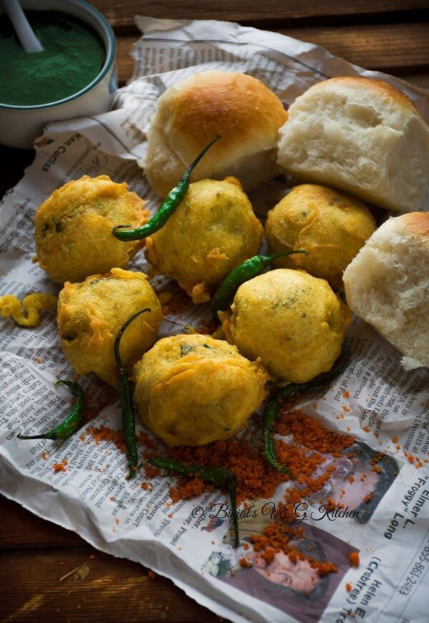

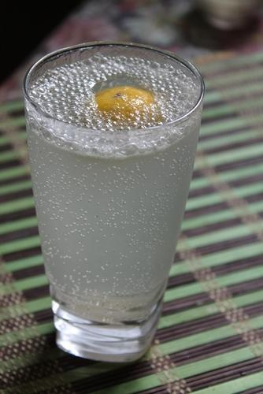

The nearest Shopping places will be Pune city. Also there are local shops near fort where you can buy Unique local items of that place.

**Pratapgad:**

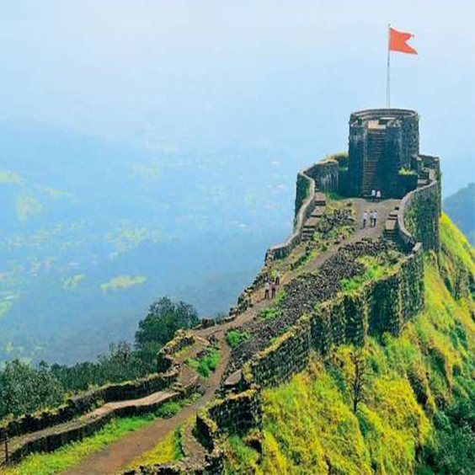

Pratapgad (Marathi: प्रतापगड) literally 'Valour Fort' is a large fort located in Satara district, in the Western Indian state of Maharashtra. Significant as the site of the Battle of Pratapgad, the fort is now a popular tourist destination. Pratapgad fort is located 15 kilometres (9.3 mi) from Poladpur and 23 kilometres (14 mi) west of Mahabaleshwar, a popular hill station in the area. The fort stands 1,080 metres (3,540 ft) above sea level[3] and is built on a spur which overlooks the road between the villages of Par and Kinesvar.

**Battle of Pratapgad:**

The Maratha king Chhatrapati Shivaji Maharaj commissioned Moropant Trimbak Pingle, his prime minister, to undertake the construction of this fort in order to defend the banks of the Nira and the Koyna rivers, and to defend the Par pass.It was completed in 1656.

Chhatrapati Shivaji Maharaj sent an emissary to Afzal Khan, stating that he did not want to fight and was ready for peace. A meeting was arranged between Chhatrapati Shivaji Maharaj and Afzal Khan at a shamiyana (highly decorated tent) at the foothills of Pratapgad. It was agreed that they would bring only ten personal bodyguards each with them. All the ten bodyguards would remain 'one arrow-shot' away from the pair. Chhatrapati Shivaji Maharaj chose Sambhaji Kondhalkar, Jiva Mahala, Siddi Ibrahim, Kataji Ingle, Kondaji Kank, Yesaji Kank, Krishnaji Gayakwad, Surji Katake, Visaji Murambak & Sambhaji Karvar for the meet. Afzal Khan hid a katyar (a small dagger) in his coat, and Chhatrapati Shivaji Maharaj wore armour underneath his clothes and carried a concealed wagh nakha in one hand.

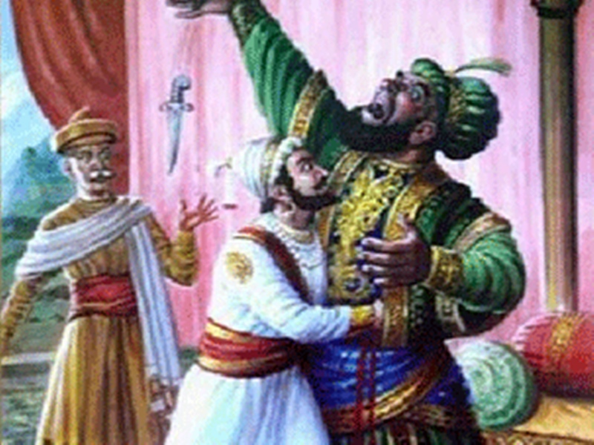

As the two men entered the tent, the 6'7" tall Khan embraced Chhatrapati Shivaji Maharaj. He then tried to strangle Maharaj in his vice-like grip and pierced his dagger in Shivaji. But the armour under Maharaj's clothes saved him. Chhatrapati Shivaji Maharaj retaliated by using his "wagh nakh" (tiger claws) to slash Khan's stomach and disemboweled Khan.

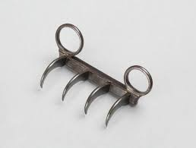

Thereupon Afzal Khan's bodyguard Bada Sayyed attacked Maharaj with swords but Jiva Mahala, Maharaj's personal bodyguard fatally struck him down. Also a lawyer of afzal khan krushna bhaskar kulkarni attacked on Chhatrapati Shivaji Maharaj. Chhatrapati Shivaji Maharaj being aware he killed krushna kulkarni by sword. Afzal Khan managed to hold his gushing entrails and hurtled, faint and bleeding, outside the tent and threw himself into his palanquin. The bearers hastily lifted their charge and began moving rapidly away down the slope. Sambhaji Kavji Kondhalkar, Chhatrapati Shivaji Maharaj 's lieutenant and one of the accompanying guards, gave chase and beheaded Afzal Khan. The severed head was later sent to Rajgad to be shown to Chhatrapati Shivaji Maharaj 's mother, Rajmata Jijabai. She had long wanted vengeance for the deliberate maltreatment of Shahaji Maharaj(Shivaji Maharaj father) while a captive of Afzal Khan, and for his role in the death of her elder brother, Sambhaji Shahaji raje Bhosle. Chhatrapati Shivaji Maharaj speed up the slope towards the fortress and his lieutenants ordered cannons to be fired. It was a signal to his infantry, hidden in the densely forested valley, to raid the Adilshahi forces.

Maratha troops commanded by Chhatrapati Shivaji Maharaj 's captain Kanhoji Jedhe, swept down on Afzal Khan's 1,500 musketeers; resulting in a complete rout of the musketeers at the foothills of the fort. Then in a rapid march, a section of Adilshahi forces commanded by Musekhan was attacked. Musekhan, Afzal Khan's lieutenant, was wounded and subsequently fled the field.

Meanwhile, Moropant led the Maratha infantry toward the left flank of Adilshahi troops. The suddenness of this attack on Afzal Khan's artillery at close quarters made them ineffective in providing artillery cover for the main portion of their troops. And as a result of this the rest of their troops rapidly succumbed to an all out Maratha attack. Simultaneously Chhatrapati Shivaji Maharaj 's Sardar (captain), Ragho Atre's cavalry units swooped down and attacked the large but unprepared Adilshahi cavalry before they were able to be fully geared up for battle and succeeded in completely routing them in short order.

The Maratha cavalry under Netaji Palkar pursued the retreating Adilshahi forces, who were attempting to join up with the part of their reserve forces stationed in the nearby village of Wai. They were engaged in battle before they could regroup and were defeated prior to reaching Wai. The Adilshahi forces not withstanding the onslaught of the Marathas started retreating towards Bijapur. The Maratha army chased the retreating army and on their way captured 23 Adilshahi forts. In fact, the Adilshahi Killedar of the Kolhapur fort (Panhalgad ) himself handed over the keys to the Marathas.

Aftermath

Adilshahi forces lost their artillery, 65 elephants, 4000 horses, 1200 camels, jewels worth 300,000 Rupees, 1,000,000 Rupees, heaps of precious clothes, tents to the Marathas. They also lost their money and grain stored at Wai.

5,000 Adilshahi soldiers were killed and almost as many were wounded. 3,000 soldiers were imprisoned, and the remainder were allowed to go home in defeat. The Marathas lost 1,734 soldiers, while 420 soldiers were wounded.

As it was the policy of Chhatrapati Shivaji Maharaj to humanely treat the defeated army, neither the men nor women were sold as slaves or molested. Wounded commanders were offered treatment deserving of their rank and either imprisoned or sent back to Bijapur. Some of the defeated Adilshahi generals like Siddi Hilal changed their loyalties and joined the Marathas to serve under Maharaj. Two of Afzal Khan’s sons were captured by the Marathas but were let off by the Maharaj. Fazal khan (son of Afzal Khan) and the Adilshahi soldiers with him who were badly injured were shown a safe passage out of the forest of Jawli by Prataprao More. Chhatrapati Shivaji Maharaj also buried Afzal Khan as per Islamic customs and built his tomb near Pratapgarh, as per his philosophy of ‘once the enemy is dead, the enmity is dead too’.

The sword of honour was presented to Kanhoji Jedhe for his invaluable and outstanding performance of service to Chhatrapati Shivaji Maharaj. The relatives of the killed soldiers were offered service in the Maratha army. Families without any male left alive to support, the family were awarded pensions. Heroes of the war were rewarded with medals, kada (bracelets) and horses.

Khan's death dealt the Adilshah's rule a severe blow. A quarter of his territory, forts and a fifth of his army were captured or destroyed, while King Shivaji doubled his territory, losing a tenth of his army, within fifteen days of the Battle of Pratapgadh. Chhatrapati Shivaji Maharaj maintained his momentum, sending cavalry towards Kolhapur, which succeeded in capturing seventeen forts, including the prestigious fort of Panhala. Cavalry was also sent towards Dabhol and Rajapur under the command of Doroji Patil, which was successful in capturing forts in the southern Konkan.

This remarkable victory made Chhatrapati Shivaji Maharaj a hero of Maratha folklore and a legendary figure among his people. Having established military dominance and successfully beaten back a major attack by a powerful empire, Shivaji had founded the nucleus of what would become the Maratha Empire.

**Gallery**

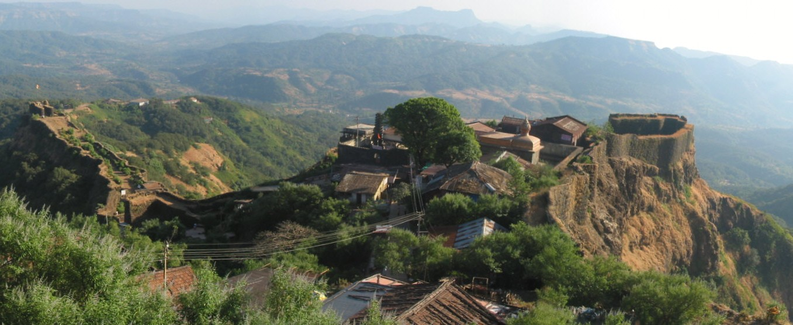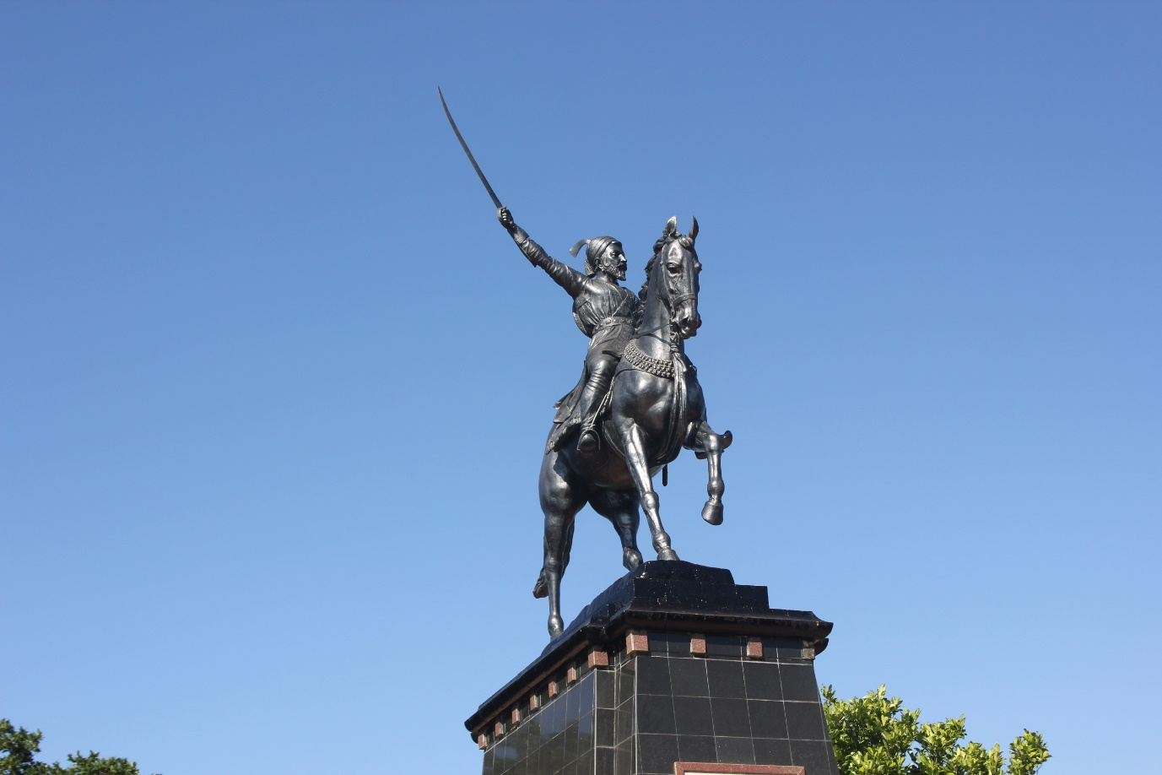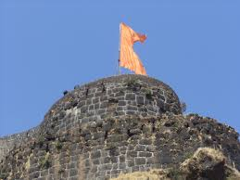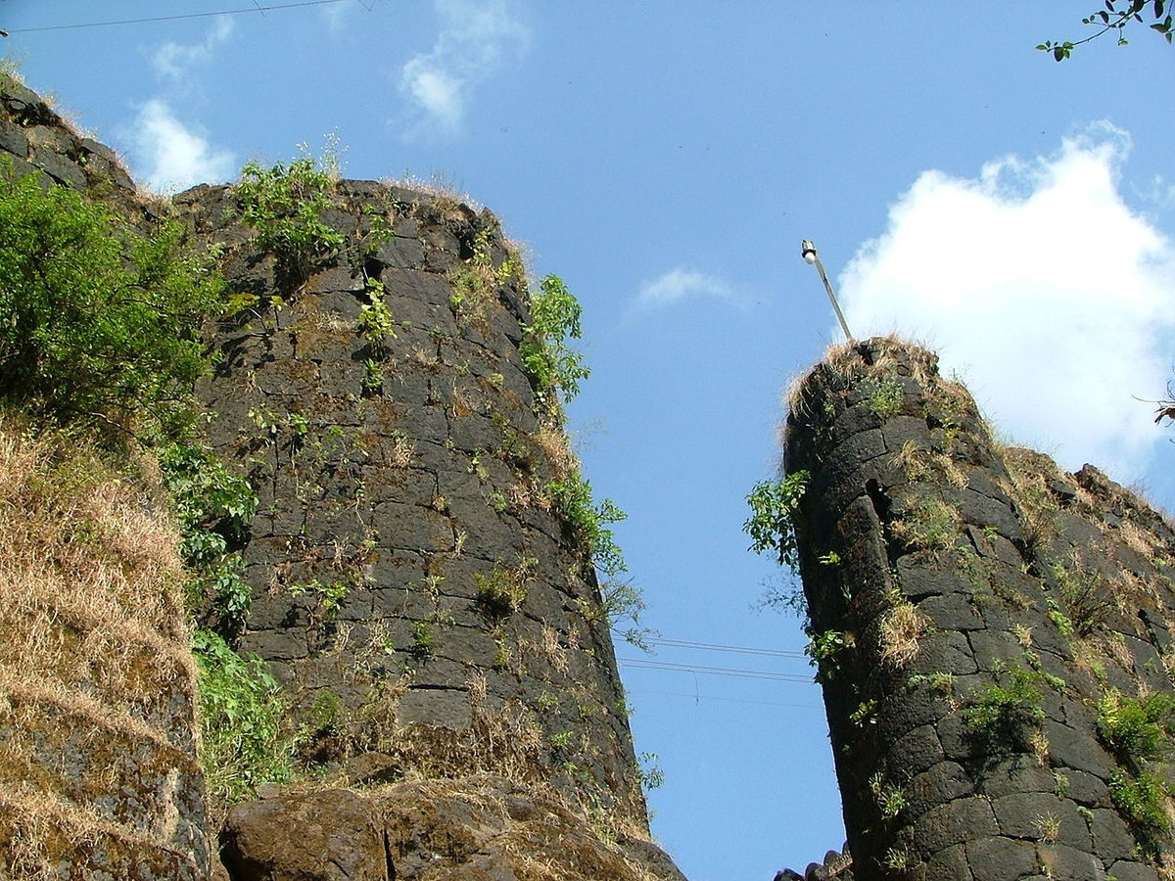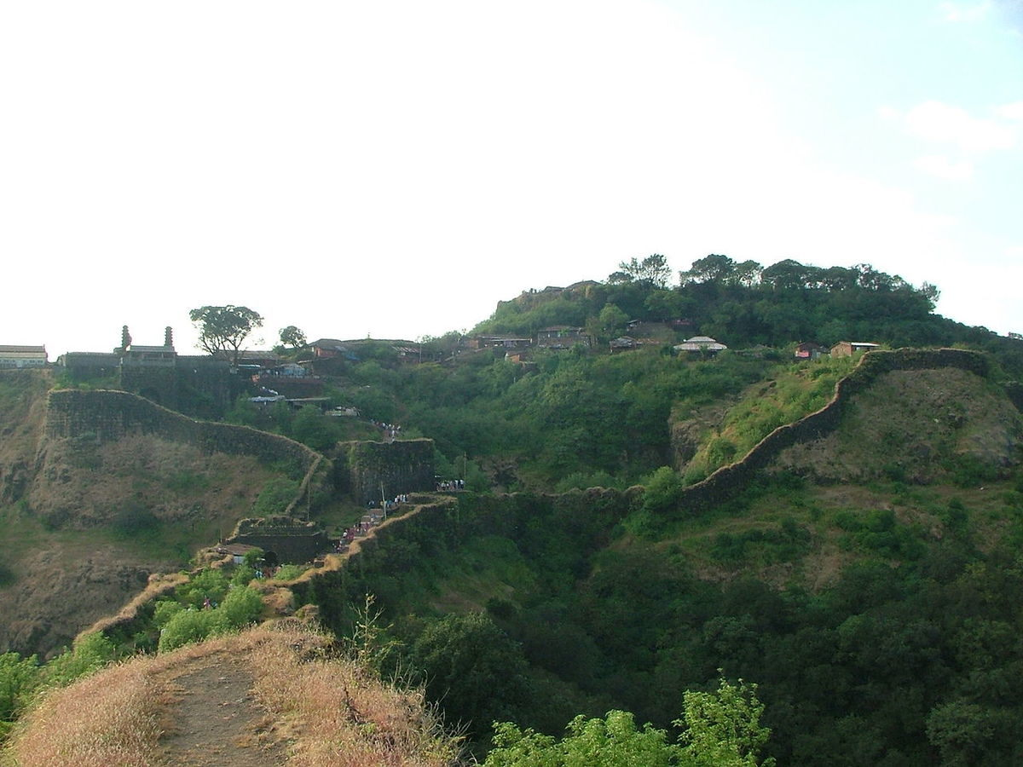

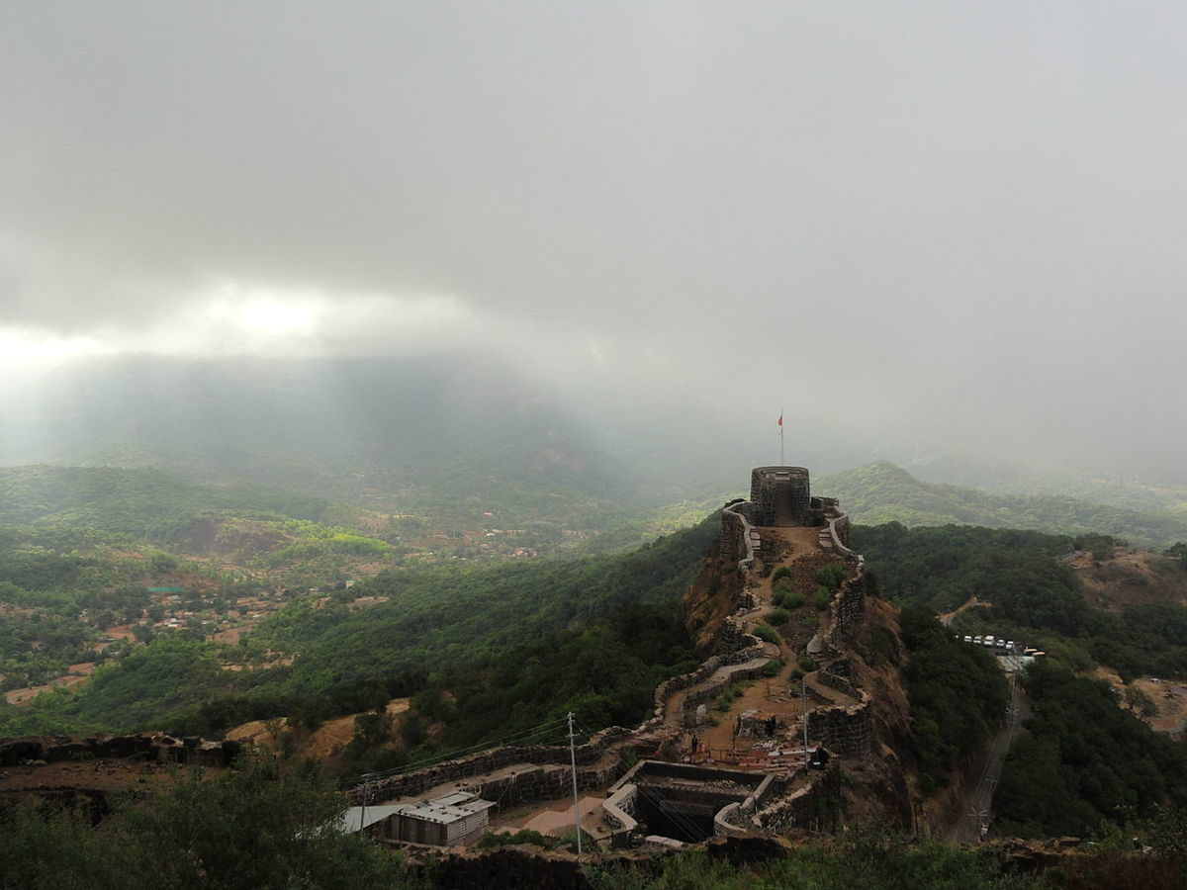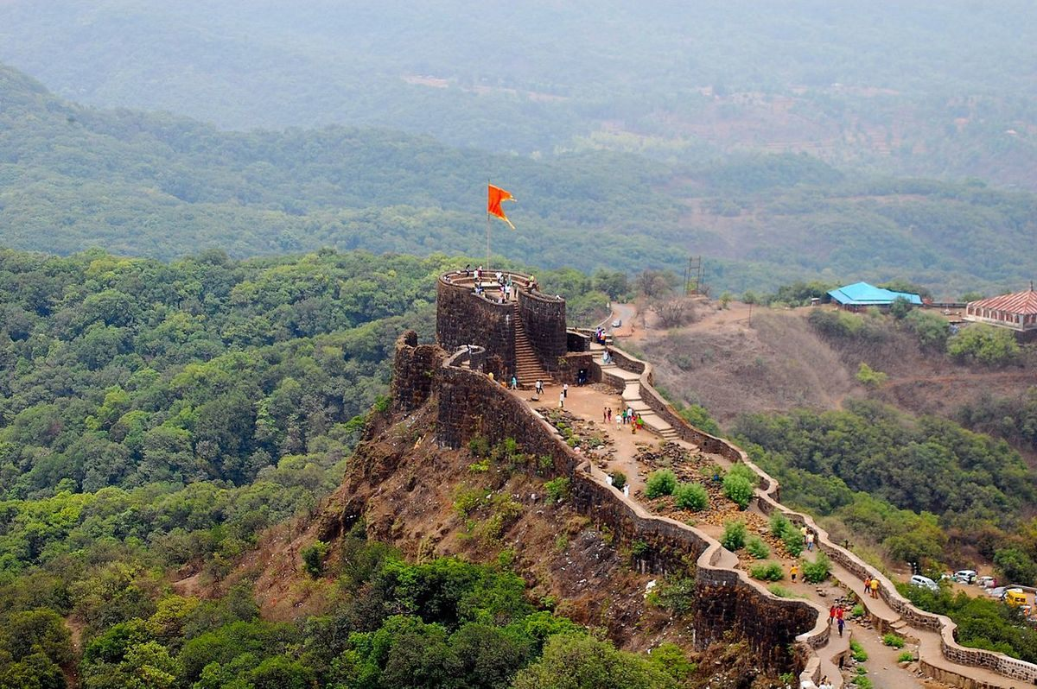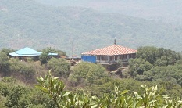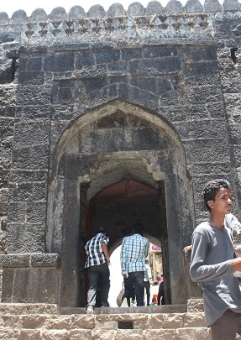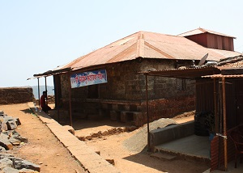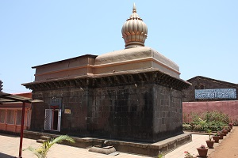

the fort can be divided into the lower fort and upper fort.

The upper fort was built upon the crest of the hill. It is roughly square, 180m long on each side. It has several permanent buildings, including a temple to the god Mahadev. It is located at the northwest of the fort, and is surrounded by sheer cliffs with drops of up to 250m.

The lower fort is around 320m long and 110m wide. It is located at the southeast of the fort, and is defended by towers and bastions ten to twelve metres high.

The Afzal tower extends out from the fort proper and defends the approach to the fort. It is said to have been constructed after the Battle of Pratapgad, and Afzal Khan's body is said to be buried under the tower.

In 1661, Shivaji Maharaj was unable to visit the temple of the goddess Bhavani at Tuljapur. He decided to dedicate a temple to the goddess at this fort itself. This temple is on the eastern side of the lower fort. The hall has been rebuilt since the original construction, and consists of wooden pillars about 50' long, 30' broad and 12' high. The shrine is made of stone, and contains a clothed black stone image of the goddess. The roof of the temple is flat inside, but covered in lead covering put up by the Satara Raja Pratapsinha (1818–1839). A small spire or shikhar covers the shrine.The temple also has the sword of Maratha General Hambirao Mohite adorned with 6 diamond stones signifying that he had killed 600 soldiers in the battle. There is also a spatikha linga being worshipped inside the temple.The armors used in the battle during that period by the infantry soldiers are also on display just outside the temple, A dargah of Afzal Khan is located a short while away from the fort to the south-east.

How to reach:-

Road

Mahabaleshwar is 32 km from Wai. It is 260 km from Mumbai, the state capital. The nearest major city is Satara, 45 km and it is 120 km from Pune and 263 km from mumbai thane Mahabaleshwar is connected by the National Highway 4. Bus services by state-run MSRTC and private organizations connect it to Pune, Mumbai, Sangli and Satara.

Rail

Nearest railroad is Satara, 60 km. Nearby major railway junctions include Pune (120 km), and Miraj (170 km) . State-run bus services are available in these locations to Mahabaleshwar. Rail station Diwan Khavati on Kokan Railway near Khed gives a route of 60 km via Poladpur to Mahabaleshwar.

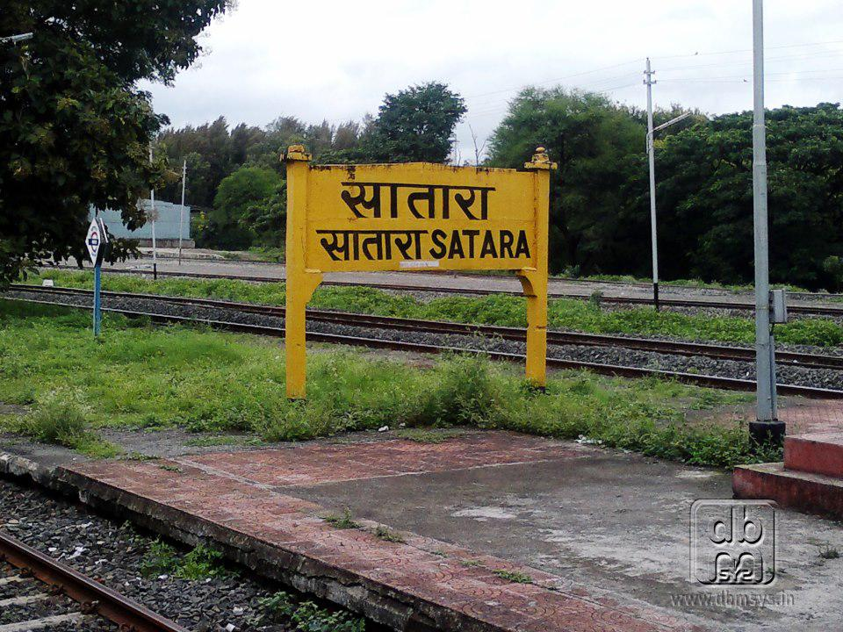

Air

The nearest airport is Pune International Airport, serving the city of Pune, 120 km from Mahabaleshwar. Chhatrapati Shivaji International Airport of Mumbai is 270 km.



**Nearby tourist attractions:**

**Arthur seat point**

Officer Sir Arthur Malet (1806–1888)[3](Not to be confused with British born actor of same name), who sat here and gazed at the Savitri River, where he lost his wife and children in a tragic ferry mishap.

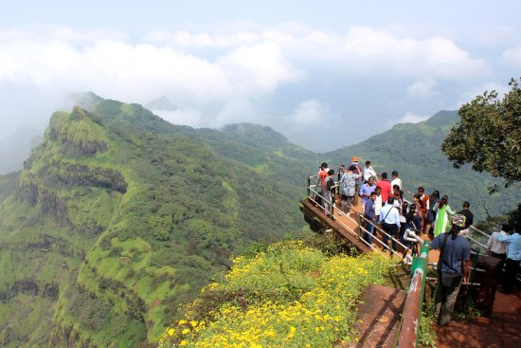

**Panchganga Temple**

**The Panchganga Temple is constructed at the convergence of five rivers Krishna, Venna, Savitri, Koyna and Gayatri. It is believed that five rivers originate from gaumukhi inside Panchganaga temple.**

**The temple was constructed in the 13th century by "Yadava King Singhandeo". The construction improvement of the Panchganga Temple was done during the 16th and 17th Century by "Chanda Rao More" and Chhatrapati Shivaji Maharaj. Panchganga temple in old Mahabaleshwar is said to be 4500 years old. However, there is no historical evidence of this claim.**

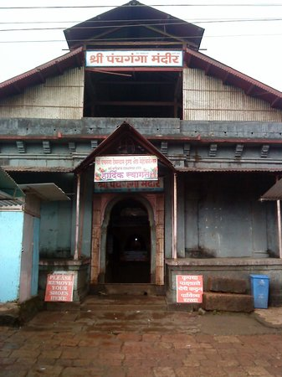

**Mahabaleshwar Temple**

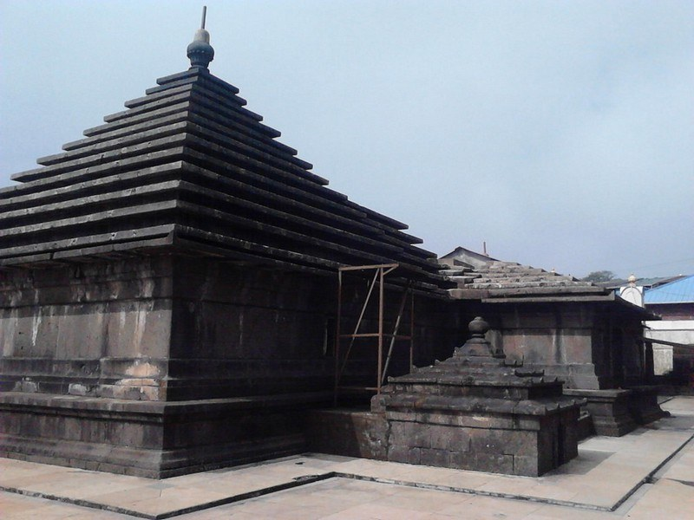

**Mahabaleshwar Temple is built in 1215 AD as per historical records. This temple is built in Hemadpanti style.**

**The temple houses Shiva's bed, damru and trishul which date back to approximately 300 years. It is believed that every morning, the bedsheet is found crumpled indicating Shiva's presence at night within the temple.**

**Ramdasi Math: Beside Mahabaleshwar temple is Ramdasi Math which has a copy of Dasbodh. Samarth Ramdas himself had edited (corrected) this dasbodh copy.**

**Krishna Temple**

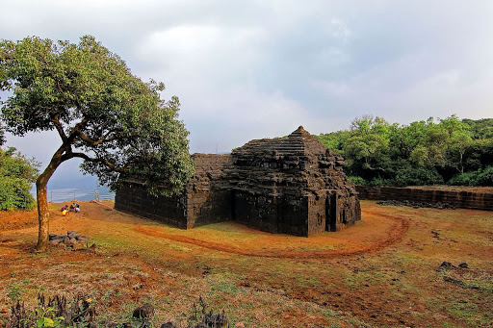

**Krishnabai temple.**

**Krishna temple which is 1 km away from Panchganga temple is built in Hemadpanti style, In front of the Krishna temple is Krishna valley. As per mythology, Krishna river had jumped from this place.**

**3 Monkey Point**

**Named because of the natural sculpture of the stones which looks like three monkeys sitting beside each other and portraying 3 monkeys of Gandhiji. Nestled deep in the valleys one can figure out from the outline of a big stone a natural cut out it give an effect of 3 monkey sitting next to each other portraying the Three Wise Monkeys. This point is on route to Arthur's Seat.**

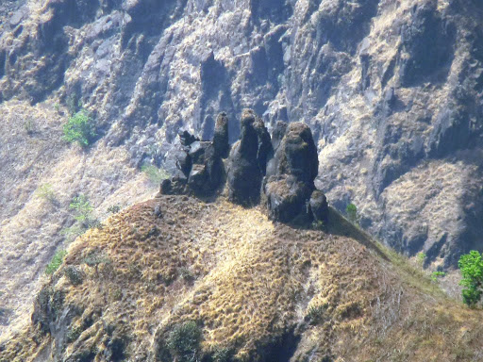

**Venna Lake**

**Mahabaleshwar is a holiday resort, honeymoon spot, and a pilgrimage site for People.**

**Boats on the Venna lake in Mahabaleshwar.**

**The Venna lake is one of the tourist attractions of Mahabaleshwar. The lake is surrounded by trees.**

**There are hotels from budget hotels to 3 Stars hotels. There are hotels with the Lake's View or in the market.**

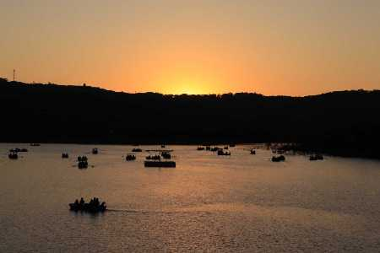

**Kate's Point**

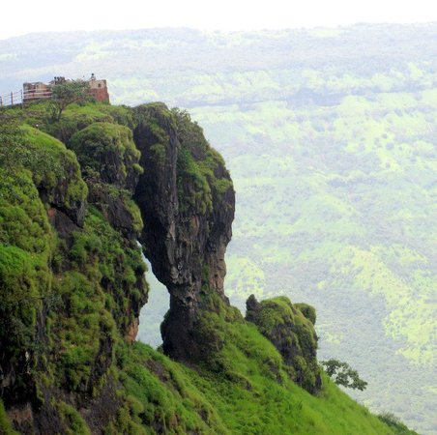

**Balakwadi dam viewed from Kate's Point**

**Kate's point is located to the east of Mahabaleshwar and is famous for its view of two reservoirs, Balakwadi and Dhom. The point is around 1,280 m high.**

**Needle Hole Point / Elephant Point**

**Needle hole point is located near Kate's Point. One can see a natural rock formation with a hole in between, thus giving the name Needle-hole. The point is also famous for the view of Deccan traps, which look like an elephant's trunk.**

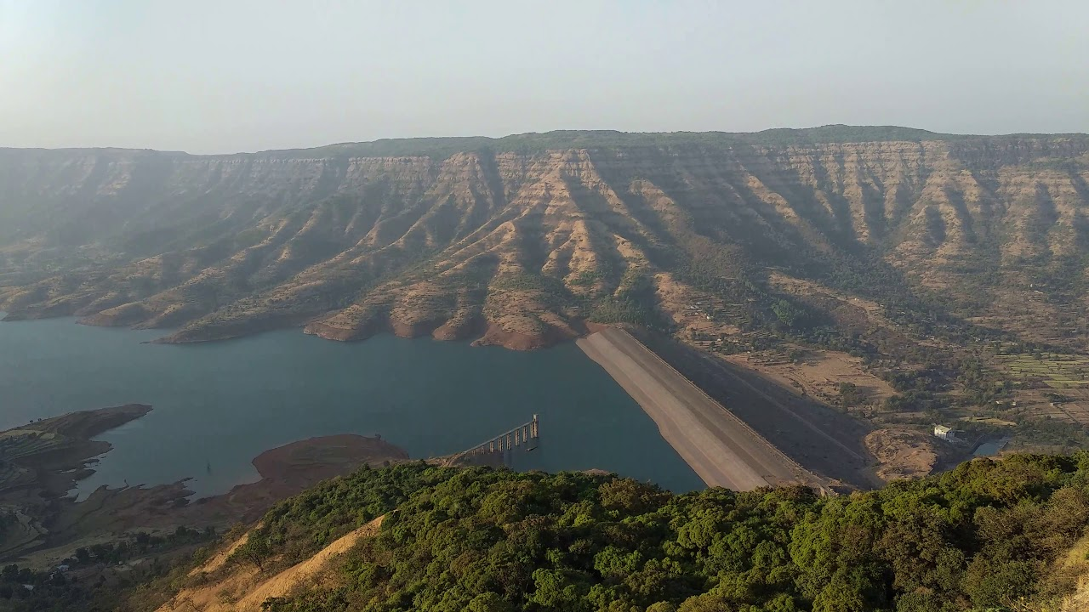

**. Wilson Point**

**Named after Sir Leslie Wilson, the Governor of Bombay from 1923 to 1926, Wilson Point is the highest point in Mahabaleshwar at 1439 m. Known as Sindola Hill during the colonial rule, Wilson point is the only location in Mahabaleshwar where both sunrise and sunset can be seen. It offers a spectacular glance of Mahabaleshwar in all directions. It located at behind Mahabaleshwar-Medha road at 1.5 km from Mahabaleshwar city.**

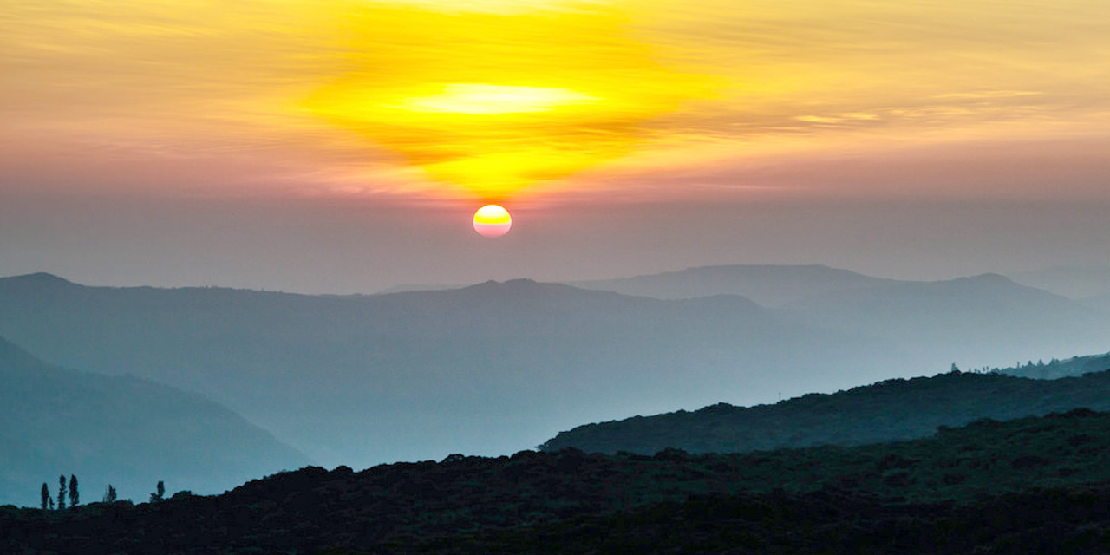

**Lingmala Waterfalls**

**Panoramic view of Lingamala waterfalls**

**This waterfalls is located near Mahabaleshwar. The water here falls from a height of approximately 600 feet. The water of Lingamala waterfalls cascades into the Venna Lake. The waterfalls are divided by outward projecting rocks into multiple tiers.**

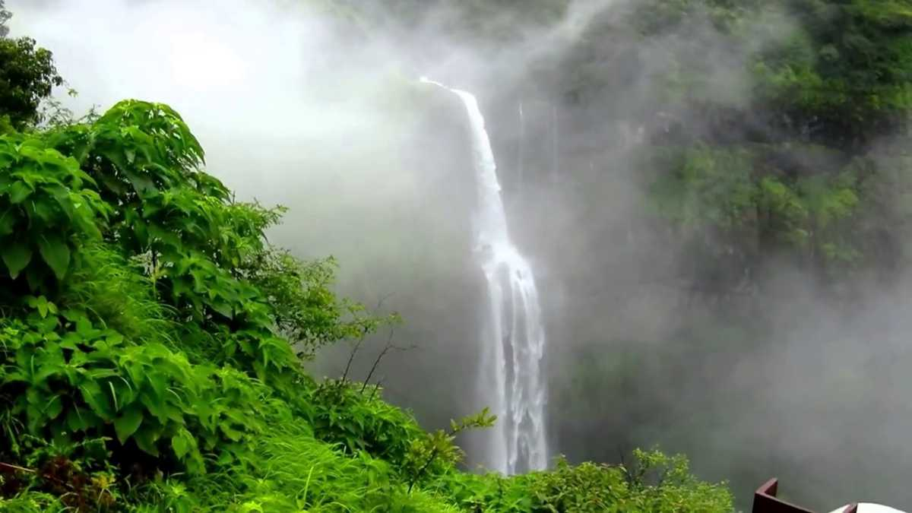

**What to eat and shopping**

Strawberries, Mulberries, Carrots, Corn, and Cherry size tomatoes are the natural treasures of Mahabaleshwar's cuisine. Delicious indulges made from strawberries are a speciality of the town such as toffees, syrups, fudge, ice creams, whipped creams, jellies as well as the Corn Pattice.   
  
Going to Mahabaleshwar on a short weekend trip is incomplete without paying a visit to the renowned restaurant - Bagicha Corner, which is extremely famous for its strawberry cream, mulberry cream, ice creams and syrups, corn patties, zunka bhakari and corn Frankies. Mapro Garden Restaurant serves lip-smacking Italian delight pizzas and chocolate brownies for a delectable lunch, which can be followed by a round of colourful ice-cold chuskis and garden carrots from local vendors.

Top 4 restaurant

Hotel raajmahal

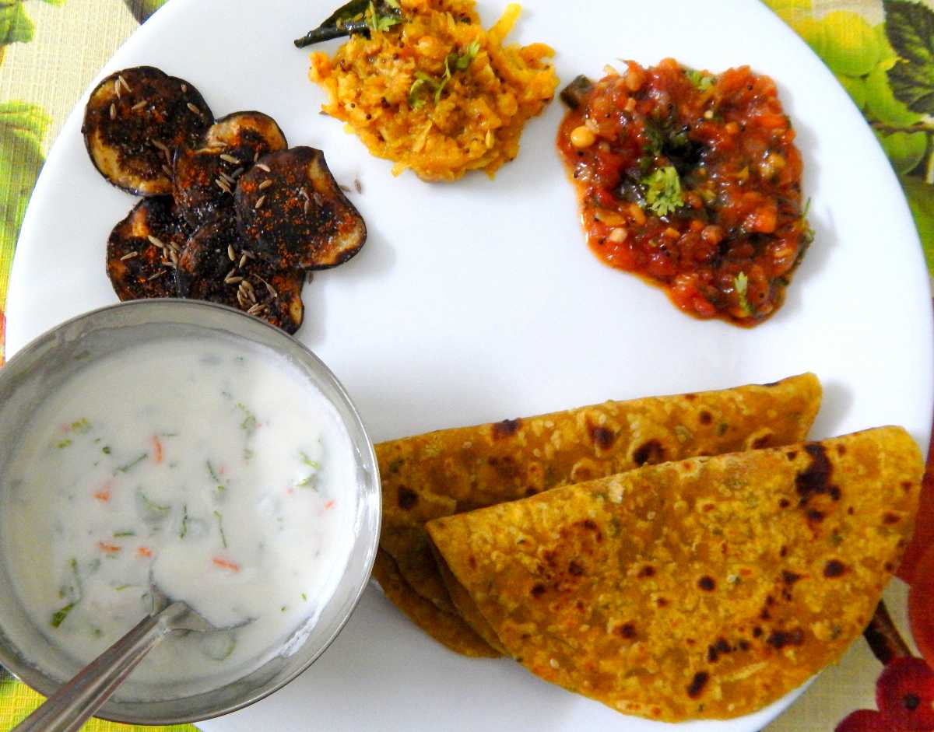

* 1. Grapevine



3)aman restaurant

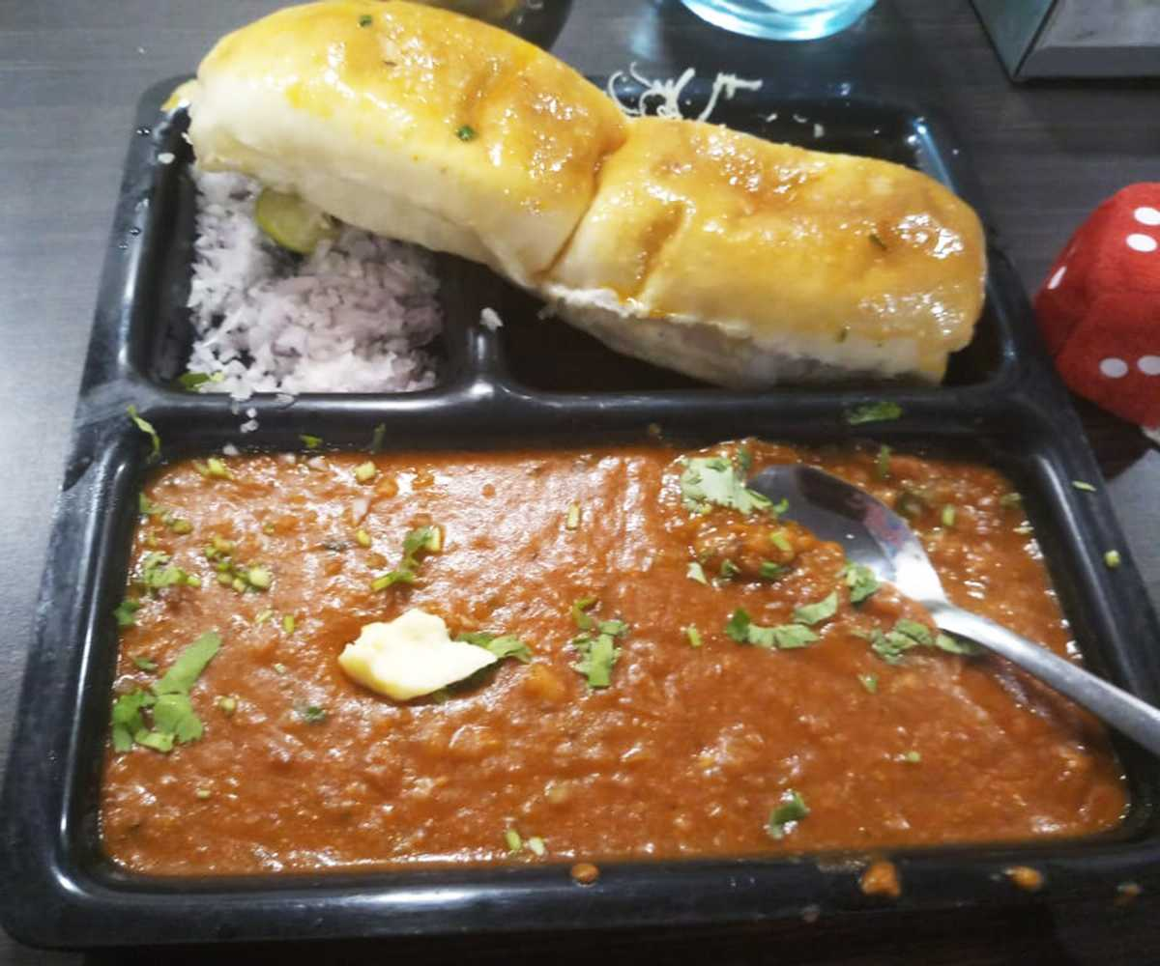

* 1. Elsie’s dairy and bakery

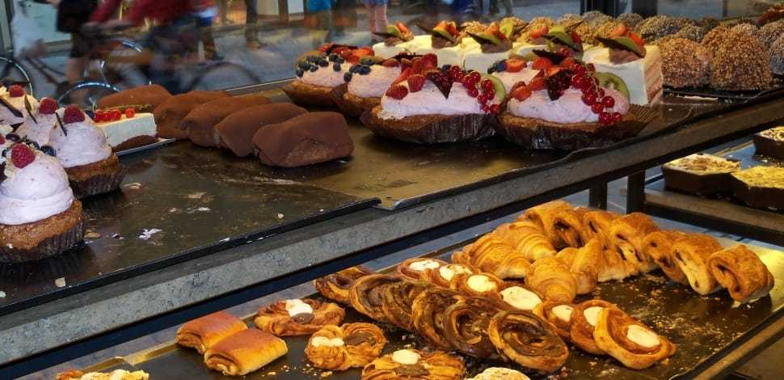

**Nataraj Chikki & Fudge**

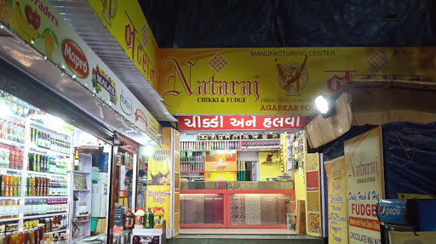

Head to Nataraj for the freshest and highest quality chikkis in Mahabaleshwar. They’re made with peanuts, sesame and all your favourite nuts, and jaggery or honey. They have the perfect texture, with that perfect snap, and are among the best in the area. Don’t forget to try their in-house chocolate fudge, made from scratch each day.

**Rustom’s Strawberry Inn**

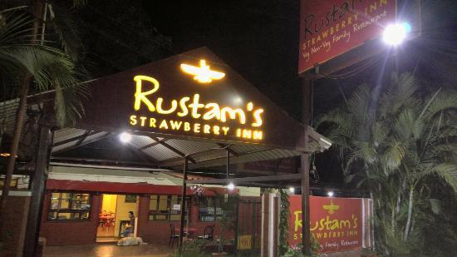

As the name suggests, the berries are big in this bistro located on the Panchgani-Mahabaleshwar road. Fresh strawberry ice cream is their specialty, but they also serve food. You can have omelettes, parsi style dal, hearty vegetables and roti to get you going for all the long hikes in the area.

What to buy

* **Strawberries –** Yes, this is the first thing you should be looking for when you are in Mahabaleshwar. The season of strawberries begins from October. So, for strawberry picking, you can visit Mahabaleshwar in the month of October. Here, you can get strawberries at lower prices as compared to other parts of India.
* 
* **Wooden products –** Mahabaleshwar is not only famous for strawberries, it is also famous for its wooden products. So, while you are in Mahabaleshwar, you can go exploring the wood handicraft shops. Here you will get high-quality wooden trays, wooden sticks and wooden toys. These will adorn your showcase beautifully when you come back from your Mahabaleshwar tour.
* 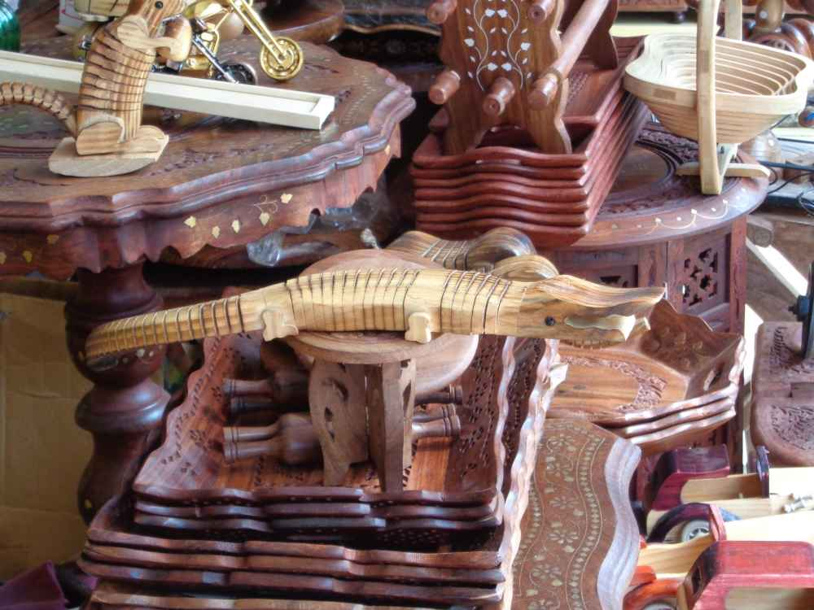
* **Leather items –** It is a well-known fact that the leather goods of Mahabaleshwar are famous. However, which of them should you buy? Leather footwear is a famous shopping item which tourists buy from this city. You will find countless shops in the market that sell leather footwear.



* **Syrups –** Many travellers who have been to Mahabaleshwar will tell you that the fruit crushes and the syrups Mahabaleshwar stores sell are the best ones. This has been made possible by the fact that Mahabaleshwar sells a variety of berries which go in as ingredients in these crushes and syrups. You can bring home some syrups to relive the fond memories of your Mahabaleshwar tour. Mapro Garden is one of the best place to buys variety of items
* 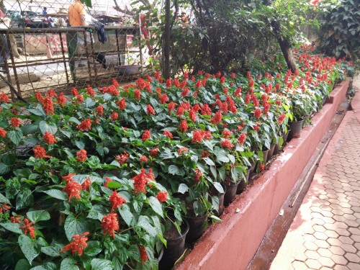
* **Strawberry cream –** If you are in Mahabaleshwar, you need to try this out. Many restaurants in the city sell this yummy, refreshing cream.

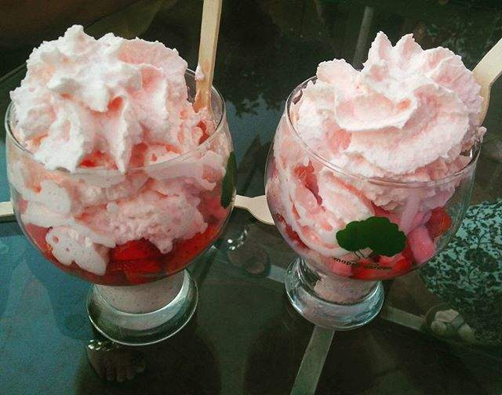

* **Turmeric –** A number of shops and roadside stalls in Mahabaleshwar sell pure unadulterated turmeric powder and fresh turmeric root. The bright colour of the turmeric and its pleasant aroma make it a special item for the travellers to collect.
* 